Clinical Leads

Name | Photo | Pen Portrait
Caroline Annesley | 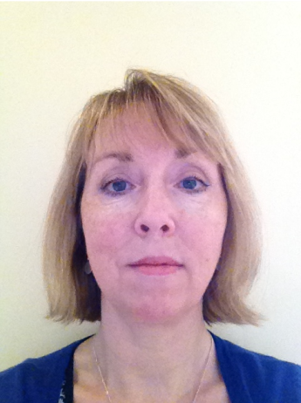 | Caroline qualified in London in 2010 as a mature student with a background in languages, international market research and teaching. She completed her post-graduate medical training in Bath, with elective placements in both Swindon and Salisbury. She has been with St Chads Surgery since 2015 and represents Bath sessional GPs on Wessex LMCs. Caroline spent two years working for B&NES CCG as a ‘Clinical Integrator’, on initiatives to support closer interdisciplinary and primary-secondary collaborative working. She also became Clinical Lead for ‘End of Life’ in the run-up to the BSWCCG merger, a role that cemented a long-standing interest in Cancer, and builds on her training experience with breast and colorectal cancer patients. Caroline is committed to working for improved cancer care outcomes and a better experience for people affected by cancer across BSW.  Caroline is GP clinical lead for Cancer (Elective Programme)
Ian Williams | 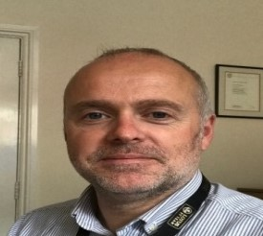 | Ian qualified in 1993 and completed his GP training in Malmesbury. He is the Managing Partner at Southbroom Surgery in Devizes, where he has been a Partner for nearly 20 years. He is a GP Trainer and Appraiser as well as the Clinical Director for Devizes PCN. He was formerly the Urgent Care lead for Wiltshire CCG prior to the merger in April 2020. In his spare time, he enjoys running, skiing and playing golf. He also spends a few weeks every year training in expedition medicine.  Ian is GP clinical lead for Urgent Care (Urgent Care programme)
Jeremy Cottrill | 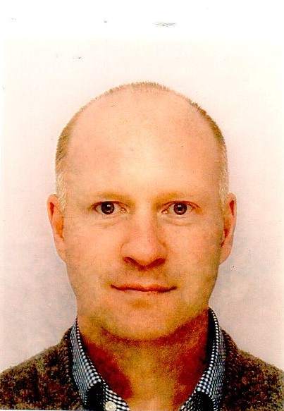 | I qualified from UCL in 2000 and completed my GP training in Frome in 2005. I have worked as a GP in the Bath and Wiltshire area ever since, initially as a locum GP followed by salaried and then partnership roles. I currently work 4 sessions a week at The Three Shires Medical Practice, Colerne Surgery. I am a GP appraiser and also have an honorary contract with the Royal United Hospital for 1 session a week whilst developing a role as a GPwSI in Cardiology.  Jeremy is GP clinical lead for clinical pathways (Elective Care programme)
Katherine Oldridge | 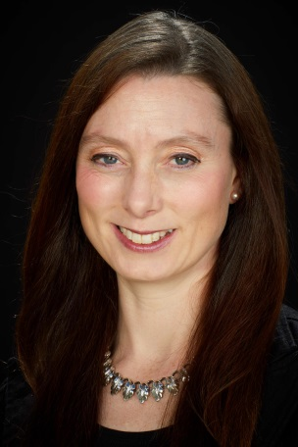 | Katherine joins us as Clinical Lead for maternity and children. She studied Physiology at Bristol University and worked in management consultancy before returning to study medicine at Cardiff University where she qualified in 2007. She undertook Foundation and GP training in Bristol and Bath, completing in 2012. She has worked as a 6 session salaried GP for the past 8 years in OLD Town Surgery in Swindon, which has recently become part of Wyvern Health Partnership. She was the GP Representative on the Swindon Integrated Care Alliance Board which aimed to embrace new ways of working and interacting across social and health sectors. She lives with her husband and two children and returned from her second maternity leave earlier this year, hopefully allowing for empathy with a patient perspective in her role.  Katherine is GP clinical lead for maternity and children (supports the Local Maternity System with links into other programmes for children)
Louise Abson | 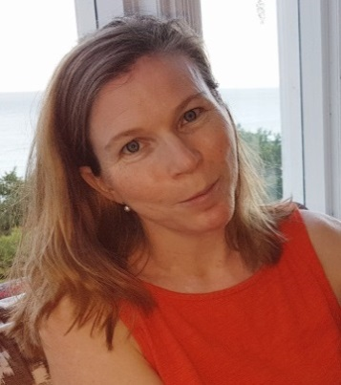 | I am a GP Partner at Widcombe Surgery Bath. My special interests include contraception and women’s health as well as joint injections. Other roles include the following: - GP Appraiser, mainly in the South Gloucester area and more recently GP Educational Supervisor. I have a husband and 3 children who keep me busy in my spare time.  Louise is GP clinical lead for clinical pathways (Elective Programme)
Mark Boothman | 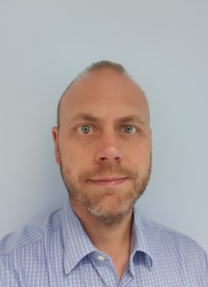 | Having qualified in Glasgow and then worked in London, Mark completed his GP training with the South West Deanery in 2006. He then moved to work in Swindon where, since 2013, he has been a partner at Lawn Medical Centre. Mark has been actively involved in GP training and the teaching of medical students for several years. More recently he has been involved with commissioning as a GP representative on the Governing Body of Swindon CCG leading up to the merger and formation of BSWCCG in April 2020. During that time he developed an interest in the provision of Urgent and Emergency Care. He feels optimistic that the newly emerging primary care networks will contribute significantly towards improving the quality of care for patients across BSW and helping General Practice become more resilient.  Mark is clinical lead for urgent care (Urgent Care Programme)
Mark Luciani | 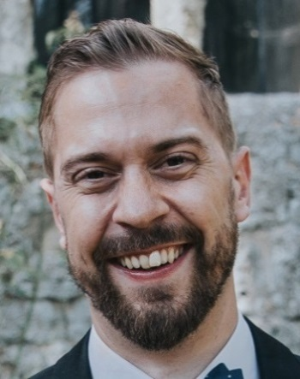 | I am Danish-Italian, though born and raised in South-East Asia attending British International schools, and a medicine graduate from Copenhagen University in 2012. A "third culture kid" with a love of food, comedy, philosophy and games! I found myself aligned with the values of primary care rather than the hierarchies of hospital medicine, and since then have worked in primary care in Copenhagen, rural medicine in Artic northern Norway and then moved to the UK with my wife 5 years ago and completed GP training in Swindon in 2019. Through those experiences, I have developed a passion for care of the elderly. My goal is to deliver compassionate care for these vulnerable adults, to foster an environment of respect and autonomy with expert guidance and support, so we can ameliorate suffering and promote dignity. We all have one life, that is our story, and the ending matters.  Mark is GP clinical lead for ageing well, dementia and end of life (End of life programme)
Molly Moffat |  | Molly has worked as a GP in Highworth since 2018 after she relocated to Gloucestershire with her family. She has led the development of the role of the mental health nurse at her practice and has been involved in setting up group consultations. She strongly believes in a patient centred approach and knowing when her role as a GP means being an advocate for her patients. She is looking forward to her role in commissioning and having the opportunity to add value at a higher level and to a larger number of patients. With learning disability (LD) and autism spectrum disorder (ASD) having been recognised as one of the key priorities and challenges within the BSW Long Term Plan, she is really excited to be part of the transformation, helping achieve improved care for these patients.  Molly is GP clinical lead for learning disabilities and autism spectrum disorder (all age LD and ASD)
Nima Satish | 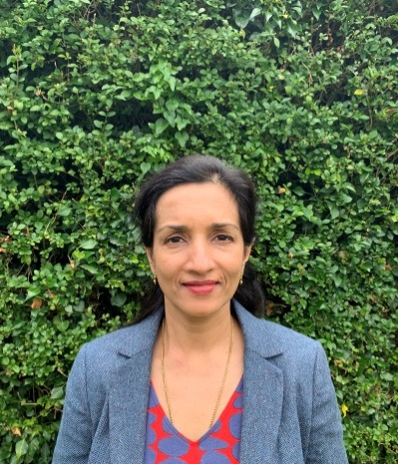 | Nima Satish worked as a Specialist Registrar in Diabetes and Endocrinology having qualified with MRCP in 1996 in Scotland. She retrained as a GP in 2002-3 in the Thames Valley Deanery and has been accredited as a GPSI in Diabetes. She has worked as a Locum and Salaried GP in Swindon and was involved in running the Non-Principals group locally . She has been a GP trainer in Swindon since 2013 and works as a Salaried GP and Clinical Lead Diabetes at Westrop Medical Practice. She is looking forward to working across the BSW area to improve Diabetes care.  Nima is clinical lead for diabetes
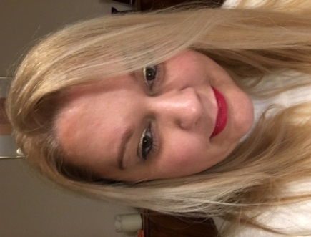  Sarah Blaikley |  | Sarah joins us as the Clinical Lead for mental health. Sarah works in Bath as a salaried GP 6-sessions a week and at the weekends for Medvivo OOH’s service provider. She trained as a GP in Bath and qualified in 2017, locuming in Wiltshire and Bath. Sarah has a background in mental health having undertaken posts during her GP specialist training through the RUH, Bath and her foundation training at The Great Western Hospital, Swindon. Sarah graduated from Bristol Medical School in 2010 having previously worked as a PR specialist in London. Her first degree from Oxford University was in Theology with specialist papers in Philosophy and Ethics. ‘She now lives in Wiltshire with her husband and two children.’  Sarah is GP clinical lead for all age mental health (All age emotional wellbeing and mental health – Thrive)
Tim King | 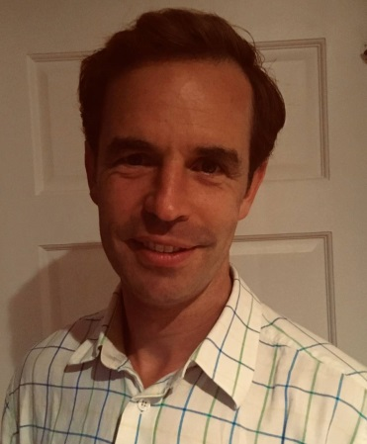 | Qualified from Oxford in 2004 before several years in surgical training. Worked abroad as an orthopaedic registrar before completing his training in general practice. Latterly he has worked in hospital posts in Salisbury District Hospital before joining Mere Surgery as a Partner and continues his surgical work one day a week. He has been involved with Wiltshire musculoskeletal (MSK) commissioning for the last 10 years and looks forward to the opportunity to continue to improve patient care and systems both within MSK and outpatient care. Two children and a bit of golf keep him entertained away from work!  Tim is GP clinical lead for outpatient clinic (OPD) transformation and MSK (OPD transformation and Elective Care Programme)
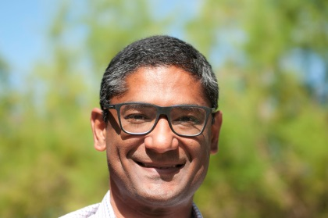  Vivek Singh |  | "My name is Vivek Singh. I qualified from University College London in 2002 and spent 10 years in surgical and orthopaedic training before starting GP training in 2012.  After qualifying as a GP in 2015 I worked as a locum GP across various practices in Wiltshire before working abroad for a year in New South Wales, Australia.  Since returning to the U.K. in 2018 I've been in my current post as a salaried GP at the Kennet & Avon Medical Partnership in Wiltshire.  My interest in MSK stems from my orthopaedic background as well as my interest in sport which I enjoyed more actively when I was younger. Nowadays, I take a slightly more passive, although no less enjoyable, role encouraging my children to develop their interest in sport as well as a love of the outdoors."  Vivek is GP clinical lead for MSK pathways

