Covid-19 vaccination programme: Stakeholder briefing

Thursday 29 July 2021

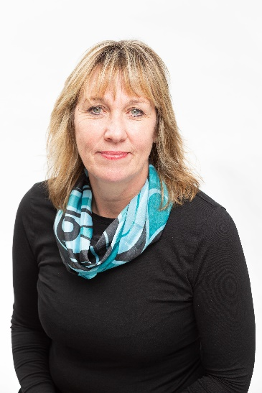
Gill May,
Director of Nursing and
Quality
“Whilst Covid infection rates are still high in many of our communities, the Covid vaccine is playing a critical role in reducing the number of patients who become seriously ill with the infection and need to be admitted to one of our hospitals.

“We are seeing the numbers of people booking to have the vaccine slow down but we know there are many that could still have it, particularly the 18-30 year olds. Our job is to encourage and provide information to support people to take up the offer. Please, if you or anyone you know is still unsure, then please look at our website (www.bswccg.nhs.uk) where there is information and frequently asked questions that may help in taking up the offer.

“Please can I ask that If you are the parent or carer of a 12-15 year old with underlying medical conditions, do wait to be called forward to book an appointment. We expect new guidance this week that will inform how we make the vaccine available to this vulnerable group.

“Vaccination is available at a range of sites across our region and we also have walk-in clinics that don’t require pre-booking. So do help us share the message about getting vaccinated if you are eligible and the importance of having both vaccines.”

At a glance: the latest coronavirus vaccine developments in BSW

- The next step is planning for autumn vaccine boosters to be administered at the same time as the annual flu campaign. In addition, we are planning how we will vaccinate specific groups of children. The two groups are children aged 12-15 years with specific health conditions and children and young people aged 12 years and over who are household contacts of persons (adults or children) that are immunosuppressed. This second group is being offered the vaccine on the understanding that the main benefits are related to the potential for indirect protection of their household member who is extremely vulnerable. Please note we still await confirmed guidance from the Joint Committee on Vaccination and Immunisation (JCVI) on the vaccination approach for children.

- We continue to plan new sites and pop-up vaccination services to complement our established vaccination sites and walk-in clinics. I’m pleased to share that in Bath, for example, there will an extra bus clinic situated on Milsom St on Sunday 1 August from 11am – 4pm (break 1-1.30pm). The Pfizer vaccine will be available for residents eligible for their first or second dose. Please note that there must be an eight week gap between the first and second dose.

- A walk-in service is still being trialled at the Racecourse and we are taking this opportunity for some market research with young people to get their views about vaccination.

- We have begun rolling out some targeted communications for pregnant women to encourage them to have the vaccine. This information guide explains the importance of vaccination and tackles the concerns some mums-to-be have: COVID-19 vaccination: women of childbearing age, currently pregnant or breastfeeding - GOV.UK (www.gov.uk)

- We continue to work with higher education colleges to drive vaccine update amongst students and young people. For example, an Instagram takeover is planned with Bath University this week. The university’s followers will be able to submit questions that will be answered in the form of written captions and short videos featuring a pharmacist from the Royal United Hospitals, Bath. This follows our recent successful Instagram live event with a local Bath influencer discussing the vaccine (having asked her followers for questions in advance) with one of the CCG’s pharmacists.

Vaccination progress to date

