Annual Health Checks: November 2021 briefing
This briefing aims to inform you of the current position for annual health checks in BaNES, Swindon and Wiltshire (BSW).

- First Option Healthcare Pilot Project
First Option Healthcare have been commissioned to support GP Practices across BSW since February 2021. To date over half of all Wiltshire practices have opted in or expressed interest in this support. This project has recently been extended to March 2022.

Bristol University are completing an evaluation on this project. Please see an extract of one of the interviews, from the evaluation that evidences that impact of an annual health check:
[First Option Nurse] “One lady came and the blood pressure was all over, the pass rate was all over, she mentioned… the trigger point was she mentioned she has been having left side of the pain radiating to the back, so that to me sounds more severe than she is thinking, despite in herself she was feeling she is okay. So, I just called the ambulance, and for sure later, because I followed up, she had blood clots, so it could have been a serious stroke or something”.
[Interviewer] “That’s fantastic that you could follow-up, so did you have to call through to A&E or something to see how she was getting on?”
[First Option Nurse] “No, actually when she was discharged, she came back to the clinic to say thank you. She just walked in to say, “I have just come to say thank you, I have been started on blood thinning medication, I have never had blood clot disorder, but now I know I have”.

- Current picture for Learning Disability Annual Health Checks in BSW
The national target for learning disability annual health checks is 75% completed by 31 March 2022. Over the past three years, practices across BSW have completed 56% for 20/21, 44.3% for 19/20 and 44.4% for 18/19. This year as of end of October 2021, using local data, Swindon have completed 31.3% of annual health checks compared to 25.5% in BaNES and 22.8% in Wiltshire.
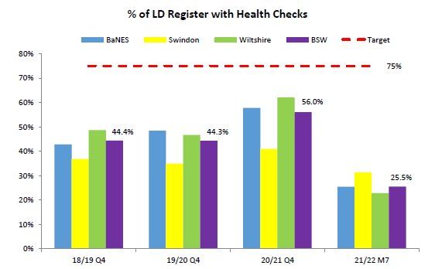
- Current picture for Severe Mental Illness Annual Health Checks in BSW
The national target for severe mental illness annual health checks is 60% completed by 31 March 2022. For BSW, 26% of patients with severe mental illness had received their annual health check at the end of at Q2 (September) 2021 - this is the highest percentage reported for BSW. At a locality level, Swindon have completed 33.1% compared to 32.4% in BANES and 19.3% in Wiltshire.

For this cohort, we are able to see analyse the results further and identify percentages by the six elements checked. For this year and last year, the reporting for checks on alcohol consumption is the lowest of the six elements in BSW. The graph below indicates most people are receiving some the elements of their annual health check, but not many people have received all six checks.

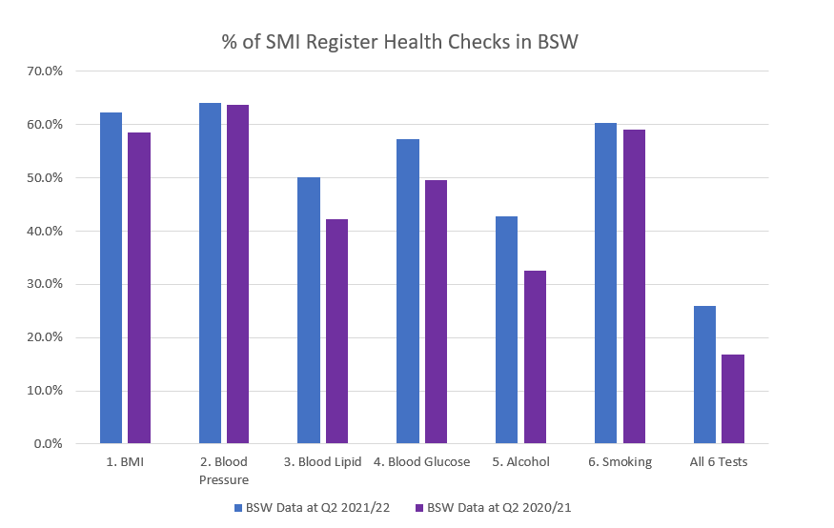

- Health inequalities
People on the LD Register in the most deprived quintile recorded a lower proportion of Health Checks (53%) than those in the least deprived quintile (63%).

Wiltshire Parent Carer Council surveyed 31 parents of young people, who would be eligible for a learning disability annual health check in October 2021. The result showed that 80% of the young people have never had an annual health check. This echoes findings from locality reporting, that found that people under 35 years have proportionally less recorded checks, with the 14-18 year age group the lowest at 41% (Mar 2021). The chart below covers BSW.
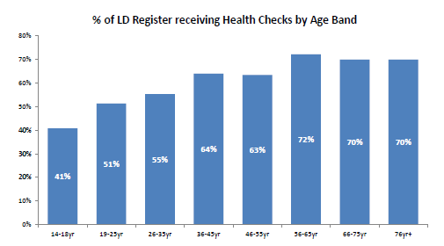

- National findings
The Confidential Inquiry into premature deaths of people with a learning disability (CIPOLD) found that 38% of people with a learning disability died from an avoidable cause, compared to only 9% in a comparison population of people without a learning disability: http://www.bris.ac.uk/media-library/sites/cipold/migrated/documents/finalreportexecsum.pdf

The Learning Disabilities Mortality Review by the University of Bristol Norah Fry Centre for Disability Studies found that out of 112 deaths reviewed in a multi-agency review panel, 19% had been potentially avoidable: http://www.bristol.ac.uk/media-library/sites/sps/leder/LeDeR_2019_annual_report_FINAL2.pdf

The Government response to the third annual LeDeR programme report was published 12 February 2020. The report identified that compared to the general population, the median age of death is 23 years younger for men with a learning disability and 27 years younger for women.

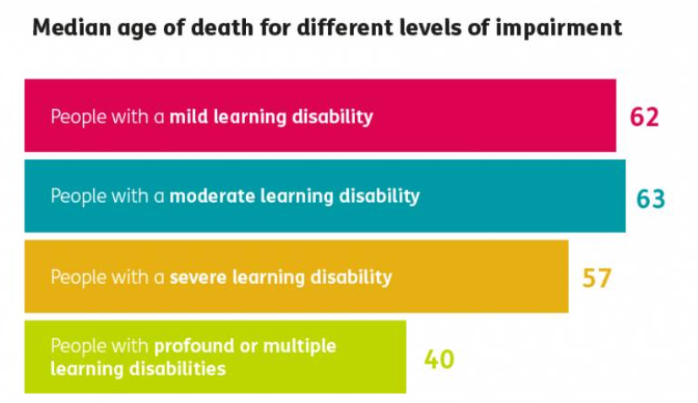

Commonly associated health conditions for people with a learning disability include mental health problems, epilepsy, and being underweight or overweight. This shows how essential annual health checks are for people with learning disabilities to ensure we reduce delays in the diagnosis and treatment of illnesses. We also now know more about outcomes associated with living in different types of accommodation.

The LeDeR report also highlights a number of issues related to the quality of care of people with learning disabilities, including delays in identifying that a person was ill, recognising further deterioration, and accessing and receiving appropriate medical care. Failure to recognise or act on signs a patient is deteriorating can result in missed opportunities to provide the necessary care to give the best possible chance of survival. The 2019 Action from Learning report was the first report on work to translate learning into action in relation to the LeDeR programme and set out work relating to the specific issues of acute deterioration, including sepsis and aspiration pneumonia.

