BSW CCG People Strategy

2020 – 2023

Supporting our ambition to empower people to lead their best life in Bath and North East Somerset, Swindon and Wiltshire.

October 2020

**NHS BaNES, Swindon and Wiltshire**

**Clinical Commissioning Group (BSW CCG)**

|  |  |
| --- | --- |
| **Policy:** | People Strategy |
| **Policy Ref No:** |  |
| **Policy Statement:** | This strategy describes our commitment to our colleagues which will support our ambition to empower people to live their best life in Bath and North East Somerset, Swindon and Wiltshire. |
| **Version No:** | 1.0 |
| **Version Date:** | 15.10.20 |
| **Review Date:** | 01/09/2021 |
| **Authors:** | Sheridan Flavin / Alison Kingscott / Catherine Phillips |
| **Owner:** | Sheridan Flavin / Alison Kingscott – Directors for People and OD |
| **Approving Body:** | BSW CCG Governing Body |

**Document Control** **Reviewers & Approvals**

This document requires the following reviews and approvals.

|  |  |  |
| --- | --- | --- |
| Name | Version Approved | Date Approved |
| Executive Committee |  |  |
| BSW CCG Governing Body | 1 | 15.10.20 |

**Acknowledgement of External Sources:**

List any policies or procedures from external institutions that have been used to inform the writing of this policy.

|  |  |  |
| --- | --- | --- |
| Title/Author | Institution | Comment / Link |
|  |  |  |

**Links or overlaps with other key documents & policies:**

|  |  |  |
| --- | --- | --- |
| Document Title | Version and Issue Date | Link/Document |
| NHS People Plan | July 2020 | (add in link) |
|  |  |  |

**Distribution:**

This document has been distributed to the following people

|  |  |  |
| --- | --- | --- |
| Name | Date of Issue | Version |
| Colleague Partnership Forum | 10.07.20 | 0.10 |
| Executive Directors | 05.10.20 | V.019 |

**Document Version Numbering:**

Document versions numbered “0.1, 0.2, and 2.4”, are draft status and therefore can be changed without formal change control. Once a document has been formally approved and issued it is version numbered “Issue 1.0” and subsequent releases will be consecutively numbered 2.0, 3.0, etc., following formal change control.

**Freedom of Information**

If requested, this Document may be made available to the public and persons outside the healthcare community as part of NHS Swindon Clinical Commissioning Group’s commitment to transparency and compliance with the Freedom of Information Act.

**Accessibility**

This document can be made available on request from the communications department in other styles, formats, sizes, languages and media in order to enable anyone who is interested in its content to have the opportunity to read and understand it. These alternatives include but are not limited to:

* Alternative languages and dialects
* Larger and smaller print options (font 8 to 18)
* Simplified versions including summaries and translation into symbols
* Audio or read versions
* Web based versions that can be zoomed into or shrunk on screen

**Table of Contents**

**Dear Colleague** 5

**1.** **Introduction** 7

**2.** **BaNES, Swindon and Wiltshire - our population** 8

**3.** **Our context** 9

3.1 NHS People Plan 9

3.2 COVID-19 9

3.3 BSW CCG Context 10

3.4 Statutory requirements 11

**4.** **Our Vision, Mission, Values and Key priorities** 12

4.1 Our corporate priorities 13

4.2 Key objectives for our colleagues 14

**5.** **Colleague experience and development** 15

5.1 Colleague wellbeing 15

5.2 Learning and Development 16

5.3 Ways of working 18

5.4 Systems and processes to support colleagues 19

**6.** **Engagement and culture** 20

6.1 Engagement 20

6.2 Culture and Inclusion 23

**7.** **Leadership Capability and Capacity for all** 26

7.1 Promote leadership at every level 26

**8.** **How we will establish our progress** 27

**9.** **Appendix 1: Our summary actions**  28

**10. Appendix 2: Leadership Academy Programmes………………………….………………………...…**30

**Dear Colleague**

As a new CCG we have created this document to describe to you the support and development we will put in place to help you to be the best you can be, ultimately supporting our patients to be able to access the best possible healthcare. Every individual across our organisation plays their part in making a difference to patient care and we aim to do so by living the values of our new organisation. We know we have more to do to jointly develop the culture and behaviours we want to embed in our organisation, reflecting the values below that we jointly developed with you, and we will prioritise this to set strong foundation for BSW CCG

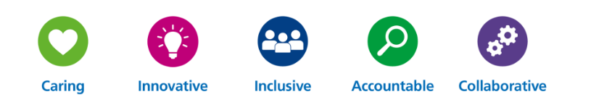

Our organisation formed on 1st April 2020, however we have been increasingly working together over recent months and years, and many of us have already noticed some of the benefits of being a single organisation in our response to COVID-19, enabling us to focus on the pandemic with reduced duplication. However, by recognising that there is learning and benefit in all of our experiences, independent of our geographies, and within every individual, we will start to build our new story together.

Our response to COVID-19 has also shown how much we can achieve in a short space of time, and that geography is not the barrier we thought it was – our use of technology leapt forward a number of years in just a few weeks. However, we recognise that our new organisation needs to strike a balance between remote working and the face to face collaboration that many of us continue to value, whilst keeping our colleagues safe and making the most effective use of tax payers’ money.

We know that the lead up to merging has been challenging for some of you, and we continue to shape teams to meet the needs of all our patients across our CCG’s geography. This strategy describes some of the support that we will provide through these changing times. We have an ongoing journey over the next year as we will reflect on our learning from the pandemic (and ongoing work to tackle COVID-19), the deeper understanding this has provided to society on inequalities, and our direction towards becoming part of an Integrated Care System (ICS) and strategic commissioners. Becoming part of the ICS will create further organisational change as we become more integrated with our provider partners to support planning and implementing more integrated services which is referenced in Our plan for Health and Care and can be found on our [website](https://www.bswccg.nhs.uk/docs-reports/strategies-and-reports/335-bsw-our-plan-for-health-and-care-2020-2024-full-version/file).

We have divided the strategy into three core areas, describing our aims and actions for each:

1. **Colleague experience and development** - ensuring that our colleagues have access to support when they need it and access to appropriate development opportunities, as well as streamlined processes and ways of working to support efficient and effective working.
2. **Engagement and culture** - creating an environment in BSW CCG in which all colleagues feel welcomed, listened to and valued and respected by the organisation as a whole and by the individuals that surround them. We recognise that communication has been a theme from feedback in previous colleague surveys and we will continue to work on this to ensure that communication is two-way.
3. **Leadership capability and capacity for all** – as a system leader, the CCG has a responsibility not only for the health system, but also those who work in it. We want to support all our colleagues to adopt a compassionate and accountable approach and put in place support to facilitate this.

We hope that you take a few moments to read the strategy and would welcome any feedback as the strategy will necessarily evolve over the coming months and years.

|  |  |  |
| --- | --- | --- |
|  | S:\HR\Tracey Cox Correspondence\Recruitment\2019 08 13 Workforce & OD\Sheridan Photos\Sheridan Flavin 273.jpg |  |
| Tracey Cox | Sheridan Flavin | Alison Kingscott |
| Chief Executive & STP SRO | Director for People and Organisation Development | |

1. **Introduction**

The Bath and North East Somerset, Swindon and Wiltshire (BSW) CCG People Strategy has been developed recognising the journey we are on to becoming an Integrated Care System (ICS). BSW CCG’s

Our whole organisational vision is “Working together to empower people to lead their best life.” As a strategic commissioning organisation, this means that we will work both with our providers and with the people that live here to deliver improved health outcomes for everyone across our population. Our People Strategy will directly support this vision by detailing how we will:

* Ensure we have the right workforce now and for the future.
* Deliver our organisation goals.
* Deliver the system objectives for the population we serve.
* Develop our workforce and nurture talent.
* Attract and retain talented people.

This strategy also outlines our challenges and opportunities, as well as an action plan describing the things we will commit to doing as we focus on our future as BSW CCG and journey to ICS. The timing of this strategy means that it is subject to further development as our work progresses. The strategy will be reviewed annually and actions for the next period will be set.

1. **BaNES, Swindon and Wiltshire - our population**

Bath and North East Somerset, Swindon and Wiltshire (BSW) has a combined population of around 940,000 served by 94 GP practices, three acute hospital trusts, two independent health providers, a mental health provider and an ambulance trust. It has a single Clinical Commissioning Group and is served by three Local Authorities.



While the area as a whole is less deprived than other parts of England, there are pockets of deprivation sitting alongside more wealthy communities where people do not live as long and are more likely to have health issues.

In the next five years, we expect our older population to grow considerably. Currently there are 80,000 people aged over 75 in the area, many with multiple long-term illnesses. By 2024 we expect this figure to exceed 100,000. We also expect significant population growth in some areas driven by military relocation and some large scale housing developments planned or underway.

Cancer, cardiovascular disease and respiratory disease are the main causes of death in BSW, but we know that people in deprived areas will suffer more from these diseases. A focus for us will be to help people to improve their outcomes, or prevent disease, by making healthier choices about smoking, over-eating and alcohol use. We will take a Population Health approach, focusing on the prevention of illness and improvement of the health and wellbeing of communities, considering the wider determinants of health.

As part of our Long Term Plan we recognise Mental Health crisis services are a priority for 2021. We aim to support people before a crisis and then ensure appropriate support when required.

The challenge for our people strategy is to ensure that we have a motivated, skilled and passionate workforce able to lead the significant changes required across the system to meet our population needs.

1. **Our context**

Our ability to deliver the best possible health and care for the people of BaNES, Swindon and Wiltshire is shaped at least in part by the national context, including policy and the COVID-19 pandemic, as well as our recent history as we have merged into a single CCG.

## NHS People Plan

The NHS People Plan was published in August 2020 and recognised workforce supply as the biggest challenge facing the NHS. It identified four key themes to deliver against the wider people agenda:

* **Looking after our people** – with quality health and wellbeing support for everyone.
* **Belonging in the NHS** – with a particular focus on the discrimination that some staff face.
* **New ways of working** – capturing innovation, much of it led by our NHS people.
* **Growing for the future** – how we recruit, train and keep our people, and welcome back colleagues who want to return.

BSW CCG is not only affected by a number of the issues identified in the NHS national People Plan, but has a strong role to play as a system leader in supporting delivery of the plan.

## COVID-19

Health and care organisations across the country including BSW mobilised their initial response to the COVID-19 pandemic during March 2020. This has featured significant transformation in a short space of time for both our patients and our workforce. Entire teams have moved out of offices and started working remotely; the barriers of BSW’s wide geography dissolved as we recognised the ability to meet each other and our stakeholders virtually, perhaps recognising our previous over-reliance on travel for face to face meetings.

A challenge for BSW and the NHS more widely post-COVID-19 will be to retain the best aspects of these changes whilst ensuring equitable access to services and equality of outcomes for our patients and colleagues. We need to develop the new culture and find the “new normal” for BSW CCG but continue to be innovative and willing to try new ways of working. We will continue to review the learning from this period to consider the next steps in our strategy.

We recognise the impact that COVID 19 has had on our workforce and as such we will aim to enhance our health and wellbeing support including psychological support to colleagues.

## BSW CCG Context

BSW CCG has experienced a period of significant change over the last year as we moved towards merging our three organisations. This was overlaid by the COVID-19 pandemic which introduced further extensive changes for our colleagues and our ways of working. Some of these have built on our planned direction of travel as we merged, but with an unexpected velocity prompted by the national and local COVID-19 response requirements.

To ensure that the health and care services we commission meet the needs of the many different communities living across BSW, we have retained three "localities". This means that our decision-making can be influenced and governed by local needs and we can continue to enhance strong relationships with the Council in each locality whilst gaining the financial and operational benefits of working at scale across BSW.

During 2019, we put in place a single Chief Executive, executive and management team across BSW before we formally merged. This enabled us to start to work as a single organisation within the wider system and set our direction. However, we know this has been a challenging time for many colleagues experiencing a new structure, new ways of working and new responsibilities.

BSW CCG has a workforce of just over 400 people, almost 40% of which are part time and 16% on fixed term contracts. We know that we have a high number of fixed term contracts but believe this is appropriate to the type of work we carry out, the majority of the fixed term colleagues being in our clinical leads, medicines management team and Governing Body. Despite our recent merger, we remain a relatively small organisation compared to some of our stakeholder organisations, such as acute trusts. However, our potential to influence and drive the health agenda is significant and ability to do so is crucial. To do this, we need to attract, retain, develop, motivate and deploy individuals to achieve our ambition to deliver the best possible health and care for the people of BSW.

Figure 1: Full time equivalent composition of BSW CCG workforce (at June 2020)

Figure 2: Temporary contracts by department in BSW CCG (total of 63 contracts, at June 2020)

## Statutory requirements for workforce

As a CCG, we have a number of statutory and NHS requirements that we must comply with in relation of our workforce, including:

* **Equality Act 2010** - legally protects people from discrimination in the workplace and in wider society. It provides the basic framework of protection against direct and indirect discrimination, harassment and victimisation. The Act makes it unlawful to discriminate in the provision of goods or services or employment on the basis of defined Protected Characteristics.
* **Public Sector Equality Duty** - The Equality Act contains special provisions for public sector bodies which mean that public bodies have to consider all individuals when carrying out their day-to-day work, including shaping policy, delivering services and in relation to their own employees. In exercising our functions as a CCG we must consciously think about, consider and be influenced by these three aims:

1. Eliminate unlawful discrimination, harassment, victimisation and any other conduct prohibited by the Act;
2. Advance equality of opportunity between people who share a protected characteristic and people who do not share it;
3. Foster good relations between people who share a protected characteristic and people who do not share it.

* **Workforce Race Equality Standard** (WRES) which aims to ensure employees from black and minority ethnic (BAME) backgrounds have equal access to career opportunities and receive fair treatment in the workplace as well as tackling inequality in our systems.
* **Workforce Disability Equality Standard** (WDES) which aims to better understand the experiences of disabled employees to support creating a more inclusive environment.

As a new, larger organisation we now have additional reporting responsibilities for some of these requirements and we will ensure that we comply with these during our first year of operating.. In the future, we will publish more detailed information as the BSW collective head count has increased. We will review the BSW [Workforce Race Equality Standard](https://www.england.nhs.uk/about/equality/equality-hub/equality-standard/) (WRES) application and provide assurance that we will advance BAME senior leadership opportunities in line with the emphasis in the NHS People Plan of ‘Belonging in the NHS’ for all colleagues to eliminate discrimination.

We will deliver our statutory and NHS requirements but we aim to go beyond those wherever we can to be a supportive and representative employer for all of our colleagues. The CCG aims to provide a working environment which is free from discrimination, victimisation and harassment on individual and/or institutional basis and deal swiftly within any allegations. We are committed to ensuring that our colleagues are reflective of the populations we serve at all levels, including senior leadership roles. We believe this will enable us to embed equality and diversity, Human Rights and recognise the learning from the Black Lives Matter movement in our business and help us to respond more effectively to the needs of our service users and communities. Our responsibilities as an employer are set out in our suite of Human Resources policies and procedures.

1. **Our Vision, Mission, Values and Key priorities**

The recent merging of BaNES, Swindon and Wiltshire CCGs and our increasing collaboration with our stakeholders and providers is part of our journey to form a new Integrated Care System (ICS). Integrated Care Systems “are partnerships that bring together providers and commissioners of NHS services across a geographical area with local authorities and other local partners, to collectively plan and integrate care to meet the needs of their population.” ([The Kings Fund](https://www.kingsfund.org.uk/publications/integrated-care-systems-explained), April 2020). This means that we can achieve more as we pool our resources across the three geographies, including staff, skills, specialisms and finances. We will work even more closely with public health, local authorities (including housing, education and leisure), voluntary and community groups across the whole area. Integrated Care Systems have been shown to deliver the best outcomes for patients and populations.

To continue to deliver system leadership in a changing environment, we have set ourselves a clear vision; to work together to empower people to lead their best life. This will enable us to deliver our mission, to deliver the best possible health and care for the people of BaNES, Swindon and Wiltshire. We have also developed our organisational values and associated behaviours to describe how we will approach our roles as an organisation and as an individual. This is described further in Engagement and Culture, below.

## Our corporate priorities

Over the next five years, we want to address the following, all of which are influenced by our People Strategy as we develop the culture and our people so that they are able to deliver this level of change:

* Reduce inequalities in people’s access to care and treatment.
* Simplify an overly complex system to improve services and make efficiencies.
* Improve people’s pathway through care by putting them at the centre of everything we do.
* Ensure we protect access to specialist treatment.
* Supporting our communities and citizens to take better ownership of their own health and care.

## Key objectives for our colleagues

To deliver our vision and mission for the patients and people of BSW, we are an organisation that supports and engages our colleagues as we transition into an ICS. To do this we need to develop:

These will be delivered via three key themes of work which will be described in the following sections.

1. Colleague experience and development – Section 5
2. Engagement and culture – Section 6
3. Capability and capacity for all – Section 7
4. **Colleague experience and development**

Our aim is to continuously develop our organisation and our colleagues so that we are able to achieve our priorities and celebrate and support our individual and collective capabilities and ambitions. To do this, we will ensure that our colleagues have access to support when they need it and access to appropriate development opportunities. We will also ensure that we are organisationally able to support teams to work collaboratively, in an agile manner and across organisational boundaries as well as across the functional teams of our organisation, including HR. This will help us to create streamlined experiences for colleagues of joining, being a valuable part of, and leaving our organisation.

## Colleague wellbeing

We will support and promote the wellbeing of all our colleagues which will help to build resilience, following significant change in the organisation and the impact of COVID-19. We support the emphasis on Health and Wellbeing as described in the NHS People Plan and will ensure that we deliver employer responsibilities as identified within the plan and appoint a Wellbeing Guardian in 2020 to support this agenda.

We will

* **Create an active and vibrant Health and Wellbeing Group** to support the delivery of the Health and Wellbeing Agenda.
* **Appoint a Wellbeing Guardian** to act as a critical friend to the CCG in the delivery of the wellbeing agenda.
* **Review our Occupational Health offering** to ensure that it meets the needs of all our colleagues.
* **Ensure that we have a robust Employee Assistance Programme** offering support and guidance and that meets the needs of our colleagues.
* **Support and promote individual wellbeing** (emotional, physical, spiritual, work life balance, personal development etc) by providing regular briefings on supporting self and others, introduction of wellbeing days, increasing the range of physical and spiritual wellbeing opportunities and to promote and increase mental health first aiders.
* **Introduction of Health and Wellbeing conversations –** in line with the ask from the NHS People Plan all new starters will be offered a Health and Wellbeing induction.
* **Introduce a range of programmes to support mental and physical wellbeing**. We currently have a range of tools available to support colleagues and we will continually review these to add and promote the health and wellbeing of colleagues and ensure they reflect the best offer to our colleagues.
* Ensure that we are working towards the best practice endorsed by **Mindful Employer** which recognises the importance of mental wellbeing in the workplace. We will continue to sign up to the Mindful Employer charter beyond 2020/21. We will also work towards the Mental Health Charter.

## 

## Learning and Development

We will support our colleagues to continuously develop and ensure that we are able to develop individually and as teams whilst also ensuring compliance with training and appraisal processes. All developments are underpinned by a robust recruitment and on-boarding process for new starters; meaningful and regular 1-1 meetings between colleagues and their line managers with a constant drive to review, set goals, and support colleagues to enable peak performance; and a yearly summarising performance review (appraisal) with more detailed focus on longer term ambitions and career objectives.

We will

* **Make a suite of colleague development opportunities accessible**. We will initially focus on the following

**Professional / Specific** - which incorporates clinical skills, professional learning and qualifications, and access to focused conferences.

**Line Management Excellence** – ensuring management practices are professional, in line with best practice policy, adopting a coaching style, and supporting the values of the organisation.

**Quality Leadership** – Driving strategy and change, leading across boundaries and systems, making the values of the organisation come alive, contribution to becoming an integrated care system.

* **Provide access to on-line e-learning modules** covering a range of development opportunities for colleagues. BSW will continue to ensure that a wide range of e-learning and virtual learning opportunities are available and taken advantage of. Current provision ranges from the extensive offers from e-Learning for Health (e-lfh), to the wide range offered from the NHS Leadership Academy. In addition, specialist training i.e. mental health first aid, safeguarding, and specific clinical themes are widely available via remote delivery. BSW will continue to encourage learning via this medium unless there is proven advantage of attending face to face sessions.

We expect that virtual learning and blended learning (on line or virtual with some face to face provision) will become more commonplace, and this lends itself well to us reducing the burden of travel across BSW geography and beyond. This form of learning also encourages colleagues to develop skills in self-directed learning, research and problem solving, and enables access to a wide range of networked colleagues from across the system.

* **Develop a Continuing Professional Development (CPD) offering for colleagues**. We believe that CPD enables learning to become a conscious and proactive activity, rather than passive and reactive. We intend to combine different methodologies to learning, such as self-directed learning, training workshops, conferences and events, e-learning programs, best practice techniques, ideas sharing and practical and academic qualifications, focused on all colleagues improving and having effective professional development. Where possible, we will facilitate work shadowing, secondments and opportunities to work across the wider system.
* **Widening access to Coaching and Mentoring**. So that we can support our talent management and succession planning, we will provide access to coaching and mentoring. We have already started to promote a coaching ethos with line managers and will develop this further via this access. We will also work to develop our own coaches and mentors, including asking our Executive and Board members to mentor colleagues across the organisation, with a focus on widening access to this opportunity. In collaboration with our system partners we will introduce reverse mentoring to support our Executive and Board members to better understand what it is like to walk in the shoes of some of our colleagues and support these colleagues to have a stronger voice.
* **Introduce a single appraisal system**. We will ensure all colleagues have agreed objectives and personal development plans in place. We will support line managers to work with their direct reports to have regular reviews as well as their annual appraisals and six monthly reviews. This ensure that colleagues have access to timely feedback and support to facilitate conversations about any development needs and aspirations. Appropriate arrangements will also be made to support appraisal across our Executive Team and Governing Body colleagues.
* **Ensure mandatory training compliance**. We have already aligned our mandatory training requirements across the whole organisation and will now work to ensure compliance in terms of colleagues completing the correct training on time. We will also ensure that all role specific training is available and completed as a platform to further development (e.g. fire warden, safeguarding, Caldicott Guardian, governing body member, and line manager essentials mandatory training). Completion of mandatory training will be a pre-requisite to access support and funding for further development.
* **Provide access to team building tools**, recognising our new organisation and new ways of working. We will use a variety of tools to suit the needs of the individual and the circumstances, which will help teams to identify natural roles to support team building.

## Ways of working

Our ways of working have changed significantly as a result of the merger but also our response to COVID-19. Changes in working practices that we might have worked on over months and years took place within the space of a few weeks to facilitate remote working. We now need to ensure that we continue to develop our culture around remote and agile working with increased collaboration and matrix working to ensure that we have the right teams to deliver the right services for our population and understand the impact of these on our colleagues’ experience.

We will

* **Develop an Agile Working Policy** in line with the use of technology and culture we want to adopt. This will build on previous policies, our new organisational structure and learning from the experiences of the COVID-19 pandemic response. Our aim in delivering this policy is to meet our population and organisational requirements and continue to attract and support the diverse needs of our colleagues to balance work and life commitments, whilst operating safely and feeling supported.
* **Continue to develop our new ways of working** to ensure that we continuing to embrace the best ways of working for our colleagues and to meet our population needs, including alignment with our organisational goals. In doing so, we will ensure that our colleagues and teams feel supported in remote working, and the differences between office and home environments, and that individuals have appropriate assessments to support safe when they are home working, including health and safety and display screen equipment. This work is being led by our Agile Working Group which has been formed specifically to look at new, more effective ways of working and the impact of these on our colleagues.
* **Provide support and training for line managers to recruit and supervise their direct reports remotely**. We recognise that colleagues require and would like some specific support on line managing in a remote environment and we will provide this in a number of accessible formats.
* **Progress more collaboration with partners** including cross boundary working, matrix management and cross-organisational teams. To do this, we know we need to further develop our culture of openness and embrace a coaching approach across the organisation so that individuals feel supported to deliver. We will consider shared workspaces and processes with some of our partners.
* **Further develop our workforce planning to meet demand and capacity modelling**, aligned to new models of care. We will ensure that our organisation continues to develop to be fit for purpose for the needs of the CCG as a strategic commissioner and also to develop to meet the needs of the Integrated Care System with our partners.
* **Continually review our HR policies and protocols** to ensure that they continue to meet our organisational needs as our new organisational culture develops. We will use the Colleague Partnership Forum to consider whether our policies are reflective of the organisation we want to create, if they are reflective of our values and behaviour framework and whether they are consistently put into practice by our colleagues in the way that they were intended. We will also consistently evaluate ourselves against these markers.

## Systems and processes to support colleagues

As a new organisation, we need to create process and system alignment to develop streamlined processes which are fit for a single, larger organisation and which is geographically distributed and working remotely. We will ensure that such systems and processes promote “digital first”. We know from feedback that smooth operation of these processes can have a significant positive impact upon colleague experience, and effective running of the CCG.

We will:

* **Standardise our induction process** to support a welcoming start to a career in BSW CCG and ensure that new colleagues know what to expect from us and what we will expect from them. An aligned induction process for new Governing Body colleagues will also be developed.
* **Develop a single annual leave system**, which interfaces with the Electronic Staff Record to support a single, electronic, auditable and remotely supported system.
* **Introduce a single expenses system**, with delegated authority to line managers and which is electronic, fully auditable and remotely supported.
* **Map our interfaces (the contact points between systems) between the functions that support HR processes** (e.g. payroll, finance, line managers) to ensure that we have a robust and integrated system that works every time. This will include the introduction of electronic solutions (digital first) to facilitate auditable decisions and a reduction in paper-based requirements. This will improve efficiency, including supporting colleagues joining and leaving the organisation, and any changes during their career. We have already introduced an electronic timesheet solution that is a good example of our digital first approach. These combined changes will support us to ensure that we have one credible source of data in relation to BSW CCG.

1. **Engagement and culture**

We want to create a culture in BSW CCG in which is reflective of the values we created together and where all colleagues feel welcomed, listened to and valued and respected by the organisation as a whole and by the individuals that surround them. We want *every* individual in the organisation to know and understand the crucial role they have in caring about and making health outcomes better for the people of BaNES, Swindon and Wiltshire. To do this, we know that we need to be better at describing what we are trying to achieve, how we are doing that and linking every colleague to this vision. We want every individual in our organisation to understand and live by the values we have developed together and to embody these in their working practice.

## Engagement

We know that employee engagement is important in a workplace, resulting in the right conditions for all employees of an organisation to give their best each day, committed to their organisation's goals and values, motivated to contribute to organisational success, with an enhanced sense of their own well-being.

We will ensure that colleagues have all they need which will support them to look forward to working as part of the BSW CCG team, have a sense of their personal contribution and achievement and their impact on their team and the organisation.

We will:

* **Develop our organisational values into a behaviour framework** to support colleagues to know and understand the behaviours associated with our values, which will ultimately be linked to our appraisal, recruitment and colleague appreciation scheme.



* **Continue to survey our colleagues regularly** to hear what we are doing well and what we could improve on. This includes our regular “Pulse Survey” and Annual Colleague Survey. We will also survey and meet with specific groups of our colleagues to ensure that their voices are heard. We will act swiftly where we can to make improvements when issues are identified. We will detail what we have heard from colleagues and respond using a “You said, we listened, we did” approach.
* **Support charity initiatives** such as International Nurses Day and fundraising for local and national charitable organisations and discharging our Corporate Social Responsibility as a dynamic organisation. We have a strong history in our localities for supporting charities and will look to find new ways of doing this across our larger geography and with more remote working.
* **Regular organisational briefings** will continue and develop further. Our whole organisation Colleague Briefings are well attended and will continue to be open and transparent, led by our Executive Team and include subject matter experts as appropriate. We will continue to experiment with the format of these meetings, and ways of making them more interactive, so that we hear colleagues’ views which will help us to continue to refine our approaches.
* **Regular team meetings** will continue. A monthly Senior Leadership Team meeting is in place, and managers will meet with their teams regularly to share work priorities, successes and operational activities. Many of these will now be remote so we will continue to work with the Agile Working Group to develop ways of working to best meet everyone’s needs from these meetings.
* **Targeted communications**. We will continue to be honest and make sure we are clear in our messaging. We will further develop two-way communications with our colleagues and give plenty of opportunity for raising questions individually and collectively, for example through the Colleague Partnership Forum.
* **The BSW Colleague Partnership Forum** will seek further engagement with a wider range of colleagues to support involvement in policy development relating to colleagues and changes affecting the organisation. The group will be instrumental in co-producing and refining our approach, as well as offering another route for feedback from and dialogue with our colleagues. The year ahead will focus on new ways of working and policy development.
* **Develop a BSW Wellbeing Group** which will draw on the work in each of the localities to support mindfulness and social occasions with colleagues. This group will also support the focus of wellbeing in the NHS People Promise contained within the NHS People Plan.



## Culture and Inclusion

We want to develop our new organisation so that people feel valued and able to achieve their full potential. We want to work with our colleagues to describe our new culture and want to recognise and embrace everyone’s unique, experiences, skills and perspectives. In doing so, we will be able to tailor our approach and help all individuals to feel supported, develop and have opportunities. The impact of the COVID-19 pandemic has been far-reaching, not least in terms of diversity and inclusion. The pandemic had a catastrophic effect on many people’s lives but has had a disproportionate impact on those from a Black Asian and Minority Ethnic (BAME) background and those with pre-existing health conditions and disabilities. The pandemic, alongside other international events, has led almost every individual and organisation to consider inclusivity, equality and affirmative action in a new light and this is also true of BSW CCG.

The Diversity Wheel below illustrates **the complexity through which all of us process stimuli and information**. That in turn leads to the assumptions that we make (usually about the behaviors of other people), which ultimately drive our own. In this way we can be aware of our unconscious bias and work to overcome these.

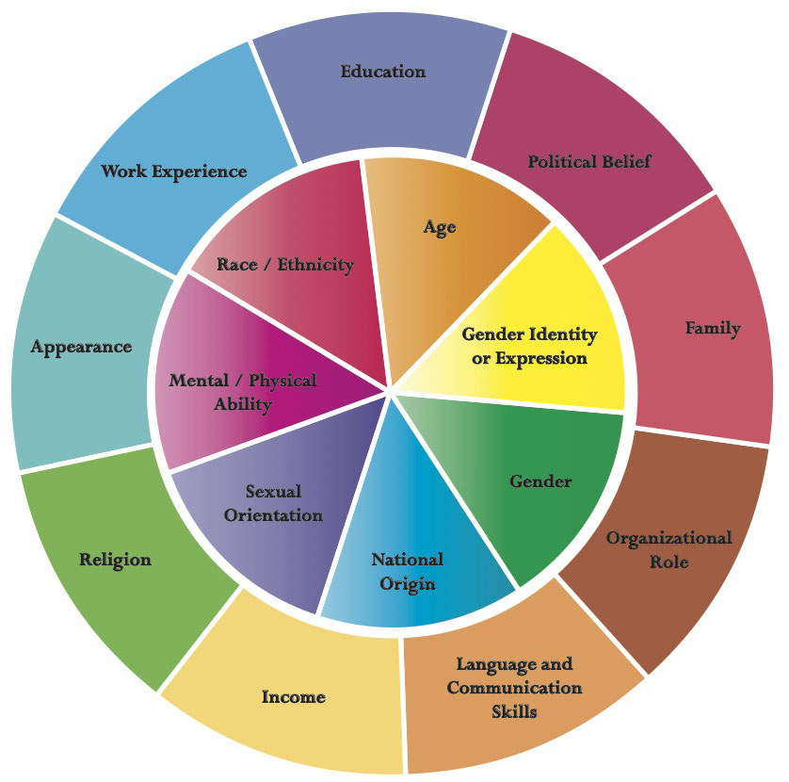

The NHS People Plan outlines the importance for all staff within the NHS to ensure they feel that they belong in the NHS. The plan reflects that there is strong evidence that where an NHS workforce is representative of the community that it serves, patient care and the overall patient experience is more personalised and improves. As a responsible employer we are committed to understanding, encouraging and celebrating diversity in all its forms. Discrimination, violence and bullying have no place in our organisation.

We will:

* **Develop and describe our organisational culture**, through the use of our values linked to the behaviour framework that will be used in appraisal to embed the culture of the organisation.
* **Work more closely with our diverse workforce** to ensure that all our colleagues’ voices are heard. We know that Black, Asian and Minority Ethnic (BAME) colleagues and colleagues with disabilities have experiences in the NHS that do not correspond with our CCG or wider NHS values. We will use data (e.g. WRES, WDES), feedback, reverse mentoring and conversations with our colleagues to help to shape a more diverse and inclusive place to work.
* **Work towards ensuring our workforce reflects the communities we serve**, for example using data from WRES, WDES, Equality Delivery System 2 (EDS2)[1], equality duty. Although these are statutory duties and we have aspirations to go further than these, we recognise the work we need to do during the first year of BSW CCG to align our processes and change some of our practices as we are now a larger organisation. This will also include reviewing and publishing the CCG’s position against the model employer goals to ensure our leadership workforce is representative of the overall BAME workforce, in line with the ask from the NHS People Plan.
* **Maintain our commitment to being a “Disability Confident” employer**. We know that we need to ensure that effective training for managers and recruiters is in place to support being a more inclusive and welcoming employer of people with disabilities.
* **Support carers** - We know that many of our colleagues have caring responsibilities outside of work, providing help and support to a family member, friend or neighbour who would otherwise not be able to manage. We will continue to promote an inclusive and approachable environment for colleagues with caring responsibilities.
* **Ensure we have effective recruitment processes to promote inclusion***.* We know that we need to fully identify where improvements could be made in our process, including ensuring that we have a single process for the organisation. The CCG continues to refine its recruitment arrangements to ensure equality of opportunity is provided to all applicants to the CCG. We will ensure that interview panels have access to recruitment and selection training and consider whether this will be a mandatory requirement for interview panels.
* Ensure that all of our colleagues are aware of how to **Raise concerns** and create an environment that everyone feels safe to raise concerns about any suspected wrongdoing in regard to the CCG’s obligations as soon as possible. This includes being aware of our policies and people they can approach, including line manager, Executive Team, our Freedom to Speak Up Guardian and our Wellbeing Guardian.
* **We support a “Just and Learning Culture”** which recognises the fallibility of individuals and the ability to learn from them individually and organisationally. We will promote and encourage employee to complete the free online just and learning culture training and accredited learning packages.
* **Apprenticeships –** we will champion the nationwide apprenticeship levy to ensure a wide range of apprenticeship opportunities are available for new people joining our organisation along with existing colleagues.
* **Develop further opportunities for volunteers and work experience** in order to create a more inclusive workforce and as part of our talent management initiatives.
* **Offer targeted development opportunities** where we can to proactively support the diversity of experiences and backgrounds of our colleagues, such as those offered via the NHS Leadership Academy: Stepping Up / Ready Now.

1. **Leadership Capability and Capacity for all**

As a system leader, the CCG needs and expects many of our colleagues to operate in strategic leadership roles, particularly as we develop towards becoming an Integrated Care System.

The CCG is fully committed to ensuring that leadership and people management skills and capacity are enhanced at all levels in the organisation, including the Governing Body, Executive and Senior Leadership teams. We need leaders and managers who are confident in not only looking after our services but who also know how to look after their people.

Leaders and managers in the CCG will adopt a compassionate and accountable approach ensuring that they support, empower, inspire and create an environment for all colleagues, from whatever background or ability to flourish. Great team working will become the norm supported by leaders who provide motivation, take personal responsibility, give great feedback, manage conflict and support colleagues’ well-being.

## Promote leadership at every level

Colleagues within the CCG operate in system leadership roles and we want to instil this philosophy within all of our colleagues to promote willingness and ability to lead and to feel accountable and empowered to provide better care for our patients and populations.

We will:

* Continue to develop and add **Leadership Development Programmes for colleagues at all levels.** We will continue to collaborate with system partners to offer leadership development opportunities across BSW that supports the development of future leaders in our organisation who have a management style that is conducive to support a positive culture in line with our values. Specific sessions will be developed for Governing Body and Executive Team colleagues and recognising that we are a clinically led organisation, also for our clinicians to ensure they have access to leadership development as we operate in an increasingly complex environment.
* Promote and support access to the **BSW Academy** (as it becomes available) **and NHS Leadership Academy** (LA) Programmes. See Appendix 2 for NHS Leadership Academy Programmes.
* **Create a Talent Management process** to focus on growing new talent from our existing workforce to drive higher performance and engagement. This will enable us to diversify the skills of the workforce to meet the needs of the changing healthcare landscape.
* **Create a Succession Planning approach** to support our talent management processes. Succession planning focuses on identifying and growing talent to fill leadership and business-critical positions in the future and promotes internal opportunities and progression. We will support colleagues to feel confident and able to apply for promotion opportunities when they arise.

[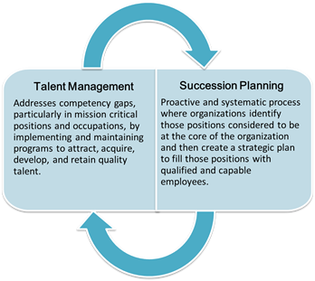](https://www.google.co.uk/url?sa=i&url=https://www.opm.gov/wiki/training/Succession-Planning.ashx&psig=AOvVaw3k7fT3xMb1voBOzfOvMGnV&ust=1591360136010000&source=images&cd=vfe&ved=0CAIQjRxqFwoTCLDPrM-U6OkCFQAAAAAdAAAAABAT)

1. **How we will establish our progress**

A good plan needs a timetable (see appendix one). Year one is detailed and we will refine a more detailed plan each year.

We will monitor our progress using the following measures:

* Improved scores in staff ‘Pulse’ survey
* Feedback from staff/colleague survey
* Increase in number & uptake of training courses available
* Percentage reduction in staff turnover
* Percentage reduction in staff sickness absence
* Increase in number of promotion pathways
* Increase in number of specialist roles

1. **Appendix 1: Our summary actions**

|  |  |
| --- | --- |
|  |  |
|  | **BSW CCG People Plan Actions** |
| **Colleague experience and development** | |
|  | **Colleague wellbeing** – to support the health and welfare of our colleagues, ensuring our OH offering is supportive and the appointment of a Wellbeing Guardian. |
|  | **Learning and Development** – to ensure our colleagues have access to a suite of development opportunities, continuous professional development and  access to coaching and mentoring. |
|  | **Ways of Working** – to assist our colleagues to work in an agile way and in a way that supports the delivery of the CCG goals and objectives. |
|  | **Systems and processes to support colleagues** – to ensure we have the most efficient and effective systems in place to support colleagues in their work |

|  |  |
| --- | --- |
| **Engagement and culture** | |
|  | **Engagement** - to actively listen to and respond to our colleagues so that we  can ensure BSW CCG is a great place to work |
|  | **Culture and Inclusion –** to support all colleagues to thrive in an inclusive workplace. |

|  |  |
| --- | --- |
| **Leadership Capability and Capacity for all** | |
|  | **Promote leadership at every level –** to nurture talent and provide access to rewarding careers for all colleagues. |

Appendix 2

NHS Leadership Academy Programmes

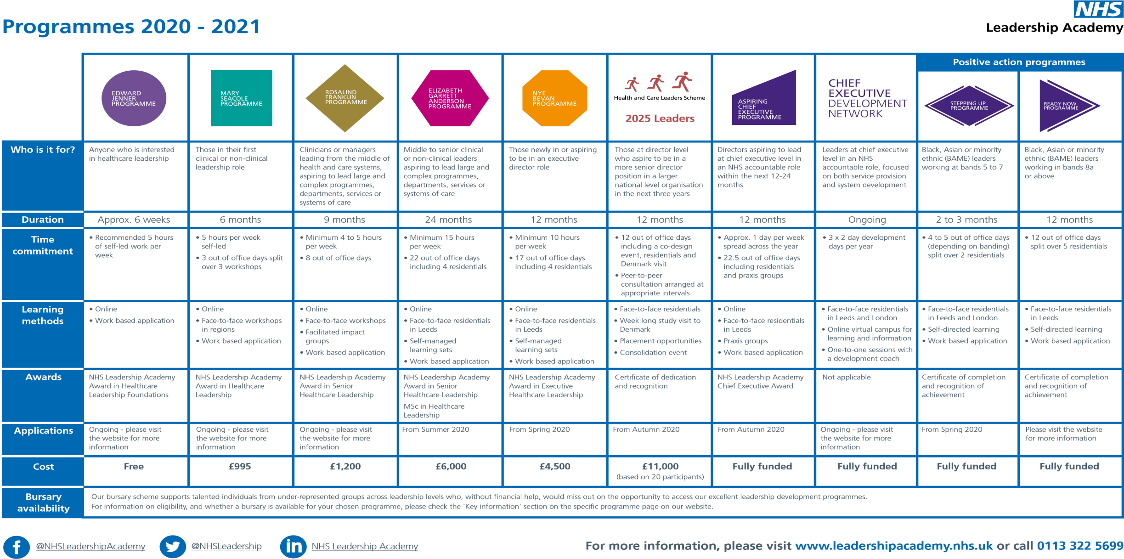

1. The main purpose of the EDS2 is to help local NHS organisations, in discussion with local partners including local populations, review and improve their performance for people with characteristics protected by the Equality Act 2010. By using the EDS2, NHS organisations can also be helped to deliver on the Public Sector Equality Duty