15 November 2021

BSW CCG has partnered with Lantum to provide a new, digital Primary Care Flexible Staff Pool

Bath and North East Somerset, Swindon and Wiltshire Clinical Commissioning Group (BSW CCG) has commissioned Lantum as a partner to create a multidisciplinary primary care flexible staff pool.

The digital staff pool will transform how you manage your workforce by giving your practice access to a larger bank of staff from across BSW, who can be booked wherever they are needed. This flexible staff pool will firstly include GPs but will be expanded to incorporate Practice Nurses, ANPs, ACPs, and at a later date, receptionists and admin staff and other roles.

The new primary care flexible staff pool will help build resilience, save time, and save money.
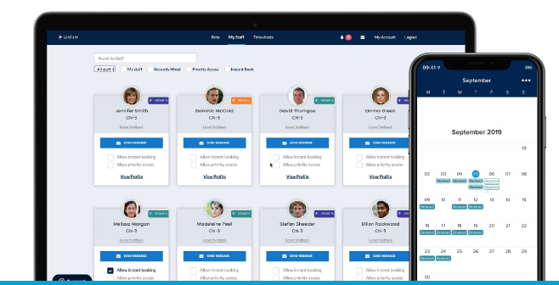

What is Lantum?
Lantum is a digital workforce platform that lets you manage staffing end-to-end with just one tool. ICSs like Greater Manchester and Our Dorset are already using it and seeing amazing results.

For our practices, we are giving you access to the primary care flexible staff pool so we can build resilience across our CCG and help Practice Managers fill sessional shifts.

For our PCNs, the CCG has bought access to Lantum’s connected scheduling tool, Rota Pro. This feature gives PCN managers visibility over your PCN as a whole, and allows you to roster, review and respond to your workforce, all in real time and under one connected platform. This initiative is completely free for PCNs to use. If you are a Clinical Director or a PCN Manager and are interested in this offer, please get in touch with Charlie Mostyn- charlie.mostyn@lantum.com

Why is BSW CCG creating a primary care flexible staff pool?

To build resilience
Having access to a system wide flexible staff pool will make it easier for you to fill shifts – even when cancellations are made at the last minute. This helps you to deliver services effectively and takes some pressure off your existing staff. It will also make it easier to collaborate with nearby practices and PCNs, and share available resources.

To save money
The flexible staff pool will help reduce your spend, as you’ll no longer need to pay agency fees to book locums – instead you can book trusted staff from your CCG at no cost.

To reduce time spent on admin
Having one platform to manage all bookings reduces administration time significantly. With verified clinical governance documents on staff profiles, compliance is much easier to track. With automatic notifications, you no longer need to contact staff individually about shifts.

Lantum consolidates statements, so you make just one payment rather than multiple, and, with the direct messaging tool, you can keep communication in one place and ensure all rota managers have full visibility.

What are the benefits for your clinical workforce?

Access more working opportunities
Clinical staff will now have access to sessional work across BSW to supplement normal working patterns. They’ll receive prompts about new opportunities and can filter for jobs that best suit their clinical profile and geographical preferences.

Paperless invoicing process
Lantum’s digital invoicing tool makes the billing process easier, greener and more efficient. Full financial records are kept for all clinical work, making it easy to see what’s been paid and what is still outstanding. Payments are remitted by Lantum and clinicians can enjoy next-day payments with Rocketpay, at a charge of 1.5% on earnings.

Clinical passporting
GPs and nursing staff can upload their clinical compliance documents onto the platform, which are then shared with Practice Managers. Other information, including qualifications, spoken languages and personal profiles, can also be added, which are available to other clinical and non-clinical staff types. All of the above can also be managed through Lantum’s app for clinicians.

Who is funding the primary care flexible staff pool and what will it cost my practice?

BSW CCG is covering the cost of creating the flexible staff pool and the commission fee on any bookings you make through the platform. Therefore, it is completely free to use for your practice.

How will the Primary Care flexible staff pool work?

- The flexible staff pool includes profiles of staff across our ICS, complete with details about their experience, skills and clinical governance documents.
- Your practice posts vacant shifts on Lantum, and staff in our area apply for them on the Lantum app.
- Your practice accepts an application from the staff member you’d like to cover your shift, and they are automatically notified of the booking.
- After the shift, Lantum can automatically pay staff the next day. You can also set up automatic signing of digital pension forms for GPs.
- On a weekly or monthly basis, Lantum provides a consolidated statement and invoice for all sessions booked, so you have one simple payment to make.

What happens next?

In the next few weeks you’ll receive more details about the flexible staff pool and we’ll invite you to virtual training sessions so you know exactly how to use it. Once onboarded, if you have any questions, Lantum’s support team will be on hand to help.

Expected timeline

15/11/21 | You will be able to create your practice on Lantum via their digital landing page. Once you are signed up, you will be invited to a 30 minute training on how to use the platform, in which you can input your availability.
15/11/21 | GPs, Practice Nurses, ANPs and ACPs can be onboarded via the staff sign up page.
22/11/21 - 02/12/21 | Clinical staff and Practice Managers can submit their availability for a 30 minute webinar, via this Google Form. You will be invited by Lantum, via Microsoft Teams.

