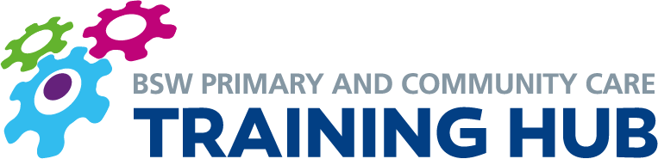

CONTINUING PROFESSIONAL DEVELOPMENT (CPD) FUNDING FOR NURSES AND AHPS

FREQUENTLY ASKED QUESTIONS
Q: What is this funding?

A: Investment in CPD for nurses, midwives and allied health professionals (AHPs) was initially announced in the NHS Long Term Plan. The funding is for the period 2020/23 and going to be held by the Training Hub on your behalf. The Training Hub has recently received the first tranche of this funding via Health Education England.

Q: How much funding is there?

A: The funding has been calculated using NHS Digital 2019 workforce data, and an amount of money roughly equivalent to £1000 per eligible nurse or AHP working in your practice (based on the 2019 staffing levels) has been allocated to be spent over a three year period on their CPD requirements, starting in April 2020. This funding will be held by the Training Hub on your behalf, and we have already received 33% of the three-year funding.

Q: What can I claim for?

A: This funding is an investment solely for CPD and cannot be used for funding backfill or administrative costs. It could, for example, be used to pay for courses aimed at acquiring clinical knowledge or skills, leadership, team working, facilitation, research or quality improvement.

Q: Which members of staff are eligible?

Included in the Scheme | Excluded from the Scheme
Advanced Nurse Practitioners | Trainee Nurses
Nurse Specialists | HCSWs
Extended Role Nurses | Phlebotomists
Nursing Partners | Pharmacists
Practice Nurses | Pharmacy Technician
Podiatrists | Dispensers
Physiotherapists | Physician Associates
Therapists | Apprentices
Paramedics | IAPT staff and trainees
Nurse Associates | Social Prescribing/Link Workers

Q: How can I find out the CPD requirements of the eligible staff within my team?

A: Ideally you will already have identified this through an annual appraisal process with each individual member of staff. If not, you may find the attached prompt sheet helpful in identifying these CPD requirements.

Please remember that although some members of staff will need to undertake training to prepare them for future roles within the practice in line with practice priorities, others may be prepared to undertake this CPD outside contracted hours as part of their wider development and future plans.

Q: What is the process for this current year 2020/21?

A: The amount of funding that is available in 2020/21 has already been top-sliced by Health Education England to take account of the modules that have been provided under contract by the University of the West of England. The funding has also been further adjusted to take account of courses that we know eligible staff have undertaken that have been funded by the Training Hub.

If you have already paid for training for any of the eligible members of staff within this financial year (not including that funded by PCN development monies), some or all of these costs can be reimbursed. To do this, please send the names of roles of the member(s) of staff, the training undertaken and the cost of the training, and the Training Hub will arrange for reimbursement. We would also like an indication of any other expenditure you anticipate will take place before 31 March 2021.

Q: What is the process for years 2 and 3 (i.e. 2021/2 and 2022/3)?

A: We know that it difficult to predict the CPD needs of your team so far ahead but we request that you work with the eligible staff within your team to complete a ‘Learning Ambition’ template, which would be a calculated guess at their CPD needs between now and March 2023. This will help us within the Training Hub ensure that suitable training is commissioned/ available to meet the needs of your team and also so we can use the CPD funding appropriately and fairly.

Please note that we will need to give the names of your eligible staff, practice, PCN, and amount spent to Health Education England who are financing this provision. This is to give an audit trail of spend and ensure that the provision is going to the intended target group.

Q: What happens if my practice does not use all the funding allocated in one particular year?

A: We are trying to work on ways to carry over as much as possible, but if we are unable to use the allocation during the year, HEE reserve the right to ask for this to be returned to them.

Q: Who do I contact for further information or if I have any queries?

A: Please email the Training Hub on bswccg.traininghub@nhs.net and we will aim to respond to your email as soon as possible.

