**From CQRF 15 March 2021**

**QOF year-end actions required**

Preparation and actions for the 2020/21 year-end QOF collection must be completed by **the deadlines indicated.** This willenable us to collect your 2020/21 QOF achievement payments and calculate 2021/22 aspiration payments.

|  |  |
| --- | --- |
| **Action** | **Deadline** |
| 1. Ensure you are participating in QOF 20/21 on CQRS. Contact your commissioning organisation if you have not been offered QOF 20/21. | **26 March 2021** |
| 1. Agree to participate in QOF 21/22 on CQRS. Practices will start to see the offer in CQRS from the first week of March 2021. | **26 March 2021** |
| 1. Complete all the relevant actions in the QOF 2020/21 year-end checklist on our website. | **31 March 2021** |

**If you do not complete all actions above, your aspiration payment calculation will be affected and payment for April 2021 may be delayed.**

**Manual Indicators**

All manual indicators for QOF 20/21 have now been set to ‘Yes’ automatically, no further action is required at a practice level and we request these values are not changed to prevent errors during the year end calculations.  The following indicators were populated:

|  |  |
| --- | --- |
| **QIECD005** | The contractor can demonstrate continuous quality improvement activity focused upon early cancer diagnosis as specified in the QOF guidance. |
| **QIECD006** | The contractor has participated in network activity to regularly share and discuss learning from quality improvement activity focused on early cancer diagnosis as specified in the QOF guidance. This would usually include participating in a minimum of two peer review meetings. |
| **QILD007** | The contractor can demonstrate continuous quality improvement activity focused on care of patients with a learning disability as specified in the QOF guidance. |
| **QILD008** | The contractor has participated in network activity to regularly share and discuss learning from quality improvement activity focused on the care of patients with a learning disability as specified in the QOF guidance. This would usually include participating in a minimum of two network peer review meetings. |

**Income Protected Indicators**

A number of indicators will have credited points applied for the QoF Year End Achievement Calculation 2020/2021 as outlined in [*2020/21 General Medical Services (GMS) contract Quality and Outcomes Framework (QOF)*](https://www.england.nhs.uk/coronavirus/wp-content/uploads/sites/52/2020/03/C0713-202021-General-Medical-Services-GMS-contract-Quality-and-Outcomes-Framework-QOF-Guidance.pdf), these credited points will be summed with conditional points during the year end calculations and displayed within the Achievement Summary Report and Detailed Provider Achievement Report within CQRS.  No action is required by the practice, this will be automated.

**Detailed Provider Achievement Report**

**Domain Level Reports**

At the clinical domain level reports are unchanged and the total achievement will be displayed including any income protected achievement.

**Indicator Level Reports**

At the indicator level additional information will be displayed depending on if the indicator is conditional or income protected.

**Conditional Indicators**

Data will display data as normal and are indicated by the Indicator Type as ‘Conditional’.

The Max Points (column) = the max Conditional points

Achieved Points (column) = Conditional points credited

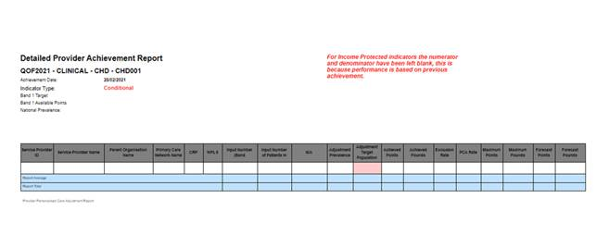

**Income protected indicators**

Data will not show the numerator or denominator values as performance is based upon previous achievement.

Max Points (column) = the max Income Protected points

Achieved Points (column) = Income Protected points credited

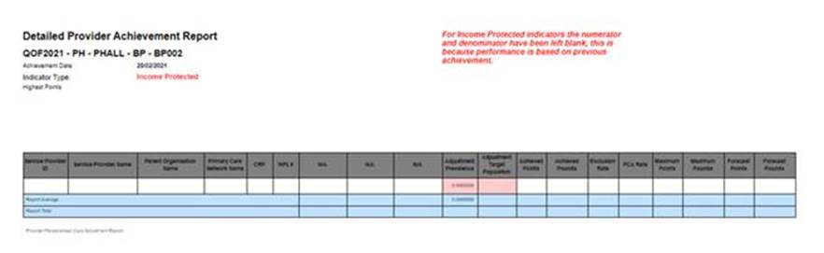

**Achievement Summary Report**

**Domain Level Reports**

At the clinical domain level reports are unchanged and the total achievement will be displayed including any income protected achievement..

**Indicator Level Reports**

For conditional indicators data will display data as normal and are indicated in the Income Protected/Conditional column as ‘Conditional’.

For income protected indicators the numerator and denominator will be left blank as performance is based upon previous achievement.

Within the final drill down of the achievement summary report, for income protected indicators the summary will include historical performance data.

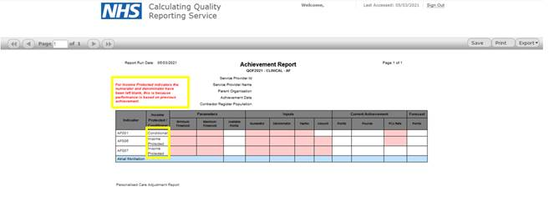

Within the final drill down of the achievement summary report, for income protected indicators, the summary will include historical performance data on which the achievement will be based.

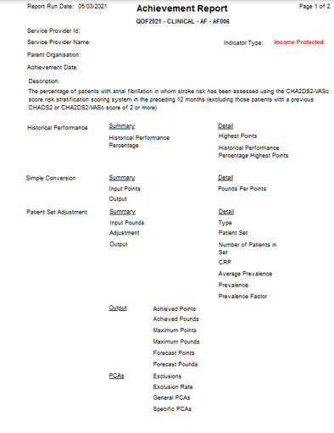

**QOF extract timetable**

The below timetable shows the dates for the upcoming QOF year-end 20/21 extract

|  |  |
| --- | --- |
| Extraction window | Thursday 1 April to Friday 2 April (2 days) |
| Achievement and Aspiration calculations | Tuesday 6th April |
| Achievement available to view and declare in CQRS | By Wednesday 7th April |

We will distribute a further update following extractions to inform practices if the data collection has been successful. It will also advise what action needs to be taken to receive payment if your data is not available in CQRS.

**Achievement summary report**

You will be notified when within the CQRS system once your practice’s achievement has been calculated. Once complete, you are able to run the achievement summary report for QOF to view your achievement. Guidance is available in the FAQs on our website.

**Year-end user support**

If your query is not resolved through the year-end specific FAQs on our website, assistance is available via the contacts below:

|  |  |
| --- | --- |
| **CQRS Support Team:** | [support@cqrs.co.uk](mailto:support@cqrs.co.uk), 0330 124 4039, 8am-6pm Mon-Fri (excl. bank holidays). |
| Contract/policy queries: | [england.gpcontracts@nhs.net](mailto:england.gpcontracts@nhs.net) (NHS England) |
| Training: | CQRS Training |
| System: | [CQRS log in](https://login.cqrs.nhs.uk/cas/login) |
| Web: | [CQRS](https://welcome.cqrs.nhs.uk/qof.html) |