Stay creative, connected, learn new skills and be inspired by the world around you.
Join a taster session, start a new creative wellbeing project or join a creative peer led group.
We look forward to meeting you online or face to face in friendly, fun and sociable sessions. Free for B&NES residents. All places need to be booked in advance. Contact details below.

Creative Community Peer-led Groups
No previous experience necessary to join these social, friendly groups:

Feel Good Photography creative wellbeing  Thursdays 11am - 1pm weekly meetings  Creativity Works in partnership with Bath Mind  Weekly meet-ups, to appreciate Bath’s beauty, through photography. A warm, gentle and supportive group, where we share conversation, our experiences of the locations we visit and a joke here and there. We work towards our members developing an increased sense of wellbeing, belonging and purpose. Visiting artist, Sally Collister will be helping us find new ways to enjoy being creative with our photography. We'll also be working towards holding regular exhibitions of our photographs. | 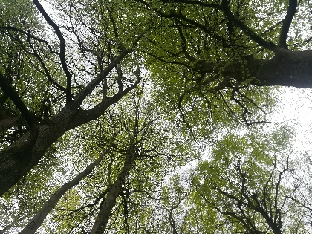
If you’re interested in joining these sessions, contact Paul on 07932 502 384 paulrimmer@bathmind.org.uk

Writing Space – Tuesdays 2pm – 3.30pm
- This friendly group meet indoors in central Bath and online via zoom on alternate weeks.
- For people of all writing skills. This is a sociable group who enjoy fun sessions to develop and share ideas. Each session is led with many suggestions to inspire you.
- Let us know if you’d like to receive the Writing Space newsletter if you can’t make the sessions.
- Contact Karen: karen@creativityworks.org.uk Phone: 07517 110612
- Sign up and book through this online Survey link: https://conta.cc/3xzqQTD

Get Creative art group - Tuesdays 1.30pm – 3pm
- Meeting at The Hub, Foxhill, Bath, and meet us online if you cannot make it to the venue.
- Sept – Oct exploring Creative Sketchbooks. We explore different art techniques, develop new skills and plan sessions together. Facilitated by Creativity Works volunteers and occasional visiting artists.
- Booking essential: Contact Karen: karen@creativityworks.org.uk Phone: 07517 110612 Sign up and book through this online survey link: https://conta.cc/2WMdUwG

Keynsham Snap & Stroll – 10am to 12 noon 2nd and 4th Tuesday of the month
- No experience necessary or fancy camera required! Bring camera or phone, appropriate clothing for weather and an open mind, meet new people and enjoy snapping and strolling
- A local wellbeing photography group explore in and around Keynsham and further afield. This friendly group offers opportunities to discover new ways of seeing.
- Meet at Keynsham Memorial Park. Supported by Bath Mind Contact Becky 07538 113 890
- Sign up and book through this online Survey link: https://conta.cc/3u7PtW1

Keynsham Snap & Stay - 10am – 12 noon 1st and 3rd Tuesday of the month
- Meet at One Community Trust staying in one locality – suitable for anyone less able to walk.
- Sign up and book through this online Survey link: https://conta.cc/3iWLQ17
- Contact Creativity Works karen@creativityworks.org.uk or Supported by Bath Mind contact Becky 07538 113890

Courses run by EcoWild

Men's Woodland Project Group, Greyfield Woods,
Wednesdays 10-1. A relaxed session including a walk, fire and simple woodwork; bring a mug and a packed lunch. Free. Register & find out more on ecowild.org.uk/book-now or call Emily 07812 155 659

Lakeside Wellbeing, The Community Farm (Chew),
Mondays 10-3. Guided practices and self reflection for wellbeing including mindfulness, movement, nature connection and creativity. Free. Register & find out more on ecowild.org.uk/book-now or call Emily 07812 155 659

Winter Solstice
Community gathering with music, stories and song on 21st December 3.45-5.45pm.
Candle-light and good company in the darkness at the Roundhouse, Greyfield Woods. £5 Bring a mug. Register & find out more on ecowild.org.uk/book-now or call Emily 07812 155 659

