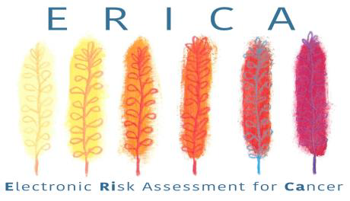
The ERICA study is a large randomised controlled trial assessing the clinical and cost effectiveness of six electronic risk assessment tools (eRATs) for bladder, kidney, lung, colorectal, ovarian and oesophago-gastric cancers in general practice. We will recruit 530 English practices to compare the effect of eRATs (vs usual care) on: cancer staging at time of diagnosis, cost to the NHS, patient experience of care, and service delivery.
We hope to see a 4-5% increase in the proportion of early stage cancers diagnosed if the intervention is successful.
The trial runs for two years, with the software being available on EMIS, Vision and SystmOne. A pop-up appears when a patient aged 40+ has recorded symptoms/test results with a 2+% risk of one of the six cancers. A symptom checker is present for recording additional clinical events, leading to the recalculation of a new risk score. GPs decide the next appropriate course of action themselves. We estimate one to two pop-ups per GP per week.
For the main trial outcome, we are not asking practices to collect data; this is provided by National Cancer Registration and Analysis Service. Practices may choose to take part in nested studies involving giving feedback on the eRATs. Participating practices receive £470.55 if randomised to the intervention arm and £204.40 in the control arm. We provide full support for practices and will liaise with CCGs to arrange software installation where necessary. We’re recruiting practices now but randomisation will not take place until January 2021.
Principal Investigator: Professor Willie Hamilton, CBE.
For more information please contact us: Tel: 01392 726555 Email: erica@exeter.ac.uk
Trial website: ERICA trial Twitter: @EricaTrial
Watch our introduction videos here: http://erica-hub.co.uk/
You can review the local document pack here: https://www.theericatrial.co.uk/gp-resources/

