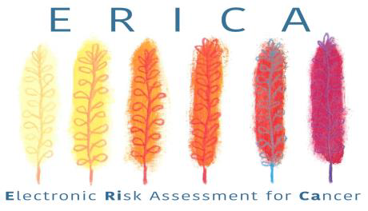
The ERICA study is a large randomised controlled trial assessing the clinical and cost effectiveness of six electronic risk assessment tools (eRATs) for bladder, kidney, lung, colorectal, ovarian and oesophago-gastric cancers in general practice.
We are recruiting 530 English practices for this two-year trial comparing the effect of eRATs (vs usual care) on: cancer staging at time of diagnosis, cost to the NHS, and patient experience of care.
The ERICA eRATs are an important tool for GPs to have at their disposal. They have the potential to save lives by catching cancer sooner. With the rise in undiagnosed cancers as a result of the COVID-19 pandemic, eRATs offer timely solution. Your participation offers a genuine opportunity to support a national study that may generate important improvements to the delivery of care and patient outcomes. We hope you see these tremendous benefits too and will join us in in our attempts to catch cancer sooner - Through using eRATs we hope to see a 4-5% increase of early stage cancers diagnosed.
Trial details:
- The eRATs are cloud-based software working on your clinical system (EMIS or SystmOne).
- A pop-up appears in patients aged 40+ with symptoms/test results indicative of a 2+% risk of one of the six cancers.
- A symptom checker allows for the recording of additional clinical events.
- GPs decide the next appropriate course of action themselves.
- We estimate one to two pop-ups per GP per week.
- Practices receive £470.55 in the intervention arm and £204.40 in the control arm.
The main trial outcome is provided by National Cancer Registration and Analysis Service.
Principal Investigator: Professor Willie Hamilton, CBE.
“I’d really love you to join this trial. Of course we think eRATs are a good thing for patients and their doctors. But nowadays thinking something works isn’t enough; we want to know if eRATs work, and in a way that helps patients and GPs”.
For more information please contact us: Tel: 01392 726555
Email: erica@exeter.ac.uk
Trial website: ERICA trial Twitter: @EricaTrial
Watch our introduction videos here: http://erica-hub.co.uk/
You can review the local document pack here: https://www.theericatrial.co.uk/gp-resources/

