During Pregnancy

Q1 I have just found out that I am pregnant- What do I need to do?

Please contact your local midwife or GP to notify them you are pregnant. You will be offered support for you antenatal care including advice on health and care in pregnancy. You will be offered an appointment with a midwife, usually before you are 10 weeks pregnant.
If you are already over 10 weeks pregnant please contact your midwife or GP who will ensure you can access care quickly

Your local hospital website will provide information on how to contact a midwife (Maternity page).

The NHS recommends that all women considering pregnancy and pregnant women take Folic Acid to aid in the development of your baby during the early weeks of pregnancy. The recommended amount is 400 micrograms daily until you are 12 weeks pregnant. You may be advised to take a higher dose by your midwife or doctor if you have epilepsy, diabetes or if there is any history of neural tube defects in your family or other children. Please discuss with your midwife or GP.

- NHS vitamin and mineral supplements in pregnancy:
- https://www.nhs.uk/conditions/pregnancy-and-baby/vitamins-minerals-supplements-pregnant/

Vitamin D: As the current government advice advises us to stay at home, you may not be getting enough sunlight if you are indoors most of the day. The NHS recommends a daily supplement of 10 micrograms of vitamin daily. This is particularly important for pregnant women and people with black or brown skin who are pregnant (BAME) and anyone with limited exposure to sunlight including night shift workers and those people who cover their skin when outside.

You can buy vitamin D supplements at most pharmacies and supermarkets. Please don’t buy more than you need.

If you are pregnant or breastfeeding you may qualify for the Healthy Start Scheme and may be able to receive vitamins free of charge.

Further information is available here:
- COVID19 NHS vitamin D advice: https://www.nhs.uk/conditions/vitamins-and-minerals/vitamin-d/

Q2 When will I get a scan?

When you have registered with maternity services you will be offered a dating scan to confirm the estimated date of your baby’s birth. This is usually around 11-13 weeks of pregnancy.

At this scan you will also offer screening for Down's, Edward's and Patau's syndromes (Nuchal Translucency scan in combination with antenatal screening blood test).

Q3 Can my partner attend antenatal appointments with me?

Maternity services support partners to be present at antenatal appointments where there is space to enable social distancing.

Due to restrictions in GP practices there may be restrictions in place for additional visitors. We are working with GP practices to support a safe phased return of access for birthing partners, however due to an increase in COVID-19 numbers and tighter government restrictions it has not been possible to resume access to all antenatal appointments.
Please check with your midwife/doctor regarding local arrangements, which may include waiting asking additional visitors to wait outside of the practice until you are called in for your appointment, this is to reduce the number of people of the waiting space so that social distancing is in place to keep everyone safe.

Q4 Can my partner attend scans with me?

Birthing partners are currently able to accompany women to the scan around 20 weeks of pregnancy (anomaly scan) at Great Western Hospital, Royal United Hospital and Salisbury Hospital.
We are working hard to allow partners to be safely present at over scans, particularly the 1st scan, however due to the size of scan and waiting rooms this isn’t currently possible across all of our hospitals, we are working to review the space available to find a resolution for this as quickly as possible.
The guidelines are constantly changing so please contact your midwife for the most up to date information

www.ruh.nhs.uk/patients/services/maternity/index.asp
www.gwh.nhs.uk/wards-and-services/a-to-z/maternity-services/
www.salisbury.nhs.uk/InformationForPatients/Departments/Maternity/Pages/Home.aspx

Q5 Should I still attend my antenatal appointments

Yes, maternity care is here for you and you should still continue to attend all antenatal appointments unless you have been informed otherwise. *Please contact your midwife or GP if you have displayed symptoms of COVID-19*

Q6 Are antenatal and breastfeeding education workshops still available?

Currently all face to face group antenatal educations sessions are cancelled in line with government advice. To ensure we are able to support you we are now offering the following education sessions for all women and partners.

Bath and surrounding areas- Antenatal For parent education and videos at RUH -https://www.ruh.nhs.uk/patients/services/maternity/antenatal_education/index.asp

Swindon and surrounding areas-GWH- https://www.gwh.nhs.uk/wards-and-services/a-to-z/maternity-services/information-for-parents-and-parents-to-be/

Salisbury and Wiltshire https://www.salisbury.nhs.uk/InformationForPatients/Departments/Maternity/Pages/Home.aspx

Your midwife will discuss antenatal education with you and can offer additional resources and support where required. If you are a younger mum or have additional worries, concerns or would just like to have additional support please let your midwife know.

Q7 What should I do if the baby’s movement are slowing down?

Your baby’s movements in pregnancy are a sign that they are well. If your baby moves less or if you notice a change in the pattern of your baby’s movements this can sometimes be an important warning sign that your baby is unwell.

- PLEASE do not hesitate to contact your local maternity services if you have any concerns about your baby’s movements.
- Follow the advice and guidance that you have been provided by your midwife relating to observing your baby’s movements and do not delay contacting your midwife or day assessment unit.
- Maternity services are focused on keeping you safe and are available to provide care if you have concerns about your baby’s movements. Do not put off calling, it is important for the midwives and your doctors to know if your baby’s movements have slowed down or stopped.
-Fetal monitoring should be only carried out by an appropriately qualified maternity health care professional who is trained to detect the difference between a mother’s heart rate and your baby’s heart rate. Devices available for home use to detect fetal heart rates are not recommended as these can give false reassurance and delay parents seeking professional advice and care at the right time.
- Information is available on the hospital websites and hospital contact numbers are on the front page of your maternity records as well as on the websites.

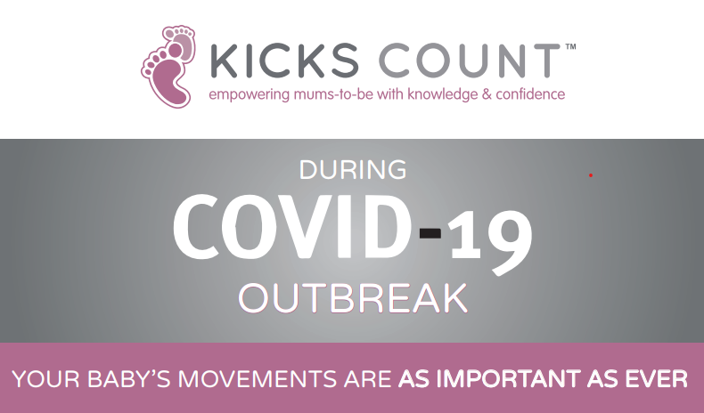

Q8 I have been advised by my maternity team that I should have additional scans during my pregnancy to check my baby is growing well. I am concerned that coming to the hospital increases my risk of possibly catching COVID-19?

The recommended pathway of your care in pregnancy is developed with you to meet your individual needs. If your pathway of pregnancy care includes the advice to have additional scans in pregnancy to check that your baby is growing well, this will be because there have been some factors identified that may indicate a slightly increased chance of the baby not growing as well as expected. Hospitals have a range of measures in place to keep you safe when you attend for any appointments and we would ask that you contact your midwife if you have any concerns about attending growth scan appointments.

Q9 I am concerned that I am not able to have the COVID-19 vaccination as I am pregnant or breastfeeding my baby or planning to become pregnant?”

Current government national guidance in England is that the Covid-19 vaccination is not advised for pregnant women, women planning to become pregnant and women who are breastfeeding. We know that this may concern you but want to reassure you that there are still actions that you can do to keep yourself safe during the coronavirus pandemic. You can reduce your risks by following the government guidance on social distancing, use of facemasks, good ventilation of rooms with other people in and washing your hands. Breastfeeding your baby/child provides many long lasting health benefits for you and your baby. Please talk to your midwife or Obstetric (maternity) doctor or GP if you have any concerns or questions.

Labour and Birth

Q10 Can I have a home birth?

All three areas in Bath, Swindon and Wiltshire are maintaining the home birth service at this time. If you plan to have your baby at home and live in an area that Royal United Hospital, Great Western Hospitals or Salisbury Hospital maternity services cover then we will support you with your choice of home birth.
Please discuss with your midwife.

Q11 If I have problems with childcare is it easier to choose my home as a place of birth?

It is always advised that you discuss your choice of place of birth with your midwife who will be able to help you consider your choices. Wherever you choose to give birth you will need to have arrangements in place for the safe care of your children, whether in the home or otherwise, this could be your birthing partner, doula or other support. Please consider who would look after your children if you have to transfer to hospital and who would be available to care for your children in this situation. During the Covid-19 pandemic we need to maintain social distancing so ask that you have just one birth partner present in the room – please discuss with your midwife.

Q12 Can my partner come in with me to hospital if I need my labour to be induced?

We are supporting partners to be present wherever possible during the induction process. We understand how important this is for your partner to be able to support you. Please visit your local hospital website for the most up to date information on maternity access. If there are increases in Coronavirus rates locally this may change so please discuss with your midwife.

Q13 When I think I am in labour will my partner have to drop me off and wait for confirmation of my labour before being able to stay and support me?

If you are attending because you think that you are in labour you will be seen in a single assessment room where social distancing can be practised and your partner can be with you. If you are found to be in early labour you may choose to go home or you may need to stay in on the antenatal ward in which case your partner will not be able to stay on the antenatal ward with you if this is outside of visiting sessions. This is to support safe social distancing on the wards at this time. We will be reviewing this policy frequently as the incidence of COVID-19 decreases to support partners to be present as soon as this is safe to do so.

Q14 Can I have my birth in a Midwife Led Birth Unit?

The maternity services in Bath, Swindon and Salisbury (Wiltshire) are continuing to support birth in the Midwife Led Units. You are advised to give birth in an Obstetric maternity unit if you suspect or are confirmed to have COVID-19 as there are additional facilities and staff available to care for you if you are unwell and to monitor your baby’s health.

Q15 How will I be treated if I am giving birth while having symptoms of COVID-19? Can a pregnant woman with suspected or confirmed COVID-19 still give birth in hospital?

Maternity services will continue to care for you if you have or are suspected to have COVID-19 during birth.
If you go into labour and have symptoms of coronavirus you will be advised to give birth in a maternity unit where there are obstetric doctors available. This is so that the team can monitor you and your baby more closely.
The team caring for you in labour will ask you to consider monitoring of the baby’s heart rate using continuous electronic fetal monitoring and also checks of your oxygen levels during labour. This will enable the team to reassure you that you and your baby’s health is not being affected by the COVID-19.
You will be cared for by staff who will be wearing aprons, masks and eye protection. This is to keep you, your baby and the staff caring for you safe and stop the spread of infection. Having coronavirus should not have any impact on whether you have a vaginal or caesarean birth. Your maternity team has been trained on how to keep you and your baby safe. They will make sure you get the best care and respect your birth choices as closely as possible.

After the birth of your baby

Q16 Who should I contact if I am feeling anxious or depressed in pregnancy or after birth

Please continue to communicate with your midwife – tell them if you are feeling anxious or down. There is still support available for women with mental health issues including talking therapies to more specialist perinatal mental health teams.

There is a variety of online or face to face support that your midwife can share with you to help you. If you or your partner are in crisis and need to speak to some urgently call this telephone number 0300 303 1320.

Q17 What happens if I need an interpreter or an additional carer?

Staff in all areas are supporting your partner or an essential supporter to be present if they are made aware of any identified needs such as requirement for translation, learning disabilities, cognitive impairment and previous pregnancy loss.

Q18 How can I look after my mental wellbeing during this crisis?

It is understandable to feel more anxious and stressed than usual in times like these particularly when we are being asked to mostly stay indoors and not socialise with others at this time. It is important to look after yourself and particularly your mental health.

Taking active steps to stay healthy and well will help you manage anxiety and help you to fee more in control. Try to:
- Stay active as best you can
- Avoid caffeine
- Don’t smoke or drink alcohol
- Eat well
- Drink plenty of water
- Prioritise rest and relaxation wherever possible.
- It is important to look after your mental health during the Coronavirus pandemic. Try to stay connected with friends and family. This could include using video calls and messaging services. Try and keep a daily routine. Keep active, eat well, make a to-do list, plan lunch breaks and be gentle with yourself – resting when you need to. Speak to your midwife if you are anxious or worried – we are here to care for you and answer your queries/concerns.

Some of these links might be useful resources for you to read
https://mentalhealth.org.uk/coronavirus/staying-at-home

Tommy’s wellbeing resources for pregnancy and post birth
https://www.tommys.org/our-organisation/about-us/charity-news/new-wellbeing-resource-pregnancy-and-post-birth

https://www.tommys.org/your-babys-mum

Mind resources to support mental health during pregnancy and post birth
https://www.mind.org.uk/information-support/types-of-mental-health-problems/postnatal-depression-and-perinatal-mental-health/self-care/#collapse6e2be

https://www.mind.org.uk/mumsmatter

Maternal Mental Health Alliance support
https://maternalmentalhealthalliance.org/news/mmha-members-offer-reassurance-amid-coronavirus-outbreak/

Q19 Are there risks related to feeding my baby/child during the Coronavirus (COVID-19) pandemic?

There is currently no evidence that the virus passes into breast milk. The well-recognised benefits of breastfeeding outweigh any potential risk of transmission of coronavirus through breast milk. The main risk of breastfeeding is close contact between you and your baby, as if you cough or sneeze this could contain droplets which are infected with the virus leading to infection of the baby after birth.

Mothers who have symptoms should try to wear a mask when feeding and in intimate contact with their baby. You should also strictly follow hand washing instructions.

When you are anyone else feeds your baby the following precautions are recommended:
- Wash your hands before touching your baby, breast pump or bottles
- Try to avoid coughing or sneezing on your baby while feeding the baby
- Consider wearing a face mask if you have any symptoms of COVID-19 or if you are self- isolating following contact with someone who has tested positive for COVID-19.
- Follow recommendations for pump cleaning after each use
- If you are unwell consider asking someone who is well to feed your expressed breast milk to your baby
https://www.unicef.org.uk/babyfriendly/infant-feeding-during-the-covid-19-outbreak/

Q20 What support and information is available about breastfeeding when I get home?

There is infant feeding support via telephone, virtual consultation and face to face visits.
You can contact your midwife via the telephone number provided on your maternity notes.

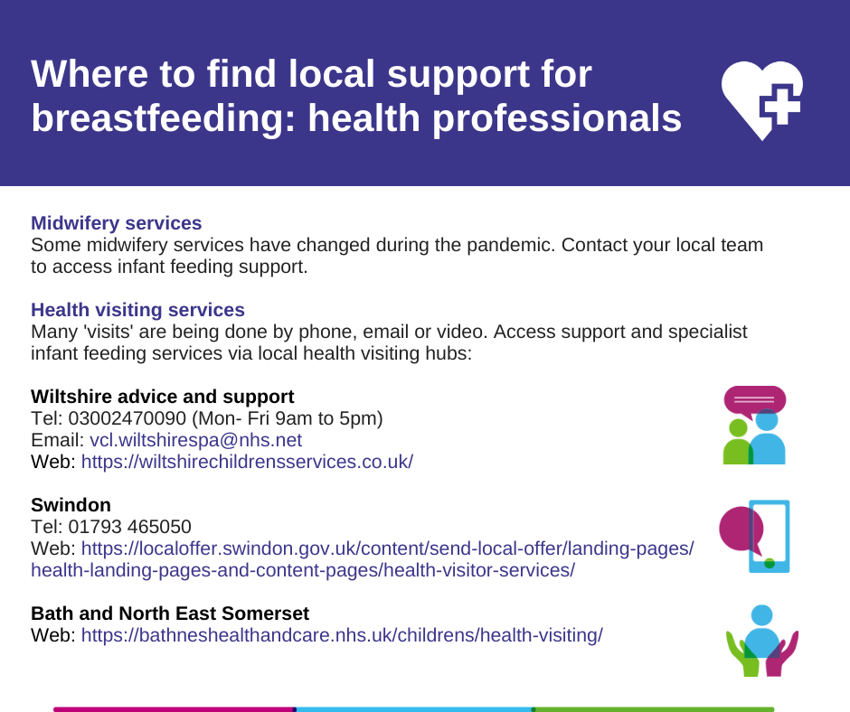

Q21 Is there anything that I need to think about doing differently if I am formula feeding my baby?

If you are feeding your baby with baby formula milk it is important that formula milk is prepared as directed on the manufacturer’s instructions and is not watered down as this will result in your baby not receiving the adequate nutrients required for health.

It is also important that the correct stage baby milk is used for your baby e.g. First Infant formula (Stage 1 milk). Follow on formula milk should never be used for babies under 6 months and they can continue to have First Milk up the age of one year as part of their diet. If you have any problems obtaining formula milk, try shopping around smaller shops if you can’t find it in your usual supermarket. The manufacturers are still distributing regular supplies to shops and increasing production. See question 18 for general information on how to reduce the risk of COVID-19 transmission when feeding your baby.

Q22 How will I care for my baby alone on the ward if I can’t move following my caesarean birth and my partner is not present all of the time?

The members of maternity staff want to reassure you that they will be there to support all women on the wards with care of their baby. Each new parent will have access to a call bell to ask for assistance when unable to care for their baby at any time.

Q23 What guidance are maternity services using to decide how best to provide safe care during the COVID-19 pandemic?

All maternity care during each phase of the pandemic is provided in line with the most recent national and professional guidance from Public Health England, NHS and Professional Colleges including the Royal College of Obstetricians and Gynaecologists, Royal College of Midwives and the Society and College of Radiographers. This guidance has been reviewed and amended frequently throughout the pandemic with any decisions to restrict services only made after much deliberation of the facts by the multiagency teams.

We recognise the significant impact that the visiting restrictions have had on all women, partners (and staff) accessing NHS Services throughout the pandemic and are sorry that during these unprecedented times that these measures are necessary to ensure safety for everyone. All decisions to introduce any restriction measures are only made after much deliberation of the facts and with the advice and guidance of infection control colleagues.
The CCG, BSW Local Maternity System and the Maternity Care providers are committed to resuming pre-COVID-19 services as quickly and as safely as possible balancing the needs of the parents with the requirement to provide safe and timely care and reduce transmission rates of COVID-19 for women, partners and the staff. The maternity care providers are resuming normal pathways of care and in line with the National Framework for reintroduction of visiting published on 8 September by RCOG, RCM, SCoR and NHSE, which was released just prior to the identification of the increasing trend in numbers of COVID-19 infections. This framework advocates a phased approach taking into account the national and local incidence and prevalence, the physical space in each maternity service including waiting areas and clinical rooms, the number of women expected to attend clinics/ultrasounds and use of shared waiting spaces and the number of inpatients and the ability for safe social distancing. Each of the three maternity providers of care have different space available within their clinical areas with different challenges to maintaining compliance with safe social distancing.

Q24 When will the visiting restrictions be lifted?

All maternity services recognise the significant impact that the visiting restrictions have had on all women, partners (and staff) accessing NHS Services throughout the pandemic and are sorry that during these unprecedented times that these measures are necessary to ensure safety for everyone. All decisions to introduce any restriction measures are only made after much deliberation of the facts and with the advice and guidance of infection control colleagues.
The CCG, BSW Local Maternity System and the Maternity Care providers are committed to resuming pre-COVID-19 services as quickly and as safely as possible balancing the needs of the parents with the requirement to provide safe and timely care and reduce transmission rates of COVID-19 for women, partners and the staff.

Staff in all areas are supporting the partner or an essential supporter to be present if they are made aware of any identified needs such as requirement for translation, learning disabilities, cognitive impairment and previous pregnancy loss. Partners are also supported to be present if there are any conversations relating to unexpected news are required. All women experiencing baby loss will be supported to have partners with them.
The risks associated with the number of people in a hospital are very different from the risk in a bar, café or shopping centre. Social distancing is difficult when providing health care and the more people who come into the hospital (footfall) the greater the amount of virus staff and patients could be exposed to. Increased footfall increases the risk of people catching COVID-19 in hospital which would potentially increase the numbers of staff who cannot work due to illness. In particular ultrasound staff are critical staff with limited availability to backfill them if they become sick. Lack of staff increases the risk that we would not be able to provide the level of maternity or ultrasound services we would like or need to provide which could potentially increase the risks to all pregnant women. Ultimately the safety of the staff, the birthing people, their babies and their families are our greatest priority.
Visiting restrictions are reviewed regularly and will be lifted in the phased approach advised by the national Visiting Framework for Maternity Services when a reduced risk of contracting COVID-19 makes it appropriate to do so.

Q25 If I have another question or concern that has not been covered here where can I look for information or who can I ask?

You can ask your midwife, Obstetrician or GP about any concerns relating to your pregnancy or health. The contact numbers are on the Hospital websites along with links to relevant information about pregnancy and Coronavirus (COVID-19)

www.ruh.nhs.uk/patients/services/maternity/index.asp

www.gwh.nhs.uk/wards-and-services/a-to-z/maternity-services/
www.salisbury.nhs.uk/InformationForPatients/Departments/Maternity/Pages/Home.aspx

Another source of information about maternity provision is the local Maternity Voices Partnership https://www.bswmaternityvoices.org.uk/

Bath & North East Somerset, Swindon and Wiltshire (BSW) Maternity Voices Partnership Plus is a group of volunteer parents and birth workers, midwives, doctors and commissioners. We work together to review and contribute to the development of local maternity services.

Local Area volunteers are parents who have recently used the local maternity services, or people involved in providing services for pregnant and new parents, such as antenatal teachers or breastfeeding supporters. They are a crucial part of the team – the MVP couldn’t function without these volunteers.

The Maternity Voices Partnership has played a pivotal role providing feedback from women and families on the impact of the COVID-19 related changes to enable us to understand the impact of women and families.

Q25 How long will I have to stay in hospital for?

The length of stay will depend upon you and your baby’s medical needs following your birth. Your midwife and maternity team will discuss this with you following the birth of your baby.

If you have any additional questions that you think need to be added to this list of frequently asked questions please contact https://www.bswmaternityvoices.org.uk/

