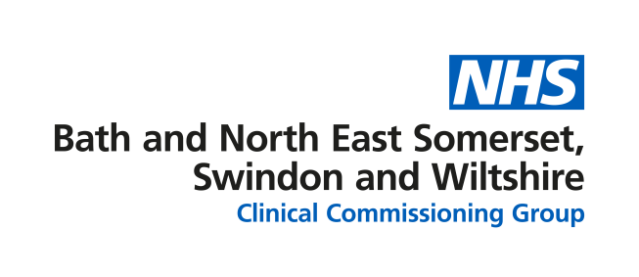
West Wiltshire Centre for Health and Care

Questions and answers

- Where will the new centre be built?
The new building will be on the Hammersmith Fields site off Seymour Road in Trowbridge. It is next to the existing Trowbridge Community Hospital and adjacent to Trowbridge Health Centre.

- How much is the development going to cost?
The Department of Health and Social Care has allocated £16m for this project, subject to business case approval.

- What services will be provided from the building?
The building will accommodate a range of services including:
- Primary Care
- Urgent care (including minor injuries)
- Outpatient Services
- Phlebotomy
- Physiotherapy
- Podiatry
- Diabetes/Endocrinology
- Mental Health
- Maternity Services

- Will there be a minor injury unit or accident and emergency unit at the centre?
A minor injuries service is provided from the existing Trowbridge Community Hospital and this will remain the case in the new building.

The building will also accommodate same day appointments for minor illness giving patients improved access to urgent care

- Will maternity services be provided from this centre?

On the basis of the agreed proposals for BSW-wide maternity services, the new building includes ongoing provision of ante-natal and post-natal outpatient care, with associated screening/imaging, and support for home births.

- Will there be any inpatient beds at this centre?
No. There will be no beds at this centre.

