Frequently Asked Questions

This section includes questions with suggested answers for patients, the public and healthcare professionals. These questions will appear on a public-facing website in due course. The website is currently under construction (July 2020). We will update this document with the correct links as soon as they become available.

For patients and members of the public

- Q: How do I find out more about this survey?
A: You can find out more information about this survey by:
- visiting the survey website (under development: www.CancerQoL.england.nhs.uk);
- calling the free helpline: 0800 783 1775;
- sending an email to helpline@quality-health.co.uk;
- or writing to FREEPOST Quality Health.

- Q: My cancer treatment finished a long time ago, why are you contacting me now about this survey?

A: The NHS wants to understand about the longer-term impact that cancer can have on people. We want to support people to live with a good quality of life. It would be great if you could fill in the survey whether you feel in good health or not. This will help us build up a full picture of all the different ways people are experiencing life after a cancer diagnosis.
- Q: My quality of life is good, so why should I fill in this survey?
A: We want to understand about the longer-term effects that cancer may have on people. It would be great if you could fill in the survey whether you feel in good health or not. This will help us build up a full picture of all the different ways people are experiencing life after a cancer diagnosis.
- Q: My quality of life is poor, but the reason has nothing to do with cancer, should I still fill in this survey?
A: Yes, it would be great if you could still fill in this survey. Your answers could be because of your cancer diagnosis and treatment, other illnesses, or other things happening in your life.
- Q: Should I answer these questions just about cancer?
A: No. Your answers should be about all things affecting your life - which could be your cancer, other illnesses, and other things happening in your life.
- Q: My quality of life is poor, and I need some help – what should I do?
A: If you are experiencing any problems or concerns with your health or wellbeing you should contact a healthcare professional. This could be your GP, nurse or cancer support worker. They can support you to get the help that you need.
Please be aware that your answers to the survey will not be shared with any healthcare professionals involved in your care. You must raise any problems or concerns with a healthcare professional yourself.
- Q: Why have I received this survey?
A: This is a national survey of people in England who have been diagnosed with cancer. From 2020, people who have had a breast, prostate or colorectal (bowel) cancer diagnosis are being invited to complete the survey around 18 months after diagnosis. We are trying to understand the longer-term impact of having cancer.
You have been contacted because you are on the national cancer register in England. The register shows that you are someone who had been diagnosed with cancer around 18 months ago. You can find out more information about the cancer register here: https://www.gov.uk/government/publications/cancer-registration-patient-information-leaflet
- The survey complies fully with the Data Protection Act 2018.
- The survey is being carried out under Public Health England’s permissions to gather and use patient data to improve population health.
- This survey is being run for Public Health England by a company called ‘Quality Health’. Your personal information will be kept safe by them, and your answers will be dealt with in confidence.
- Your answers will be shared with and securely held within Public Health England; no personal or identifiable data will be published.

We apologise if you think you should not have been contacted about this survey. If you have any questions or concerns, or wish to make a complaint, please contact the helpline 0800 783 1775, send an email to helpline@quality-health.co.uk or write to FREEPOST Quality Health.

- Q: Who is running this survey?

A: This survey is being run jointly by Public Health England, NHS England and NHS Improvement. They have hired a company called Quality to Health to send out the survey invitations and collect answers to the survey.

- Q: I don’t think I should have been sent this survey. What should I do?
A: We apologise if you think you should not have been sent this survey. We are sorry if being sent this survey has caused you any upset or distress. If you have any questions or concerns, or wish to make a complaint, please contact the helpline 0800 783 1775, send an email to helpline@quality-health.co.uk or write to FREEPOST Quality Health.

We will try to work out why you have been sent the survey and let you know what happened as soon as possible. We will also try to make sure that you are not sent any further survey reminders. If a reminder has already been sent out, please ignore it when it arrives.

- Q: I’ve not been sent a survey, but I think I should have been. Why haven’t I been sent a survey?
A: The survey is only being sent to people who have had a diagnosis of breast, prostate or colorectal (bowel) cancer about 18 months after their diagnosis was made. People with other kinds of cancers will be included in the survey from 2021.
If you were diagnosed with breast, prostate or colorectal (bowel) cancer around 18 months ago and have not received a survey, please call the free helpline 0800 783 1775, send an email to helpline@quality-health.co.uk or write to FREEPOST Quality Health. We will investigate why you have not received a survey and let you know what has happened.
- I want to opt out of this survey, what should I do?
We are sorry you do not want to take part in this survey.
You do not have to complete the survey. Your medical care will continue in the same way whether you choose to take part or not.
If you want to make sure that you are not contacted again about this survey, please contact the free helpline 0800 783 1775, send an email to helpline@quality-health.co.uk or write to FREEPOST Quality Health. If you can, please include the patient reference number at the top of your letter. This number starts with the letter P and is followed by 8 numbers e.g. P12345678
- How did you get hold of my details?
You have been contacted because you are on the national cancer register. The register shows that you are someone who has been diagnosed with cancer around 18 months ago. The register holds information, including contact details, about all patients who have been diagnosed with cancer. You can find out more information about the cancer register here: https://www.gov.uk/government/publications/cancer-registration-patient-information-leaflet
- The survey is carried out within strict procedures to ensure compliance with the Data Protection Act 2018
- The survey is being carried out under Public Health England’s permissions to use patient data to improve population health
- This survey is being carried out for Public Health England by a company called ‘Quality Health’. Your personal information will be kept safe by them, and your answers will be dealt with in confidence.
- Your answers will be shared with and securely held within Public Health England; no personal or identifiable data will be published.

- Q: What is this survey and why is the NHS doing this?
A: The NHS would like to understand how cancer may have changed people’s quality of life. This will help us improve services. The NHS wants to support people to live as long and as well as possible.
Public Health England will join up the answers to the survey about how people with cancer are doing, with information that is already recorded about their cancer and its treatment. It will help the NHS to judge where care may not be working well, and if any improvements should be made.
- Q: There’s a bar code/number on the questionnaire – what’s this for?

A: Each questionnaire has a unique survey reference number so that your name and address does not appear on the survey. This means that everyone’s answers can be carefully recorded without error, but also keeps your answers to the survey confidential.

- Q: I don’t want to fill in the survey online (on the internet). Can I fill the survey in on paper or over the phone?

A: Yes. A paper questionnaire will be sent out to you approximately 2 weeks after you received the initial invitation. Alternatively, you can request a large print version of the survey. This will be sent to you in the post within 2-3 days for you to fill in and return in a FREEPOST envelope.

If you would like help completing the survey over the phone, including in other languages, large print or easy read, please contact us by calling the free helpline 0800 783 1775, send an email to helpline@quality-health.co.uk or write to FREEPOST Quality Health.

- Q: Do I have to answer all the questions?

A: Please answer as many of the questions as you can. The more questions you answer, the more you will help the NHS to understand what life is like for people who have had cancer so that improvements to services can be made in the future.

If you feel unable to answer any question, or if any question makes you feel too uncomfortable, you can leave them blank.

- Q: Can the survey be completed by a partner, spouse, relative or friend?

A: Yes, you can ask someone to help you fill in the survey. You can let us know who helped you on the survey form itself. Please remember to always answer from your own point of view, rather than take the opinion from the person that helps you.

- Q: Can I talk to people about this survey?

A: Yes. You can talk about this survey with other people, and ask for help to understand the questions, but it is best if your final answers then only contain your own views.

- Q: Will I be told about the results of this survey?

A: The results of the survey will be available from 2021 and will be published on a website called ‘Cancer Data’ (https://www.cancerdata.nhs.uk/). This is open to everyone and you can explore the results through this website.

- Q: How were the survey questions chosen? Why are there no questions about problems I have because of the specific cancer treatment that I received?
A: The survey includes questions from two well-known and well-tested quality of life questionnaires.
The ‘EQ-5D’ questions are used widely across the health service and in medical research. They allow comparisons to be made with people treated for other health conditions or with the general population.
The ‘EORTC’ questions are about cancer in general. These will allow us to look at differences in quality of life across different cancer types.
The steering committee who oversee the survey considered adding in specific extra questions that were relevant to each type of cancer or treatment. They have chosen not to include these for now. They want to keep the survey short and as easy as possible to complete. The steering committee will keep the content of the survey under review and consider adding in extra questions later.
If the NHS finds that there are cancer types that have especially poor quality of life outcomes compared to others, they will then seek to understand this in more detail. The NHS will act to improve care for these patients where possible.
- Q: Why am I being sent this survey now rather than at any other time?
A: The NHS is interested in finding out about the longer-term impact that cancer may have had on people’s lives. They have chosen to send out the survey to people around 18 months after they were told they had cancer. There are two main reasons for this: firstly, this time is required for PHE to collect and link all the information about each person’s cancer diagnosis; and, if the survey were done sooner, the longer-term effects may be hidden by the shorter-term impact of the different treatments people have had. The NHS understands that cancer treatment can have an effect many years after this but have chosen to start by looking at this point.

For healthcare professionals and other NHS staff

- Q: What is the information governance set up for the survey?

A: The Cancer Quality of Life Survey is being run by NHS England in partnership with the National Cancer Registration and Analysis Service (NCRAS) based at Public Health England (PHE). A survey provider (Quality Health) is supporting the process by managing the survey invite and response system. All the survey responses are being held by NCRAS and linked with information related to each person’s diagnosis and treatment.

PHE are the data controllers for the survey. The survey provider (Quality Health) is working as a data processor for PHE.

The legal basis for carrying out the survey and sharing the patient information with the survey provider is under Regulation 2 of the Health Service (Control of Patient Information) Regulations 2002. Specifically:
“…confidential patient information relating to patients referred for the diagnosis of neoplasia may be processed for medical purposes approved by the Secretary of State which comprise or include—
2(1)(b) monitoring and audit of health and health related care provision and outcomes where such provision has been made”.
Public Health England’s privacy notice can be found here: https://www.ndrs.nhs.uk/cancer-registration-your-rights-and-privacy/
Under General Data Protection Regulation (GDPR) the lawful basis upon which the registry will process personal data is Article 6(1) (e) “processing is necessary for the performance of a task carried out in the public interest or in the exercise of official authority.”

The registry receives health and genetics data in accordance with the conditions for “special category” data set out in GDPR Article 9(1)(h) “processing is necessary for the…provision of health care or treatment or the management of health…care systems and services,” and GDPR Article 9(2)(i) “processing is necessary for reasons of public interest in the area of public health such as… ensuring high standards of quality and safety of health care… on the basis of [UK] law which provides for suitable and specific measures to safeguard the rights and freedoms of the data subject, in particular professional secrecy.”
Figure 1 – Data boundaries

- Q: What should I do if a patient returns a completed Cancer Quality of Life Survey to me?
A:
- You can send the survey onto our survey provider, Quality Health by using the following freepost address: FREEPOST Quality Health. If you have any questions, you can call Quality Health, on 0800 783 1775 or send them an email at helpline@quality-health.co.uk and they will tell you how to return the survey.

- Please also check whether your patient has brought you their survey responses because they are trying to raise a concern with you about symptoms and/or their wellbeing. If they are, please act accordingly to identify the issues. A Holistic Needs Assessment may be appropriate, in order to identify what support and interventions your patient may need so that they can be signposted or referred to the appropriate service(s).

- Q: How does the Cancer Quality of Life Survey sit alongside other ‘Living with and Beyond Cancer’ or ‘Personalised Care’ interventions? (Holistic Needs Assessment; Personalised Care and Support Planning; End of Treatment Summary; Health and Wellbeing Information and Support; Cancer Care Review)

A: There are a range of LWBC interventions that aim to improve quality of life and patients’ experience of care. The Cancer Quality of Life Survey is one of those interventions; it will both empower patients and provide data that can drive service improvement.

The aim is to collect information that can be used to produce national summary statistics (‘metrics’) that highlight any differences in QoL outcomes between different groups e.g. by cancer or treatment type. Wherever possible, this information will be ‘case-mix’ adjusted to support regional and local reporting. This information can be used to inform the direction of our work aimed at supporting people living with and beyond cancer.

There are plans in place to make the survey more meaningful for patients and clinicians by developing an individual-level report. These will be trialled in late 2020; with a decision made on implementation and roll out from 2021 onwards. The reports will be easily-interpreted infographics containing each person’s summary quality of life scores. We will provide these directly to patients and their clinicians in primary or secondary care. The summaries can be used as a prompt to inform personalised care planning and conversations. The information provided in the summary reports will be at a high level and may not cover all areas of concern that are directly affecting your patients. Other tools such as a holistic needs assessment, cancer care review, trigger questions or cancer-site specific PROMS could all be used to facilitate a more in depth conversation about your patient’s needs, and what matters most to them.

Figure 2 – Timeline for questionnaires and reviews for cancer patients

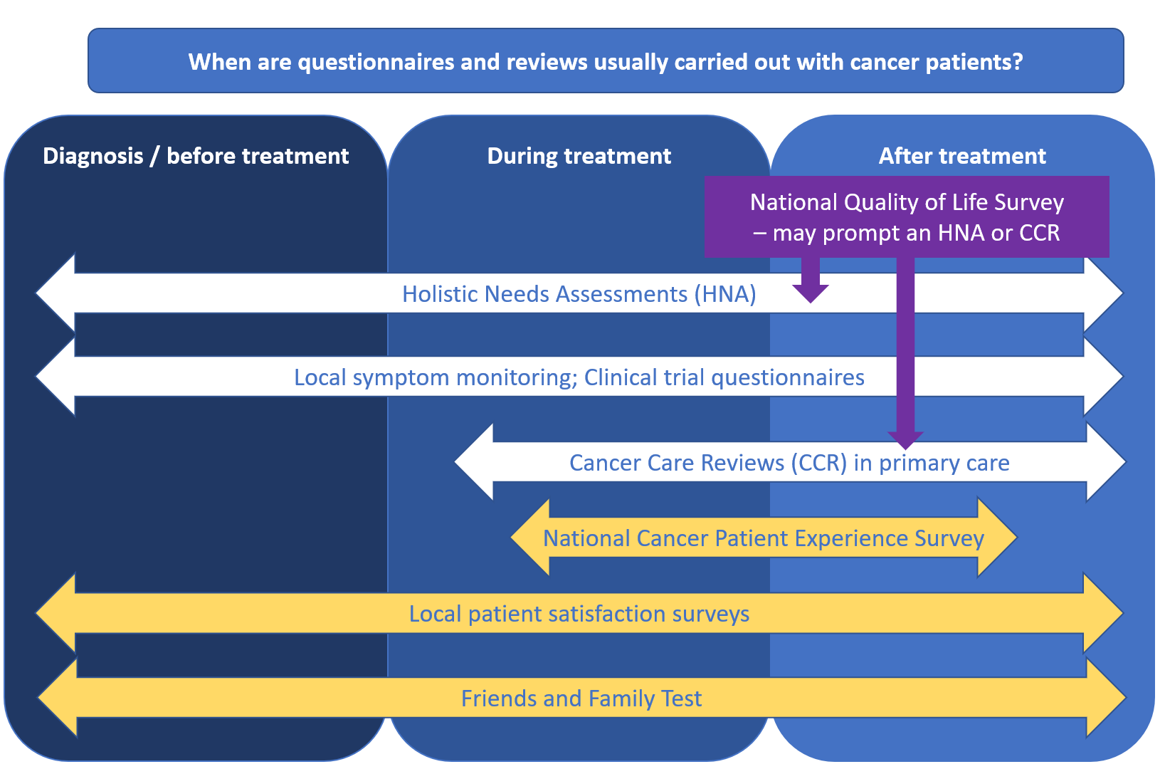

- Q: How is the Cancer Quality of Life Survey different to the national Cancer Patient Experience Survey?

A: The questions explicitly look at quality of life outcomes and do not look at the experience of receiving secondary care for cancer. The aim is to understand how well people are living with cancer and act to improve if poor outcomes are identified.

The Cancer Quality of Life Survey aims to collect information that can be used to produce national summary statistics (‘metrics’) that will highlight any differences in quality-of-life outcomes between different groups e.g. by cancer or treatment type. Wherever possible, this information will be ‘case-mix’ adjusted to support regional and local reporting. This information can then be used to inform the direction of work aimed at supporting people living with and beyond cancer.

Figure 3 – Differences between questionnaires that cancer patients may receive in England 2020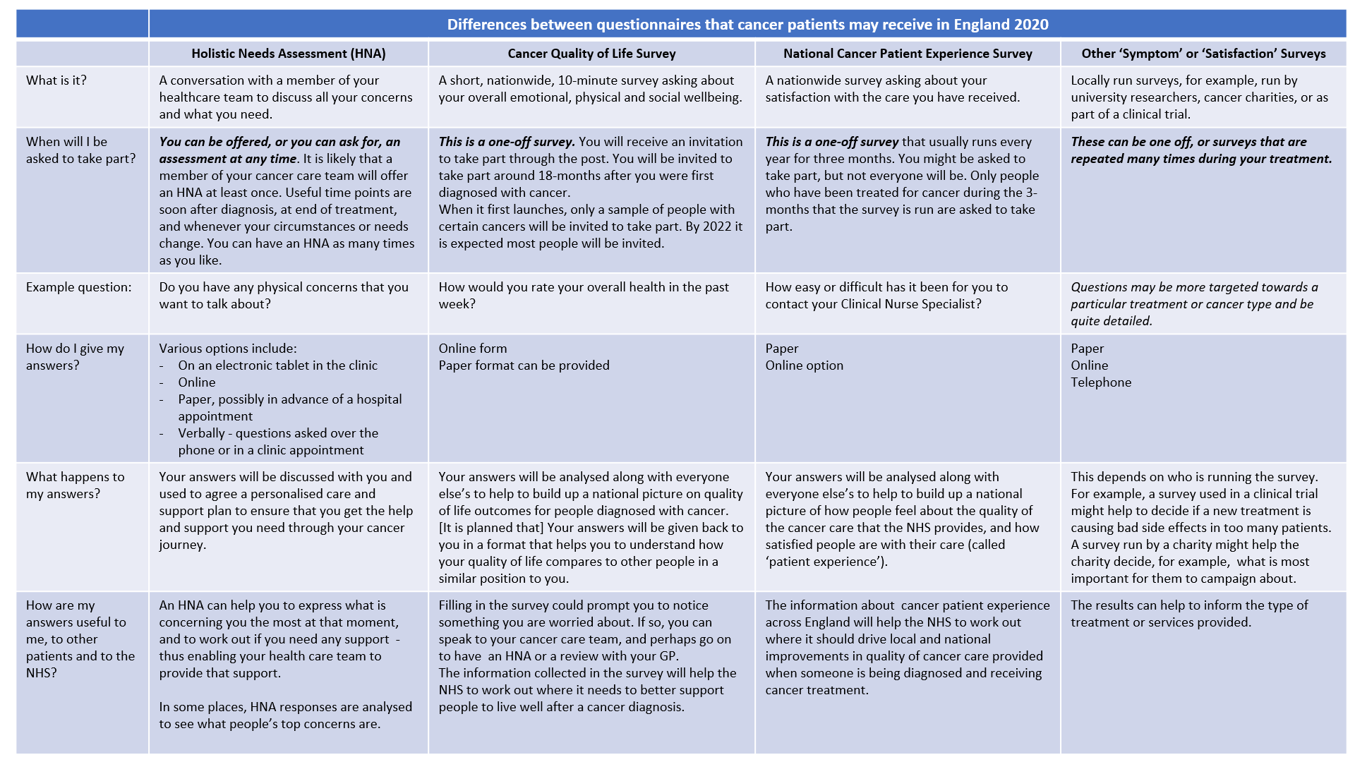
- Q: Why are you only measuring quality of life with a survey at a single point in time? Shouldn’t quality of life be measured repeatedly over time?
A: Our intention is to compare between groups rather than track individuals over time. This is a rolling survey including all patients as they become eligible. We will be able to see if overall quality of life is improving for different groups over time. We haven't ruled out a repeated measurement in the future but are confident that the single assessment point will be enough for the national and regional level monitoring that we are proposing at this time.
- Q: A patient has not been sent the survey but thinks they should have. Have you excluded some patients from the survey?

A: The survey is only being sent to people who have had a diagnosis of breast, prostate or colorectal (bowel) cancer about 18 months after their diagnosis was made. We have decided not to send the survey to patients with appendix cancer, microinvasive breast cancer, and those with cancers arising in polyps. This is because these patients may not be aware that they have a diagnosis of cancer and receiving the survey could cause confusion or distress.

- Q: I am working locally to raise awareness of the Cancer Quality of Life Survey to promote uptake, where can I find information to support this?

A: We need to maximise the number of people completing the QoL survey. We have set a minimum benchmark of a 50% response rate in the first year.

Please visit the Cancer Alliance Workspace: https://future.nhs.uk/canc/view?objectID=19564592

You will find a communications toolkit including a range of useful products to support. You can also enter into online ‘chat’ discussions with other people to share information and activity.

