GP – social media posts September 2020

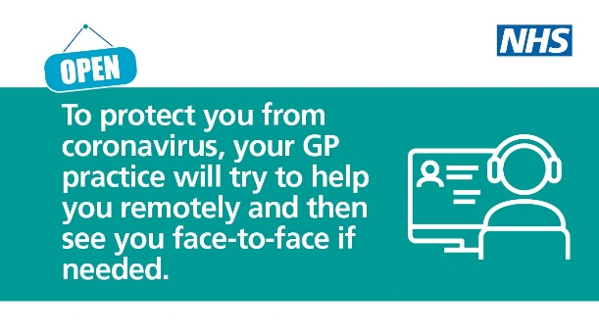 | Before turning up to your GP practice contact them online, by an app or by phone to be assessed 📱 💻  ⚠️ Please follow government safety advice if visiting your local practice for an appointment.  #HelpUsHelpYou
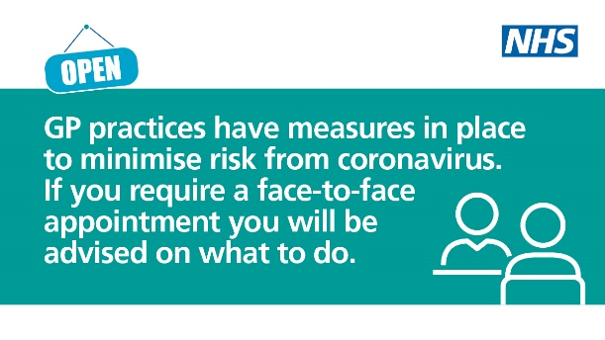 | 💙 GPs are working hard to provide care safely.  ⚠️ Please follow your practice’s safety advice if visiting for an appointment.  😷 Do not go to your GP if you have symptoms of coronavirus or are self-isolating.
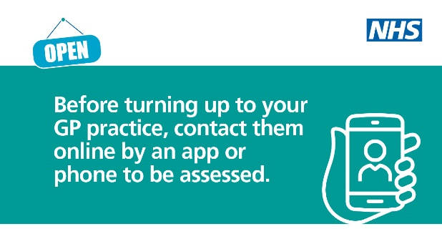 | Contact your GP practice online, by an app or by phone.  ☎️ 💻 If appropriate, you will receive advice or care via video or over the phone.  #HelpUsHelpYou

