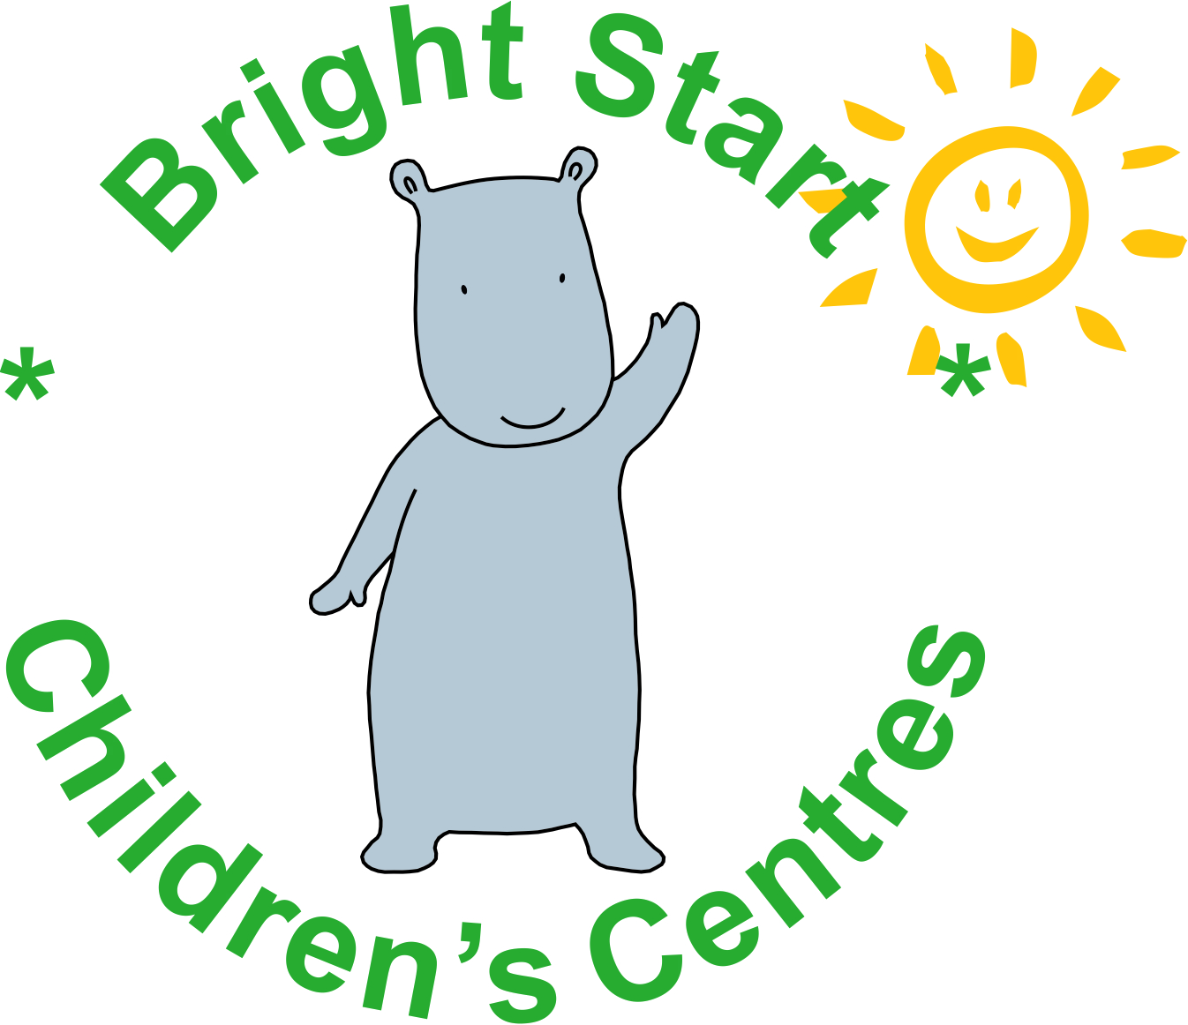

Please find updated information regarding the food clubs as we have widened the criteria to access the clubs and confirmed the times they will be running.

**FOOD CLUBS at Children’s Centres – first one STARTING THIS WEEK**

Bright Start Children’s Centre Services, in partnership with Family Action, Fareshare and Radstock Town Council, are pleased to announce the launch of Food Clubs across Bath and North East Somerset. The clubs provide local families, with children under 11yrs, a range of affordable food every week. We receive weekly produce from Fareshare who redistribute food from manufactures to people who need it the most. Further information can be found at https://www.family-action.org.uk/what-we-do/children-families/food-club/

We will have 3 clubs starting in July/August and these will be based in;

- Keynsham Children Centre- Weekly Thursday afternoon, 2pm-4pm- Starting on the 23rd July
65 West View Rd, Keynsham, Bristol, BS31 2UE Tel:01225 395400

- St Martins Children Centre (Bath area)-Weekly Friday morning, 10-12pm – Starting the 31st July
150 Frome Rd, Bath, BA2 5RE Tel: 01225 396004

- Radstock Children Centre and Library- Weekly Friday afternoon, 1.30pm-3.30pm- Starting 7th August
Church street, Radstock, BA3 3QG Tel: 01225 396660

To join the food club (Please see registration form) ; Families must meet criteria A and either B, C, D, E or F

- A: I/we live or work within 15 minutes of the Children’s Centre and have a child under 11yrs.
[We need PHOTO ID (eg Passport, Driving Licence) and proof of residency (e.g. Phone or Utility Bill) or headed paper from employer or Copy of payslip or Photo ID (Proof of work)]
- B: We receive free school meals or access Early Years 2 year funding
- C: I/we have recently been made unemployed or have loss of income
- D: I/we have been referred to the scheme by a Family Support Worker or another agency.
- E: I/we have: claimed asylum in the UK and awaiting decision, or been refused asylum,
or leave to remain with ‘no recourse to public funds’ on family or private life grounds or the right to live in the UK as the main carer of a British citizen (‘Zambrano Carer’)
- F: Exceptional circumstances – please detail:

There is a £1 annual membership and for only £3.50 the families will receive £15 worth of shopping and there will be a range of different foods on offer. If you have families who may be interested, please complete our registration form (attached) and we will make contact to explain more.

