5k Your Way, Move Against Cancer
By Lucy Gossage, Oncology Consultant

5k Your Way, Move Against Cancer is a community based initiative to encourage those living with and beyond cancer, families, friends and those working in cancer services to walk, jog, run, cheer or volunteer at a local 5k Your Way group at designated parkrun events on the last Saturday of every month.
The initiative was founded by Oncologist Consultant and 12 times Ironman champion Lucy Gossage and International Runner and MOVE Charity Founder, Gemma Hillier-Moses who was diagnosed with Cancer at the age of 24 in 2012.
5K Your Way, Move Against Cancer initiative is provided by MOVE Charity.

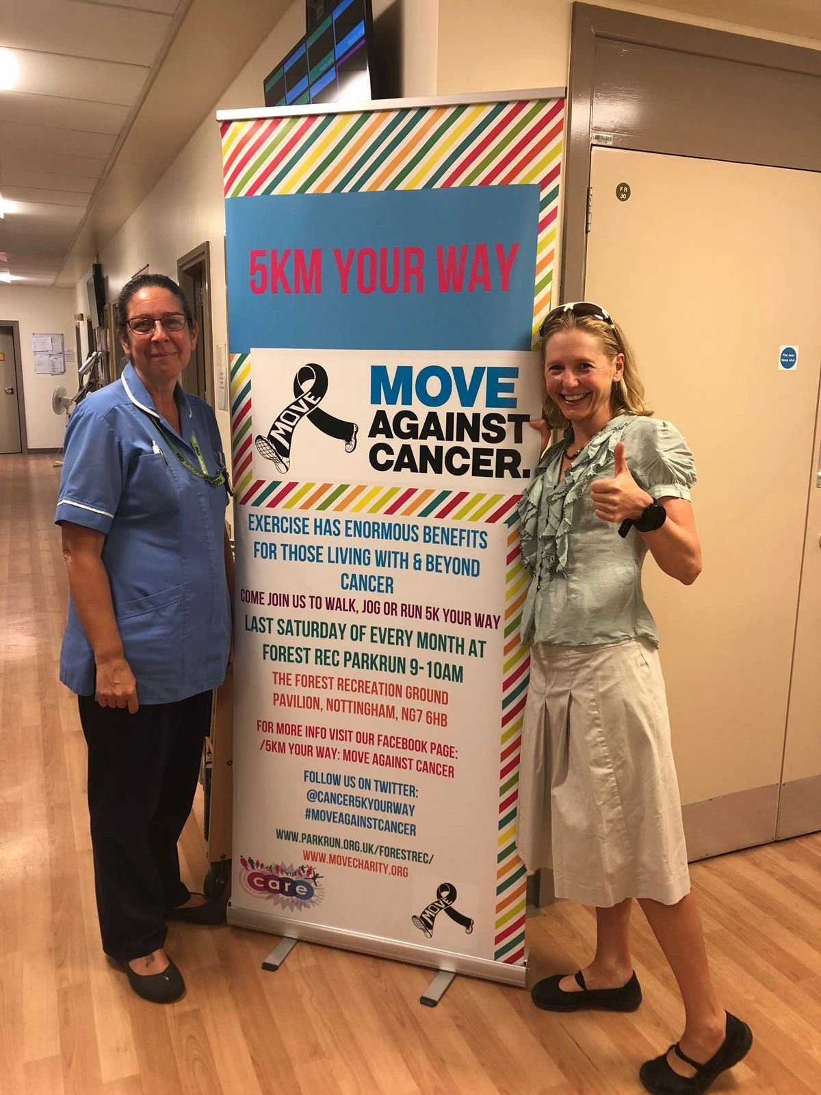

Exercise is arguably the most under-used ‘wonder drug’ in the NHS. For those living with and beyond cancer, there is persuasive and accumulating evidence that exercise and physical activity during and after cancer has a multitude of benefits; improved physical and psychological well-being; reduced treatment side effects; decreased cancer-related tiredness; enhanced self-esteem; even prolonged survival.

As oncologists we prescribe drugs and we prescribe radiotherapy. Yet, despite the growing evidence for its benefits, most of us don’t discuss exercise with our patients. This may be because exercise is not something we’re taught about in medical school and as junior doctors. It may be because, commonly, health care professionals often don’t look after ourselves; if we don’t exercise how can we tell our patients to? It may be because we are so stretched working in the NHS, that we don’t even get time to do the ‘essentials’ properly in each clinic appointment; finding the time for ‘extras’ means patients waiting anxiously to see us will spend even longer in the waiting room. And it may be because we don’t know how to bring up the concept of exercise. Having avenues to signpost patients towards makes starting the conversation around exercise much easier.

I was fascinated to learn that, to get one smoking patient to give up cigarettes, a doctor needs to advise between 50-120. However, to get one patient to meet recommended physical activity levels a doctor needs to advise just 12. Talking about exercise with our patients is good bang for your buck, whichever way you look at it. Many people with cancer are willing to try anything that might improve their survival and quality of life. If they don’t know exercise is likely to help why are they going to try it? As health care professionals I believe we owe it to our patients to make the most of the ‘teachable moments’ that come with each clinic appointment and take the time to educate them to the power of exercise alongside and after cancer treatment. Then patients can make their own, informed decision as to whether or not they want to work on increasing their activity levels. Like anything in life, if you understand why you are doing it you are far more likely to persevere.

The idea for 5K Your Way, Move Against Cancer came when I was working with some teenage and young adult patients. Many of these patients receive long, tough courses of chemotherapy. During treatment they do little other than sit in their hospital room. After treatment we offer little to help them regain their fitness. I wanted to set up something that would help change this. I knew that the best way to instigate change would be by including health care professionals in the change. What better way to do this by creating a community within the wonderful community that is parkrun.
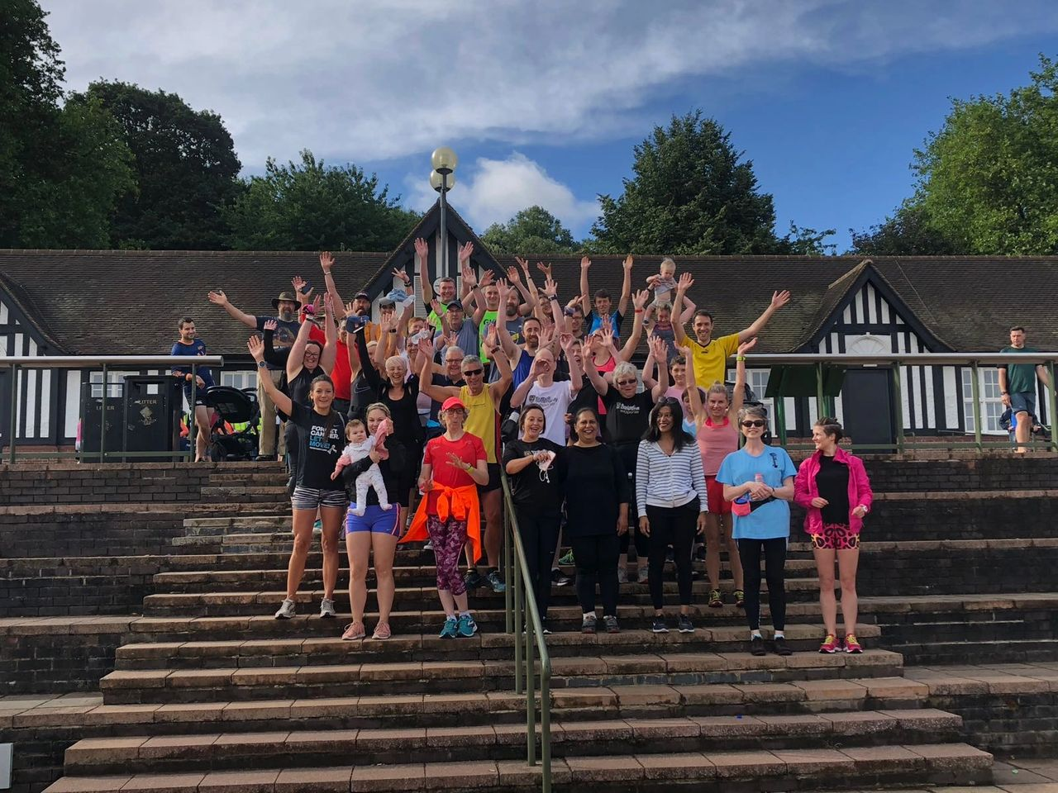

So, alongside Gemma Hillier-Moses, we created 5k Your Way, Move Against Cancer. We are a support group with a difference, a run and walking club with a difference, a social opportunity with a difference, a coffee morning with a difference. And we are spreading rapidly across the UK and Ireland, we currently have sixty-three 5K Your Way groups meeting at parkruns across the UK and Ireland, and over 175 ambassadors volunteering their time to lead these groups.

We hope that 5K Your Way, Move Against Cancer offers an avenue for health care professionals to signpost anyone affected by cancer towards activity in a safe, welcoming, supportive and empowering environment. And equally, we hope the initiative will encourage health care professionals to increase their own activity levels alongside their patients.
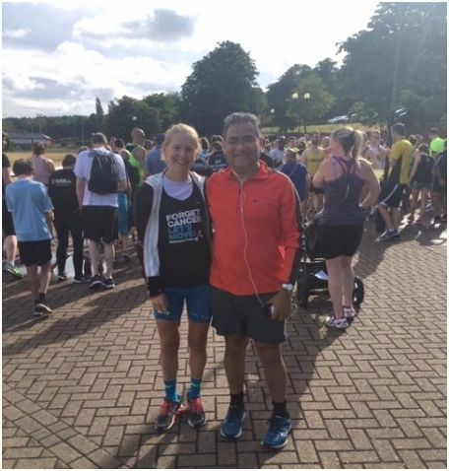

Currently, due to the Covid-19 pandemic our groups are suspended; however, when the time is right, we are ready and excited to relaunch our groups, and work towards our goal of linking 5K Your Way groups to every hospital treating cancer in the UK and Ireland. When it is safe to do so, we will be there to provide support in a positive and active environment to those living with and beyond cancer.

While our groups are unable to physically meet, we have been doing all we can to support our community virtually; to turn lockdown from a challenge to an opportunity. We have created a Lockdown Resources area on our website which includes: Our weekly live Q&A’s, blogs from our community and experts in the cancer and exercise field and our virtual Move Your Way sessions on the last Saturday of the month, in place of our normal group meet-ups. With the help of our brilliant volunteers, as an entire community we also accumulated our walk/jog/run miles to make it ‘Around the World in 80 days!’
We are not a running club. We are an active support group with a difference and we would love you to join us!
If you have any questions or would like more information please do not hesitate to get in touch via email: info@5kyourway.org

Website: www.5kyourway.org
Social Media:
Facebook: 5k your way: move against cancer
Twitter: @cancer5kYourWay
Instagram @5kyourway

