**5K Your Way, Move Against Cancer**

A volunteer-based approach based on promoting exercise, for cancer patients, and linked to local ParkRun groups, which began in Somerset and seems to be spreading far and wide – 63 groups nationally so far.  Their website is: [www.5kyourway.org](http://www.5kyourway.org)

There is already a group set up in Bath; our MacMillan GP in Bath, Jennie Wallace has joined the RUH physios and some of our cancer patients for several very enjoyable Park Runs.

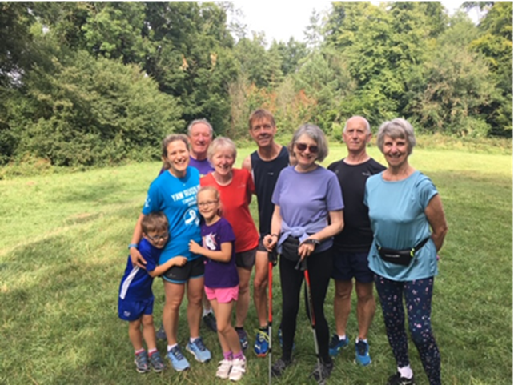

Whilst the Park Runs are currently not happening, 5K Your Way has continued to motivate patients on line via social media - they have recorded some very inspirational interviews and set fun challenges.

There may be opportunity and motivation “out there” for someone reading this to consider setting up additional groups within BSW, linked to ParkRuns, by linking up with the originators at the wesite.

It is also another resource for those healthcare staff delivering support for cancer patients, to signpost to patients, and to help promote the benefits of exercise, as part of Cancer Care Reviews and any other opportunities that arise as part of the living with and beyond cancer approach.

[Here is a recent blog](https://bswccg.nhs.uk/for-clinicians/primary-care-documents/primary-care-bulletin-documents/1329-gp-bulletin-9-october-doc-7/file) describing all this in a bit more detail.