

## Virtual Support Services

**Look Good Feel Better**

We are now able to offer some face-to-face places on a Look Good Feel Better woman’s workshop. To book phone the Macmillan Centre on 023 8120 6037 or email us at [MacmillanCentre@uhs.nhs.uk](mailto:MacmillanCentre@uhs.nhs.uk).

Look Good Feel Better are also offering online confidence boosting workshops for cancer patients to learn about skin care. The women’s workshop also focuses on the use of make-up, while the men’s focuses on grooming. Email info@lgfb.co.uk or phone 075 4555 1531 to learn more. You will need a computer or tablet with camera and microphone to participate. They also have informative and detailed tutorials on their website www.lgfb.co.uk.

**Wigs**

You can now either see the wig rep in person by phoning the centre to book an appointment or she can get in contact with you to signpost you to the wig company’s website to look at wigs or have one of their catalogues sent to you. You are able to choose a wig from Banbury Prostiche at the basic wholesale price, which is paid for by the hospital. If you want you can also choose a more expensive wig and pay the difference. We need a referral form from your medical team, prior to you receiving your wig.

**Ver 8 Published: October 2020**

Leaflet produced: June 2020

**Support services during COVID-19**



# **Macmillan Cancer Information & Support Centre**

## Welcome

The Macmillan Centre is open. We are available to listen, support and provide information Mondays to Fridays between 10am – 4pm. Due to limited space and a smaller team, which enables us to maintain appropriate social distancing and infection control measures for your safety, we are restricting numbers of visitors into the centre at the moment.

We are here to support patients and their families. You can get in touch with us by phone 023 8120 6037 or email MacmillanCentre@uhs.nhs.uk. You are important to us and if you leave a message we will respond the same day or the next working day. We check phone and email messages regularly.

Visit our page on the Hospital’s website (www.uhs.nhs.uk/macmillan-centre) to find links for quality information, support videos and relaxing hypnotherapy recordings. If you encounter any difficulty, please contact us.

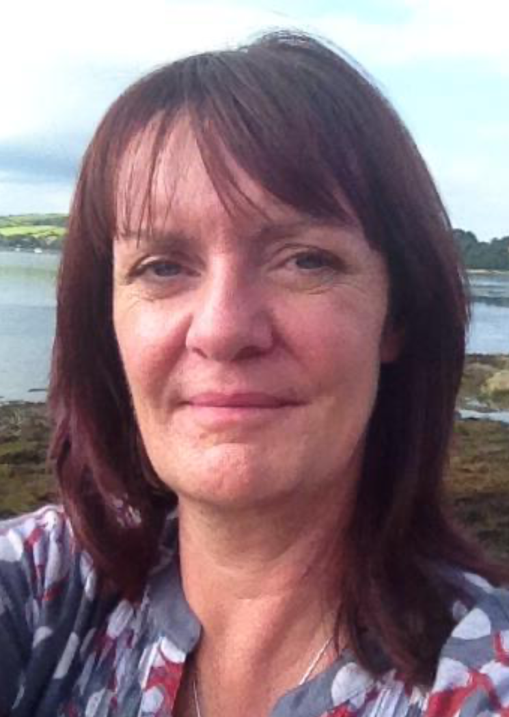 

**Andrea Lodge Mary Weavers**

**Centre Manager Centre Coordinator**

**Benefits and Financial Advice**

Phone Hampshire Macmillan Citizens Advice Service on 034 4847 7727 for help with benefits, housing or employment issues/form filling and blue badge applications. If you need a face-to-face appointment these can be arranged.

**Complementary Therapies**

We are now offering some therapies in the centre. We are also able to provide video sessions for self-acupressure, hypnotherapy, self-massage, self-reflexology and Reiki on a one-to-one basis, as well as individual and small group relaxation yoga. These can help with many aspects of your life such as reducing stress, releasing anxiety, improving sleep and improving side effects of your cancer treatment. Please get in touch if you would like to learn what is on offer.

**Counseling**

Our counselors provide one-to-one sessions by telephone and some are also able to offer video sessions. This service is available for patients and their family. Face-to-face sessions are available for patients that are unable to access the service by telephone or video.

**Fatigue**

One-to-one support sessions are available to help you manage fatigue caused by cancer. Click on the link on our webpage to get details on how to access this service or phone us.

## Virtual Support Services