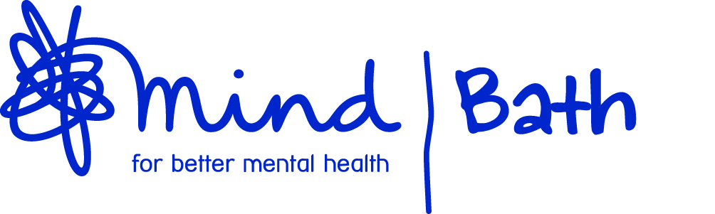
Mental Health First Aid – Online Training

This online course qualifies you as a Mental Health First Aider, giving you:
- An in-depth understanding of mental health and the factors that can affect wellbeing
- Practical skills to spot the triggers and signs of mental health issues
- Confidence to step in, reassure and support a person in distress
- Enhanced interpersonal skills such as non-judgemental listening
- Knowledge to help someone recover their health by guiding them to further support – whether that’s self-help resources, through their employer, the NHS or a mix
Takeaways
Everyone who completes the course receives:
- A certificate to confirm you are a Mental Health First Aider
- A manual to refer to whenever you need it
- A quick reference card for the Mental Health First Aid action plan
- A workbook including a helpful toolkit to support your own mental health
Format
- This is an online course delivered through the MHFA England Online Learning Hub
- Learning takes place through four live training sessions, spread across two weeks, with self-learning activities in between.
- Each session is built around a Mental Health First Aid action plan
- Courses are limited to 16 people so that the course leader can keep delegates safe and supported while they learn
To apply email: bswccg.traininghub@nhs.net
