Please note that this content is embargoed until 00.01 hours 17th February 2021
TVCA #KnowYourCancerRisk: Lung
Social Media Toolkit (Twitter): Messages & Scheduling

Dear Colleagues,
As part of the national and local lung cancer awareness campaigns we are asking local Communication Teams to kindly tweet the following messages over the next six weeks (see schedule). Alternatively, please re-tweet these messages from @ThamesV_Cancer, who will being tweeting W/C 22nd February.
In addition, we ask that local Communication Teams share their Twitter handle with us, so that TVCA can follow and re-tweet any relevant communications to a wider audience.
Many thanks for your support.
Thames Valley Cancer Alliance Team

W/C | Message
15th Feb &  22nd Feb | Message 1  If you’ve had a persistent cough for 3 or more weeks, which has continued after a negative COVID-19 test, then please speak to your GP, as it may well be a sign of lung cancer #HelpUsHelpYou #TVCAKnowYourCancerRisk  Message 2  “We are very, very keen to see you, if you have any symptoms that might be consistent with lung cancer.” Dr Karen Sandhu provides important information on the signs and symptoms of lung cancer. https://www.youtube.com/watch?v=RBFQ6LIToDU  #HelpUsHelpYou #TVCAKnowYourCancerRisk  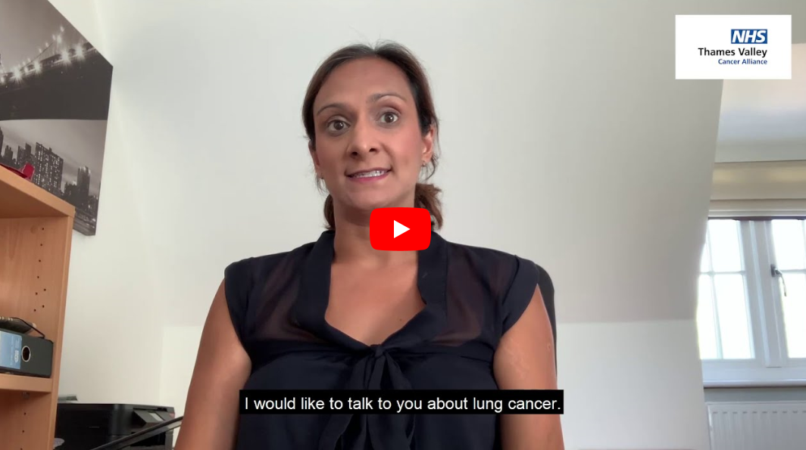  Message 3  “It is vital that you speak to your GP if you have had a cough for 3 weeks or more, which has persisted after a negative COVID-19 test”  Dr Anant Sachdev (Prevention & Early Diagnosis Clinical Lead, Thames Valley Cancer Alliance)  #HelpUsHelpYou #TVCAKnowYourCancerRisk
1st Mar  &  8th Mar | Message 1  The Roy Castle Lung Foundation is a UK Lung Cancer charity dedicated to helping everyone affected by the disease. For support visit https://www.roycastle.org/ #HelpUsHelpYou #TVCAKnowYourCancerRisk  Message 2  Macmillan Cancer Support has produced an easy read booklet for people with a learning disability, to help make them aware of the signs and symptoms of lung cancer.  #HelpUsHelpYou #TVCAKnowYourCancerRisk  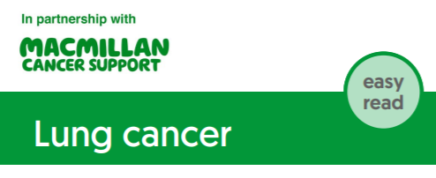  Message 3  The Northern Cancer Alliance has produced a short film for people with a learning disability, to help make them aware of the signs and symptoms of lung cancer.  #HelpUsHelpYou #TVCAKnowYourCancerRisk
15th Mar  &  22nd Mar | Message 1  Lung Cancer Symptoms include –  - A cough that has been going on for longer than 3 weeks  OR from which you bring up any blood  - Worsening of breathlessness if you already have a lung condition  - Unexplained weight loss  Please don’t hesitate to contact your GP surgery #HelpUsHelpYou  Message 2  Across the country, the NHS is raising awareness of the signs and symptoms of lung cancer. The Northern Cancer Alliance has some excellent resources and information for patients. #HelpUsHelpYou #TVCAKnowYourCancerRisk  Message 3  Dr Karen Sandhu (Swindon GP) provides important information on the signs and symptoms of lung cancer. https://www.youtube.com/watch?v=RBFQ6LIToDU  #HelpUsHelpYou #TVCAKnowYourCancerRisk

