South West Safeguarding Bulletin - Issue 11

Children and Young People Safeguarding
Working Together Safeguarding Children Reforms Newsletter - September 2021
A new cross-agency newsletter has been produced to support professionals working within local safeguarding children's partnerships (LSCPs) implementing the 'Working Together 18' partnership reforms.
This first issue includes an introduction to the facilitators, Integrated Care Systems, The National Panel Newsletter and more.

NHS Digital have shared the August CP-IS Bulletin which contains the fabulous news that as of 22nd July 2021, 100% CP-IS deployment across every local authority within England was achieved!

Adult Safeguarding
How to use legal powers to safeguard highly vulnerable dependent drinkers in England and Wales
Over the past eighteen months, as part of Alcohol Change UK's work, Professor Michael Preston-Shoot and Mike Ward have produced guidance aimed to help professionals in England and Wales to use legal frameworks to manage and protect vulnerable, chronic, dependent drinkers.
This is a shareable document for all staff who encounter people who are at risk of alcohol-related harm.
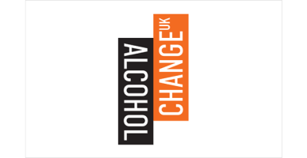
The Health, Wellbeing and Safeguarding Needs of Individuals Seeking Asylum
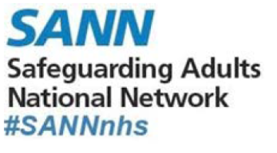
Safeguarding Adults National Network (SANN) have commissioned a report focusing on key national findings and recommendations in relation to the health, wellbeing and safeguarding needs of individuals seeking asylum. SANN commissioned the report following an After-Action Review looking at safeguarding adults in the context of the Covid-19 pandemic. The After-Action Review highlighted concerns in relation to the health and well-being of those seeking asylum and how systems responded, particularly during times of immense pressures and brought by the pandemic on all sectors.

Contextual Safeguarding
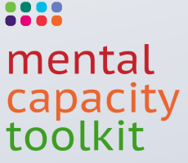

Bournemouth University have recently launched a Mental Capacity Toolkit aimed at supporting nurses and other practitioners in their understanding and duties under the HRA and MCA.
This product is free and has been funded through the Burdett Trust for Nursing.
The latest from the Social Care Institute for Excellence
The latest edition of SCIELine is now available and shares updates around the Introduction to the Care Act 2014, Dementia Awareness and Good Practice in Safeguarding training amongst others along with a special edition to celebrate their 20th anniversary!
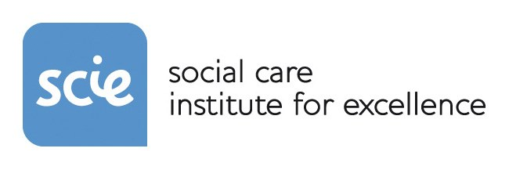

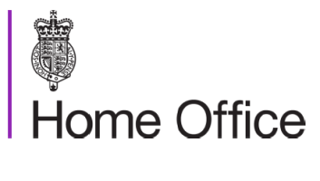

The Home Office have announced NEW E-learning for First Responders and Safeguarding Partners in England and Wales, shared within the latest NRM Reform Newsletter. This edition also includes updates to the Modern Slavery chapter of the Homelessness Code of Guidance and the Nationality and Borders Bill introduction.

Keeping you up to date, you can find out more from the latest Prevent Newsletter.
Please note;
- Page 3, item 2 - National Referral Forms would need to be amended to suit your regional referral process.
- The information in this newsletter is for internal consumption only and is protectively marked at OFFICIAL under the Government Security Classification Policy. The contents of this document should not be placed on the internet for public download.
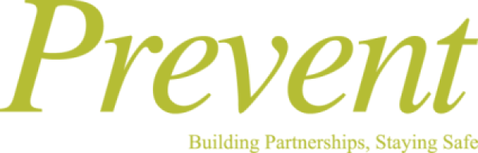

There's still time to register on the South West Regional Governance Group, Honour Based Abuse, Forced Marriage and FGM Online Conference, due to take place on Wednesday 13th October 2021 between 09:30 - 13:30.
Further information can be found here along and you can book a place by emailing punita.bassi@avonandsomerset.police.uk

Other information
- NHS England and NHS Improvement have produced an Introduction around Integrated Care Systems.
This document gives the background, purpose and what we know so far.
- Anti-Slavery Day will be on Monday 18th October 2021.

Shout Out
This issue we celebrate not one but two fabulous Safeguarding Star Awards!
Paulette Nuttall was presented with a Safeguarding Star Award on the 16th September 2021 by Catherine Randall, National Deputy Head of Safeguarding for NHS England and NHS Improvement. Nominations received included Paulette's passion around improving the lives of individuals, demonstrating system leadership both internally and externally and for all of Paulette's excellent work as Head of Safeguarding Adults/Designated Nurse for Bristol, North Somerset and South Gloucestershire CCG. Well done Paulette!
Kenny Gibson surprised the Somerset NHS FT safeguarding service during a team meeting on the 20th September 2021, awarding all members for providing a valued service in responding to the day to day requests for support, advice and guidance from staff as well as the team.
Both awards were presented for far more than this insight into their nominations but there wouldn't be enough space for me to write within this newsletter so CONGRATULATIONS to all!

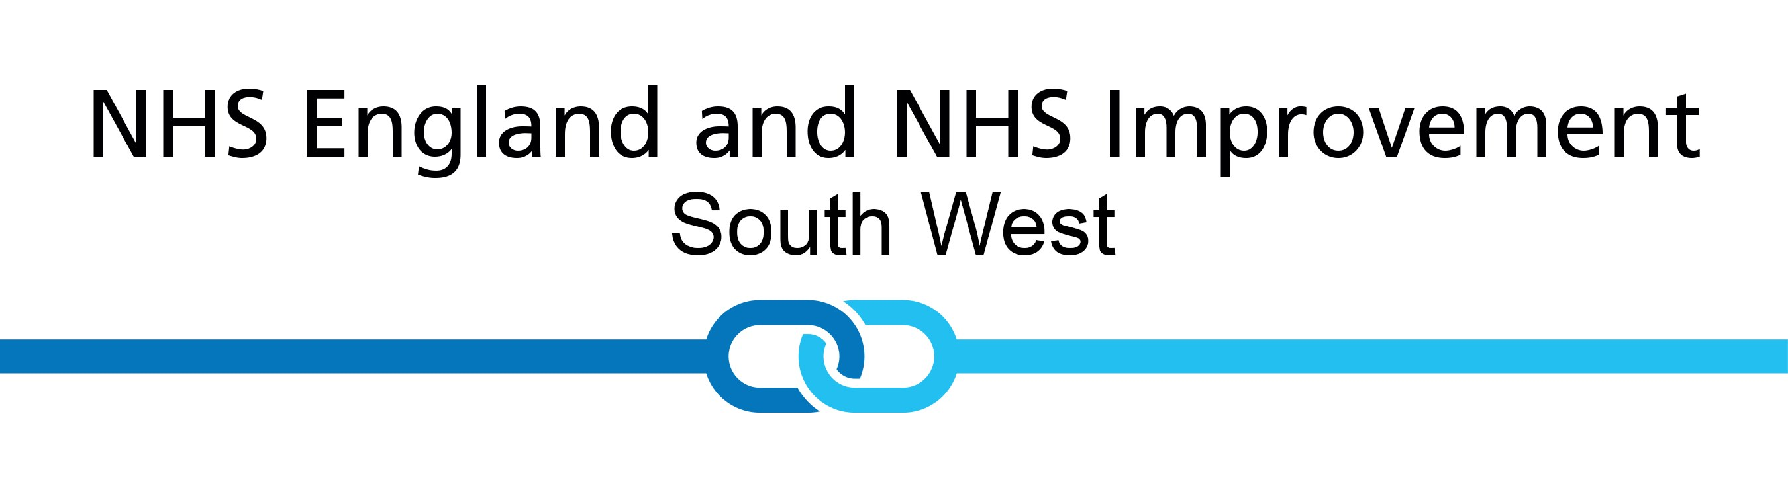
Follow us on Twitter, Facebook and Instagram
Visit our website

