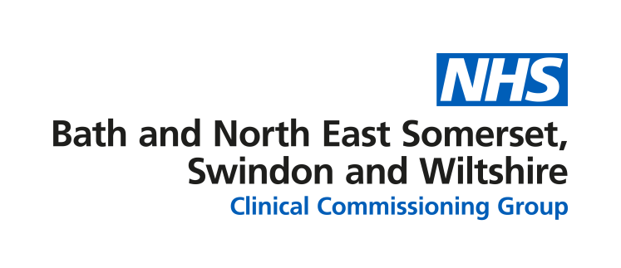
Think 111 First

FAQs

When can NHS 111 be accessed and how?
NHS 111 is available 24 hours a day, 7 days a week.
To get help from NHS 111, you should:
- go online to 111.nhs.uk
- phone 111 for free from a landline or mobile phone.

What is Think 111 First?
Think 111 First is a national programme that aims to get people to contact NHS 111 online or by phone, if they think they need to attend an emergency department for an urgent, but not serious or life-threatening health problem.

The 111 service will assess the person’s needs and direct them to the most appropriate service which could be their GP, a pharmacy, a walk-in centre, minor injuries unit or to speak directly to clinician or go to the emergency department.
If an experienced clinician at 111 decides the person needs to go to a minor injuries unit, urgent treatment centre or an emergency department, they will be able to arrange a timed arrival slot with any of these services.

What are the benefits of contacting 111 first?
- Where needed, more people will speak with a senior medical professional earlier and get the right treatment first time.
- If someone needs an urgent face-to-face assessment or treatment, this can be arranged without delay - leading to shorter waiting times for all patients
- By advising people where and when to go, we can better control queues in emergency department waiting rooms and lower the risk of catching or spreading COVID-19

Can you give me an example of an emergency and a non-emergency?
(response provided by the Royal College of Emergency Medicine)
Emergencies include:
- loss of consciousness
- acute confused state and fits that are not stopping
- chest pain
- breathing difficulties
- severe bleeding that cannot be stopped
- severe allergic reactions
- severe burns or scalds
- stroke
If you think you are experiencing any of these it is vital you go straight to your emergency department or call 999.
If your issue is urgent but not life-threatening – like a sprained ankle – calling 111 and getting a timed arrival slot to attend an emergency department can save you a long and uncertain wait in the department, allowing you to wait in the comfort of your own home until the hospital is ready to see you.
Examples of non-emergencies would be earache or knee pain. While these may be uncomfortable you are unlikely to be in any danger and could be treated more appropriately somewhere other than an emergency department.
For these types of issues contact your GP, visit 111.nhs.uk or call NHS 111.

What do you mean by timed arrival slot –is it like an appointment time?
If you need to go to a minor injuries unit, urgent treatment centre or emergency department, NHS 111 can arrange a timed arrival slot for you. They will give you a time to arrive and you can stay at home until then.
Staff will be expecting you at that time slot and will have received information from NHS 111 about why you are there.
Of course, people who need care most urgently will be seen first so you may still have to wait. But if we are able to help people get the treatment they need outside of urgent care services like emergency departments, we can reduce the time you might need to wait.

What if I turn up to an emergency department without a timed arrival slot?
If people go to an emergency department without having called NHS 111 first, they will still be seen. No one will be turned away.
Patients needing emergency treatment will be prioritised and those whose conditions are not as urgent may need to wait or will be directed to another service for treatment.

What happens if someone gets a timed arrival slot for an emergency department but doesn’t show up? Will someone check that they’re ok?
When someone who is expected at an emergency department does not arrive, there will be systems in place to assess whether a follow up is necessary. It is particularly important that if vulnerable patients or those at risk miss an appointment, they are followed up.

What if my condition changes while I’m waiting at home?
This depends on the change in your condition - if you become seriously ill, call an ambulance, otherwise call NHS 111 again to talk about what you are feeling.

I have a complicated ongoing medical problem that is looked after by the hospital. When I get ill, I normally go straight to the A&E and they call the specialist to come and see me. Should I carry on doing this?
It might be better for you to try and contact the specialists that look after you before you come to the emergency department. Some patients with complicated medical problems need to be looked after in places other than the emergency department, particularly if they are vulnerable to infections.
If you are extremely ill, you should call an ambulance.

Isn’t NHS 111 just an information line?
NHS 111 is much more than information line – it helps to get people to the right service for their health needs, first time.
NHS 111 can arrange appointments at GP surgeries, some minor injuries units and urgent treatment centres - as well as send an ambulance should the person’s condition be serious or life-threatening.
From December, NHS 111 will be able to arrange a timed arrival slot for people who need to go to a minor injury unit, urgent treatment centre or emergency department.

Will NHS 111 be able to cope with the extra calls?
To support the service and to deal with any increased pressure as we go into the winter period, capacity in the 111 service has been expanded significantly. This means that more trained health advisors and nurses than ever before will be available to respond to peoples’ health needs.

How does this ease pressure on other services?
In many cases NHS 111 clinicians and call advisors can give people the advice they need without them needing to use another services such as an emergency department. In fact, a large proportion of people who call NHS 111 are given advice and support to care for themselves at home.
By reducing the numbers of patients attending an emergency department, Think 111 First relieves pressure on busy departments and reduces the risk of COVID-19 transmissions in waiting areas.

Are call handlers trained and is it safe to follow a script?
NHS 111 health advisors undertake a rigorous training programme and what they say and the questions they ask have been developed by leading clinicians to ensure patients get the right care.
A multidisciplinary team of experienced clinicians (including nurses, doctors, paramedics and pharmacists) oversee 111 calls, providing support where a patient has more complex needs.
The NHS 111 system automatically triggers the immediate ambulance dispatch if the patient’s symptoms are considered serious, life-threatening or in need of emergency treatment.

Can NHS 111 help those who struggle with communication or hearing, or do not have English as their first language?
All 111 providers follow The Accessible Information Standard, meaning that people who have a disability, impairment or sensory loss get information they can understand and any communication support they need.
For those who have difficulties communicating or hearing, they can:
- tell the call handler that they need an interpreter
- call 18001 111 on a text phone or using the Next Generation Text (NGT) Lite app on their smartphone, tablet or computer; or
- use the NHS 111 British Sign Language (BSL) interpreter service if they’re deaf and want to use the phone service.

