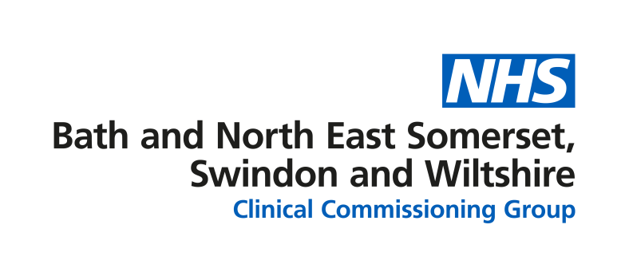
Think 111 First
We would like to tell you about Think 111 First, which is a new national initiative that will change how people access urgent care this winter.
As you will know, the NHS in 2020 has been called upon in a way that has never been seen before.
With the challenges of coronavirus set to be with us for some time to come, the health service needs to evolve and adapt to ensure that care is available for all who need it, while being provided in a safe environment for both patients and staff.
One such way that healthcare systems are helping people to get the care they need in the most appropriate location is by introducing Think 111 First.
What is Think 111 First?
Think 111 First is a national programme that will encourage people to use the NHS 111 service to access a range of urgent care services so they get the right service at the right time. This includes, for the first time, directly booking people in to be seen in an emergency departments.
What is it trying to achieve?
Think 111 First aims to reduce the number of people who walk in, rather than arriving by ambulance, to emergency departments, where overcrowding and long wait times can be common, especially during winter. Around 70 per cent of the people who use an emergency department walk in, and a significant proportion of these people could be safely treated elsewhere.
Alongside this, current social distancing and infection control procedures mean that there is less waiting space and fewer people can be seen. To keep people safe from coronavirus, and to ensure they get the treatment they need, we need to steer people who could be treated safely elsewhere away from our busy hospitals.
Those who genuinely need emergency treatment must, of course, still be seen safely, and Think 111 First will allow us to better manage the flow of people through the department.
How will it work?
We already promote NHS 111 as the place to go when someone is unsure of what healthcare is right for them, encouraging them to go online or call to be directed to the right service.
With Think 111 First, people who have an urgent health need will be advised to go online or call NHS 111 rather than using an emergency department as a first choice.
The 111 service will assess their needs and, where necessary, provide a consultation with an experienced clinician. If the clinician decides the person needs to go to a minor injuries unit, an urgent treatment centre or an emergency department, they will be able to book an appointment slot with any of these services.
Think 111 First in the South West
From December, healthcare facilities in our region, including the Great Western Hospital in Swindon, the Royal United Hospital in Bath and Salisbury District Hospital, along with our three minor injury units and two urgent treatment centres, will begin using the new NHS 111 First system.
Think 111 First is already up and running around the country, including in Cornwall, Portsmouth and in six London emergency departments. Healthcare teams in these locations have spoken highly of the impact the new system has had in reducing inappropriate attendances at hospital and in helping people to be treated in a safe and timely way.
Early trials across Bath and North East Somerset, Swindon and Wiltshire have shown equally positive results, and we are using these learnings and those from the areas already using the system to refine our processes ahead of the December launch.
Of course, people experiencing a life-threatening health emergency should always call 999 or immediately travel to the nearest hospital emergency department.
Nobody will be turned away from an emergency department if they arrive having not called NHS 111 first.
Involving patients and the public in our plans
As part of this work, the CCG is looking at how the use of Think 111 First will make it easier and safer for patients to get the right advice or treatment when they urgently need it from the most appropriate service.
To do this effectively, it is important for us to hear from people about their experience of using Think 111 First, and what would make them use service in the future.
A short online questionnaire, which has been designed for patients using the current NHS 111 service or attending emergency departments to leave feedback, is now live and will provide a snapshot of people’s feelings towards urgent and emergency care in their area that can be used as a comparison in future surveys.
You can take part in the survey using this link: https://www.surveymonkey.co.uk/r/NHS111First
This is a positive step forward for our region, and we would very much appreciate your support in helping to share this news with those in your communities.
Please do not hesitate to contact us directly using bswccg.communications@nhs.net if you have any questions or queries.

