Living with Autism - Stories, Strategies, & Strengths

A day for Parents, Teachers, Therapists and Health & Social Care Professionals
Tuesday 11th May 2021 9:30 - 4:30 via Zoom

Professional Rate: £50.00 per place

Parents Rate: £25 up to two parents or carers

To book please complete this form and send to
chair-wiltshire@familycounsellingtrust.org.
Please book early to ensure your place.

Name(s):

Role/ interest in attending:

E-mail address:

Telephone Number:

Receipt required: Yes / No (please circle)

Cheques should be made payable to: Family Counselling Trust Wiltshire and sent to WFCT, 7 Charnwood Rd, Salisbury, SP2 7HT.
Money transfers should be sent to: Sort code: 30-90-90
Account Number: 31496268. Please add your name as reference
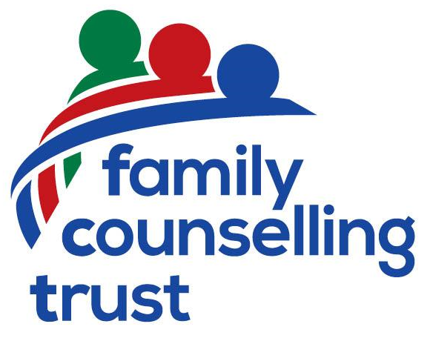
Please return this application form as soon as possible as places are limited.
We will not pass on your data to any third party,
the information you submit will be held locally and deleted after the event.

