Care Coordinator
NHS England and NHS Improvement has created the following, as a helpful resource:
- Sample job description
- Sample person specification

These optional resources are provided to support PCNs in the recruitment or engagement of care coordinators. The content has been developed to ensure it aligns with the requirements set out in the Network Contract DES and where content is in addition to the formal requirements, this is clarified. As this is complementary guidance, PCNs may decide whether or not to use these resources.

Sample Job Description – Care Coordinator
Purpose of the role

Care coordinators play an important role within a PCN to proactively identify and work with people, including the frail/elderly and those with long-term conditions, to provide coordination and navigation of care and support across health and care services.

They work closely with GPs and practice teams to manage a caseload of patients, acting as a central point of contact to ensure appropriate support is made available to them and their carers; supporting them to understand and manage their condition and ensuring their changing needs are addressed.

This is achieved by bringing together all the information about a person’s identified care and support needs and exploring options to meet these within a single personalised care and support plan, based on what matters to the person.

Care coordinators review patients’ needs and help them access the services and support they require to understand and manage their own health and wellbeing, referring to social prescribing link workers, health and wellbeing coaches, and other professionals where appropriate.

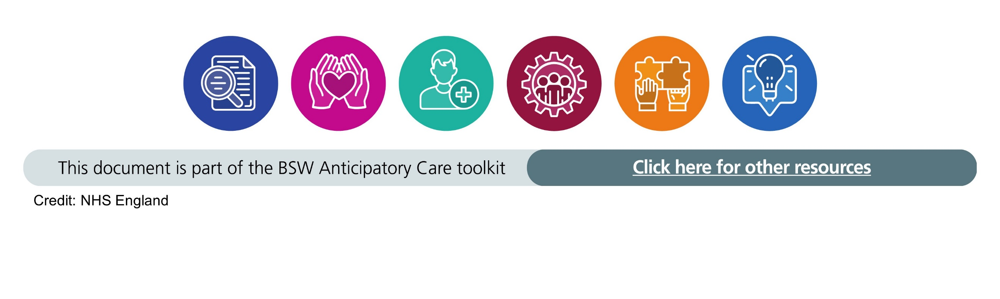
Care coordinators could potentially provide time, capacity and expertise to support people in preparing for or following-up clinical conversations they have with primary care professionals to enable them to be actively involved in managing their care and supported to make choices that are right for them. Their aim is to help people improve their quality of life.

The successful candidate will be based in a local cluster of General Practices as part of XX Primary Care Network (PCN). They will be caring, dedicated, reliable and person-focussed and enjoy working with a wide range of people. They will have good written and verbal communication skills and strong organisational and time management skills. They will be highly motivated and proactive with a flexible attitude, keen to work and learn as part of a team and committed to providing people, their families and carers with high quality support.

This role is intended to become an integral part of the PCN’s multidisciplinary team, working alongside social prescribing link workers and health and wellbeing coaches to provide an all-encompassing approach to personalised care and promoting and embedding the personalised care approach across the PCN.
There may be a need to work remotely depending on the requirements of the role. Please note that the role of a care coordinator is not a clinical role.
Salary: TBC by PCN. Reimbursement is based on indicative AfC Band 4 or equivalent.
Key responsibilities

- Work with people, their families and carers to improve their understanding of the patients’ condition and support them to develop and review personalised care and support plans to manage their needs and achieve better healthcare outcomes.
- Help people to manage their needs through answering queries, making and managing appointments, and ensuring that people have good quality written or verbal information to help them make choices about their care.
- Assist people to access self-management education courses, peer support, health coaching and other interventions that support them in their health and wellbeing, and increase their levels of knowledge, skills and confidence in managing their health.
- Support people to take up training and employment, and to access appropriate benefits where eligible; for example, through referral to social prescribing link workers.
- Provide coordination and navigation for people and their carers across health and care services, working closely with social prescribing link workers, health and wellbeing coaches, and other primary care professionals; helping to ensure patients receive a joined-up service and the most appropriate support.
- Work collaboratively with GPs and other primary care professionals within the PCN to proactively identify and manage a caseload, which may include patients with long-term health conditions, and where appropriate, refer back to other health professionals within the PCN.
- Support the coordination and delivery of multidisciplinary teams with the PCN.
- Raise awareness of how to identify patients who may benefit from shared decision making and support PCN staff and patients to be more prepared to have shared decision-making conversations.
- Explore and assist people to access a personal health budget where appropriate.

[To further enhance the role, PCNs may wish to add the following additional responsibilities to the person specification:]
- Work with people, their families, carers and healthcare team members to encourage effective help-seeking behaviours;
- Support PCNs in developing communication channels between GPs, people and their families and carers and other agencies;
- Identify unpaid carers and help them access services to support them;
- Conduct follow-ups on communications from out of hospital and in-patient services;
- Maintain records of referrals and interventions to enable monitoring and evaluation of the service;
- Support practices to keep care records up-to-date by identifying and updating missing or out-of-date information about the person’s circumstances;
- Contribute to risk and impact assessments, monitoring and evaluations of the service;
- Work with commissioners, integrated locality teams and other agencies to support and further develop the role.

Key Tasks

- Enable access to personalised care and support
  - Take referrals for individuals or proactively identify people who could benefit from support through care coordination;
  - Have a positive, empathetic and responsive conversation with the person and their family and carer(s) about their needs;
  - Work towards increasing patients’ understanding of how to manage and develop health and wellbeing through offering advice and guidance;
  - Develop an in-depth knowledge of the local health and care infrastructure and know how and when to enable people to access support and services that are right for them;
  - Use tools to measure people’s levels of knowledge, skills and confidence in managing their health and to tailor support to them accordingly.
  - Work with the wider PCN, MDTs, and the social prescribing service to look at how carers can support people - this could include the initial identification of carers onto the carer register
  - Support people to develop and implement personalised care and support plans;
  - Review and update personalised care and support plans at regular intervals;
  - Ensure personalised care and support plans are communicated to the GP and any other professionals involved in the person’s care and uploaded to the relevant online care records, with activity recorded using the relevant SNOMED codes;
  - Where a personal health budget is an option, to work with the person and the local CCG team to provide advice and support as appropriate;

- Coordinate and integrate care

  - Making and managing appointments for patients, related to primary, secondary, community, local authority, statutory, and voluntary organisations
  - Help people transition seamlessly between secondary and community care services, conducting follow-up appointments, and supporting people to navigate through wider the health and care system;
  - Refer onwards to social prescribing link workers and health and wellbeing coaches where required;
  - Regularly liaise with the range of multidisciplinary professionals and colleagues involved in the person’s care, facilitating a coordinated approach and ensuring everyone is kept up to date so that any issues or concerns can be appropriately addressed and supported;
  - Actively participate in multidisciplinary team meetings in the PCN as and when appropriate;
  - Identify when action or additional support is needed, alerting a named clinical contact in addition to relevant professionals, and highlighting any safety concerns.
  - Record what interventions are used to support people, and how people are developing on their health and care journey,

[To further enhance the role, PCNs may wish to add the following additional responsibilities to aid in data and information capture:]

- Keep accurate and up-to-date records of contacts, appropriately using GP and other records systems relevant to the role, adhering to information governance and data protection legislation;
- Work sensitively with people, their families and carers to capture key information, while tracking of the impact of care coordination on their health and wellbeing;
- Encourage people, their families and carers to provide feedback and to share their stories about the impact of care coordination on their lives;
- Record and collate information according to agreed protocols and contribute to evaluation reports required for the monitoring and quality improvement of the service.

Professional development

  - Work with a named clinical point of contact for advice and support.
  - Undertake continual personal and professional development, taking an active part in reviewing and developing the role and responsibilities, and provide evidence of learning activity as required;
  - Adhere to organisational policies and procedures, including confidentiality, safeguarding, lone working, information governance, equality, diversity and inclusion training and health and safety.

Miscellaneous

- Establish strong working relationships with GPs and practice teams and work collaboratively with other care coordinators, social prescribing link workers and health and wellbeing coaches, supporting each other, respecting each other’s views and meeting regularly as a team;

- Act as a champion for personalised care and shared decision making within the PCN;

- Demonstrate a flexible attitude and be prepared to carry out other duties as may be reasonably required from time to time within the general character of the post or the level of responsibility of the role, ensuring that work is delivered in a timely and effective manner;

- Identify opportunities and gaps in the service and provide feedback to continually improve the service and contribute to business planning;

- Contribute to the development of policies and plans relating to equality, diversity and reduction of health inequalities;

- Work in accordance with the practices’ and PCN’s policies and procedures;

- Contribute to the wider aims and objectives of the PCN to improve and support primary care.

