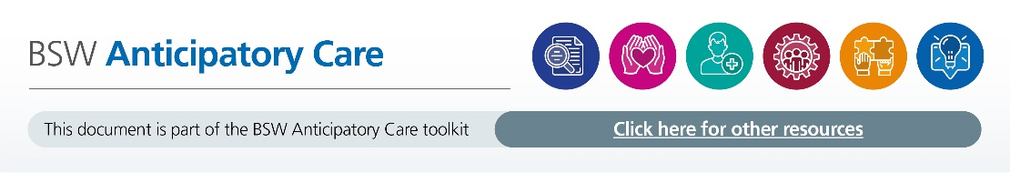

Frailty Service - Standard Operating Procedure.
The purpose of this Standard Operating Procedure (SOP) is to define the establishment of a Frailty Service within the Great Western Hospital (GWH) Primary Care Network (PCN).
Service Definition:
Frailty service is a planned proactive service maintaining the health and wellbeing of people living with frailty. The service will be managed by a suitably qualified and experienced Advanced Clinical Practitioner who will directly report clinically to Dr Pattni, and operationally to Tori Mitchell Lead Nurse Mental Health and Vulnerable Communities. A monthly update will be provided to these individuals on service development along with any operational issues.
Introduction:
Frailty can be considered as a long-term health condition characterised by loss of physical, emotional and cognitive resilience as a result of the accumulation of multiple health deficits. Frailty is progressive, typically erodes functional, cognitive and/or emotional reserves and increases vulnerability to sudden loss of independence and unpredictable deterioration following a comparatively minor stressor event such as an acute infection, new medication or constipation. While severe frailty can be comparatively easy to recognise and diagnose, lesser degrees of frailty may be more difficult to differentiate from normal ageing (The General Practice Frailty Toolkit 2017). If frailty goes unrecognised the adverse consequences for the health and wellbeing of the older person may be severe (BGS 2015).
People living with severe frailty comprise around 3% of the population aged 65 and older in England. For moderate frailty it is 12% of those aged 65 and older and 35% for mild frailty. These individuals are frequent users of services across health and social care and are particularly vulnerable to adverse outcomes, in particular health outcomes such as unplanned admissions to hospital, care home admission, acquisition of new disability or death (The General Practice Frailty Toolkit 2017).
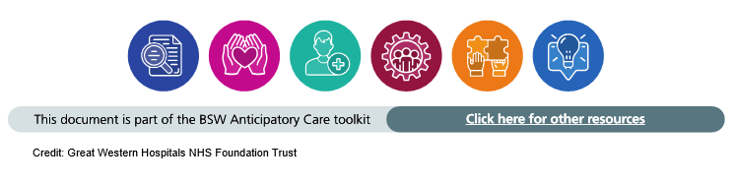

Key personnel and responsibilities:
All GWH PCN clinical and administrative staff are potentially going to be involved in contact with homes, however, the following is the defined list of key personal and responsibilities where noted:
a. Victoria Lawson – Advanced Clinical Practitioner (Trainee), Lead for GWH PCN Frailty service
b. Stephen Paul – Advanced Clinical Practitioner GWH PCN Frailty service
c. Dr Gautam Pattni - General Practitioner, Clinical Lead
d. Tori Mitchell – Lead Nurse Mental Health and Vulnerable Communities
e. GWH PCN Pharmacists and Pharmacy Technicians - Support to MDT and clinical lead for medicines optimisation
f. Community Clinical Leads/COPD/Therapy – Moredon and Abbey Meads Multi-disciplinary team involvement for co-ordinated case management
Aims of the service:
- To identify those living with frailty within the PCN
- To support the elderly to age healthier, reducing progression of frailty and risks associated with it where possible. To support them to make informed choices as to their health and welfare.
- To attend MDT and work collaboratively with community teams to support elderly and carers.
- Reduce emergency hospital admission, readmission and try to reduce care burden.
- To provide annual dementia health checks and home visits or face to face appointments.
- To identify those likely to be within their last year of life and support them to plan for their future needs.
- Develop shared care and support plans by involving older people living with frailty, their families and carers throughout all stages of progression.
- Early identification and treatment of Delirium.

Identification of Patients (1st stream):
- Patients referred by Practice staff/ community staff/ pharmacy/ self refer / relatives with area of concern.
- Age 65 and over with one of the following: frequent falls, sudden change to mobility, dementia, acute confusion, Parkinson’s, 4 or more long term conditions
- All people aged over 85
- Rockwood score 5 or above
- Referral via task or team email.

Identification of Patients (2nd stream):
- Discharge monitoring from GWH.
- Review D/C over 65.
- Logged onto spread sheet.
- Identify frailty score from GWH- 5 and above – review notes
- Routine frailty screening on SystmOne by clinicians when reviewing patients over 65, score of 5 or more triggers referral to be reviewed by frailty team

Follow-up and management of Patients (1st Stream):
- Notes reviewed, phone call by Frailty ACP and follow up visit booked if needed.
- Assessment (CGA including falls risk and 6CIT for all those with moderate to severe frailty) and areas of concern addressed and actioned, onwards referrals arranged if needed. Logged onto spreadsheet and SystmOne using the Frailty consultation tab.
- Follow up booked to review interventions.
- If needing ongoing support, then discuss with community clinical leads.
- Those identified as severely frail require annual SMR

Follow-up and management of Patients (2nd Stream):
- Review if patient is supported by community teams. Any identification of risk is assessed.
- Phone call and visit if needed to address areas of concern. Logged onto spreadsheet and SystmOne usig the Frailty consultation tab.
- Follow up phone call if needed to review interventions.
- Patients that are readmitted identified.
- Those identified as severely frail require annual SMR

Frailty / Elderly welfare review – Internal referral (to be integrated into SystmOne)
Must be over 65 years of age and meet at least one of the below criteria:
Frequent falls ☐
Sudden change to mobility ☐
Dementia or acute confusion ☐
Parkinson’s ☐
4 or more long term conditions ☐
Rockwood score 5 or above ☐
Patient details-

Area of concern-

Rockwood score-

Expected outcome-

Referrer details-

REFERENCES:

British Geriatrics Society, Fit for Frailty part 2 (2015): https://www.bgs.org.uk/sites/default/files/content/resources/files/2018-05-23/fff2_full.pdf
NICE Guideline: Dementia assessment, management and support for people living with dementia and their carers (2018) Dementia: assessment, management and support for people living with dementia and their carers (nice.org.uk)
The General Practice Frailty Toolkit 2017: toolkit-general-practice-frailty-1.pdf (england.nhs.uk)

