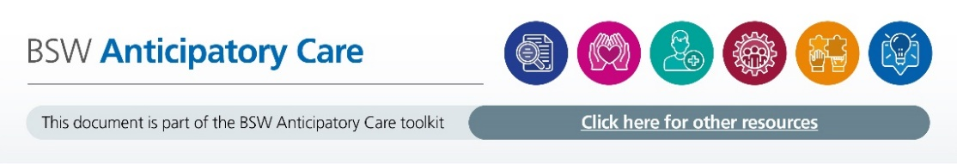
Vulnerabilities MDT SOP
Within the GWH PCN we run a biweekly Vulnerabilities MDT meeting that is attended by all members of the Vulnerabilities Team. This includes
- Lead Nurse for Mental Health and Vulnerable Communities
- Safeguarding Lead
- Frailty Practitioners
- Social Prescriber
- Lead GP for Vulnerable Communities
- Community Navigator from Live Well Team
- Mental Health Nurse
- Learning Disability Nurse
Purpose of this MDT is to provide a collaborative approach to support patients who may require a coordinated response from members of the team and may have additional vulnerabilities as a result of Frailty, Mental Health, LD or Complexity of need. Members of the team play a preventative and proactive role in the support of patients and aim to improve the experience and outcome of their care. Working as part of the wider acute hospital trust we would hope reduce expenditure in secondary care, and to avoid hospital admission/ attendance where possible.
The group can review the health and social plans for patients identified from the DASH report, ambulance attendances and A&E frequent attenders or those of concern to members of the MDT
The MDT can review patients who, in the clinician’s judgement, are at risk of an emergency admission in the near future whereby either a health or social intervention may avoid an emergency admission.

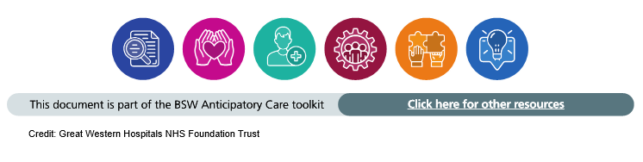
The MDT works on a cycle of 2 meetings, Part 1 & Part 2. Part One has a list of patients to be discussed. Actions will be agreed following a discussion and this will be followed up in part 2 meeting to review and evaluate actions.

Criteria for referral to the MDT:
- Increasing clinical complexity or psycho social needs
- Frequent caller / attender / user of services.
- Currently use 2 or more of the following services
- Frailty
- Mental Health
- Learning Disability
- Safeguarding concerns (adult or child)
- Where there is a social / lifestyle component to their health need
How to refer:
A referral form can be found on SystmOne …... to be confirmed
Members of the team should prepare adequately for the MDT meeting through the gathering of relevant information about patients who are to be discussed. Each patient discussed should be introduced with a brief summary to include:
- Name and age
- Social/family situation
- Diagnosis/summary
- Summary of previous medical history (if applicable)
- How they had been identified i.e. DASH, Ambulance or A&E frequent attender
The outcome for each patient discussed should include:
- Review of action points from the previous meeting (if applicable)
- Clinical management plan for the patient
- Identification of actions to be completed with responsibility allocated to a member of the team with expected timescales
- Documentation is completed for each patient at every meeting

