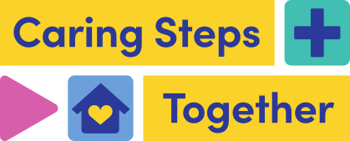

Discharge Communications

Social Media Toolkit (Public)
Version 1.0
This toolkit is designed to support BSW wide communications in the dissemination of consistent key messages and assets across all of our shared audiences to maximise our reach and engagement with our target audiences.

SOCIAL MEDIA ASSETS - All Audiences

Assets and suggested copy available to download from the BSW Together Discharge Communications Page at www.bswtogether.org.uk/discharge/professionals

 | Copy
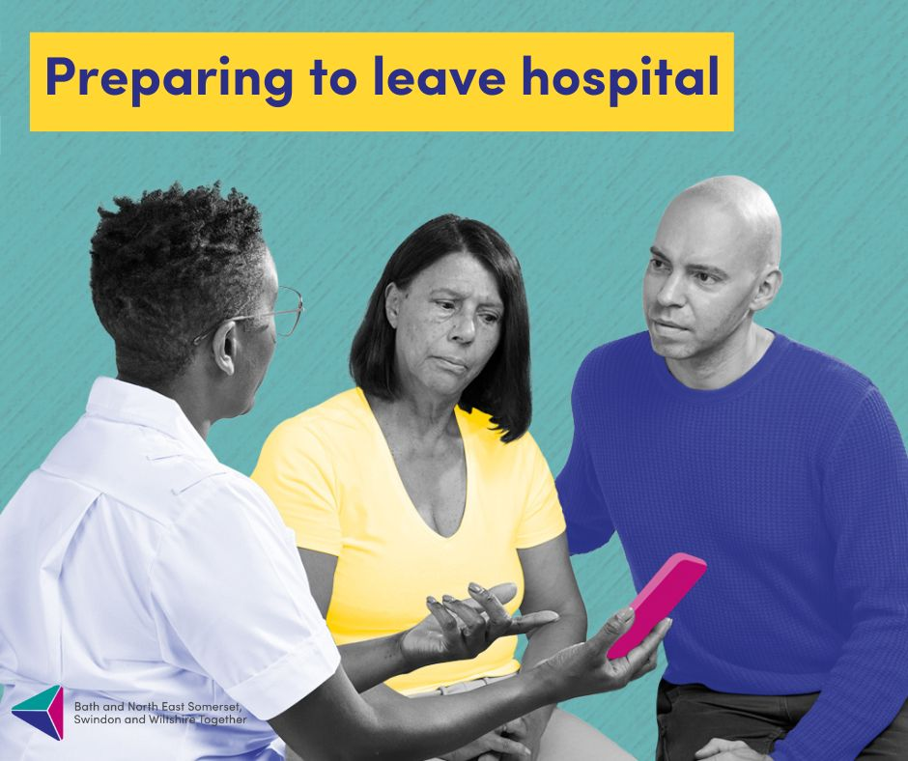 | You will be discharged from hospital as soon as you are medically well enough.  If you need it, extra support will be available for you at home or close by, to help your recovery.  For more information talk to your hospital team or visit:  www.bswtogether.org.uk/discharge
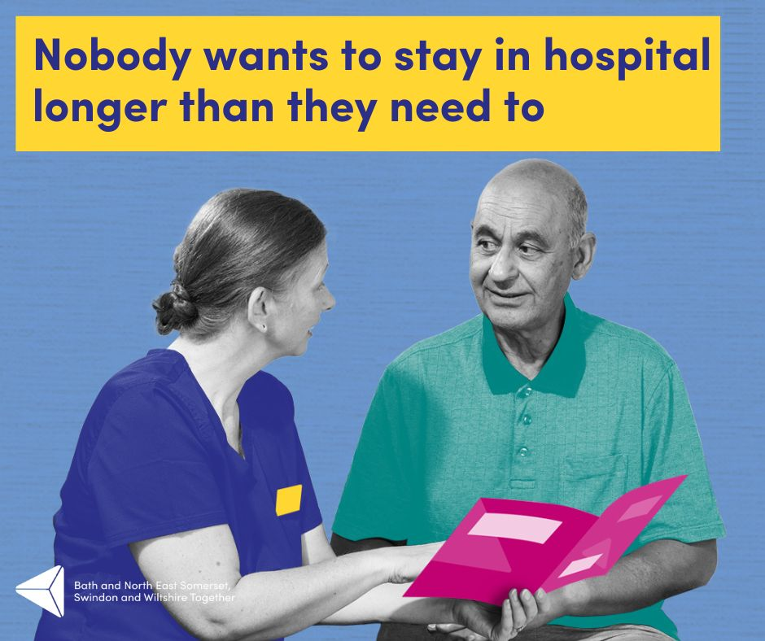 | Patients who stay in hospital longer than is necessary may face a greater risk of infection and potential loss of independence and mobility.  If you need it, extra support will be available for you at home or close by, to help your recovery.  For more information talk to your hospital team or visit:  www.bswtogether.org.uk/discharge
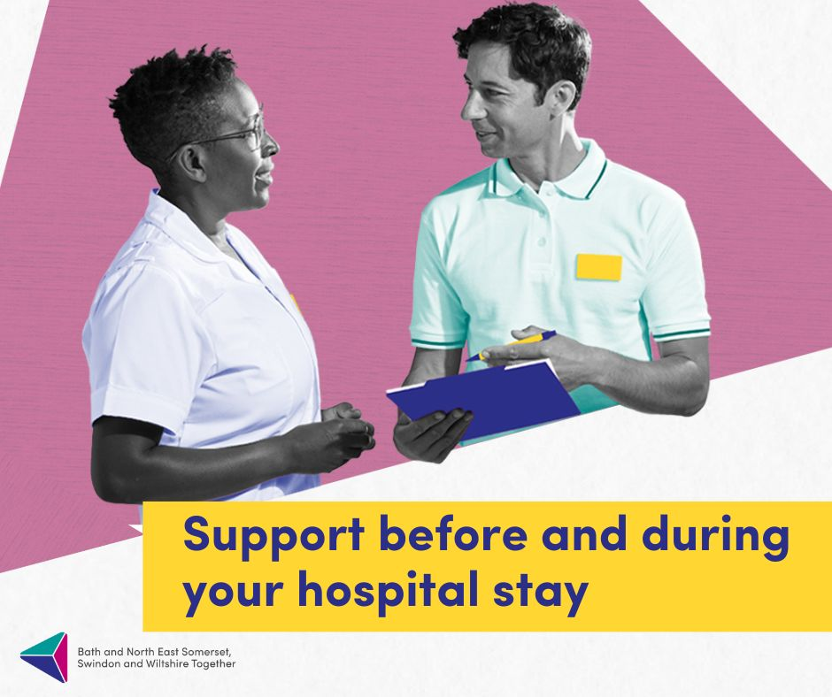 | We will support you to leave hospital when you are medically fit.  But we won't send you home until you are ready.  If you need it, extra support will be available for you at home or close by, to help your recovery.  For more information talk to your hospital team or visit:  www.bswtogether.org.uk/discharge
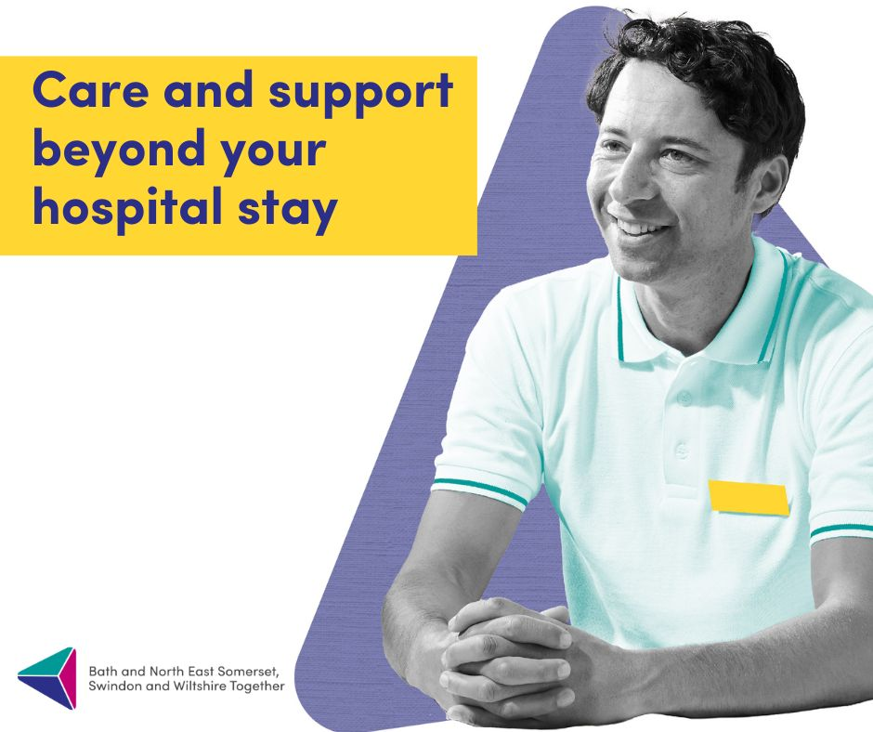 | Research shows that going home will help you get better much faster.  If you need it, extra support will be available for you at home or close by, to help your recovery.  For more information talk to your hospital team or visit:  www.bswtogether.org.uk/discharge
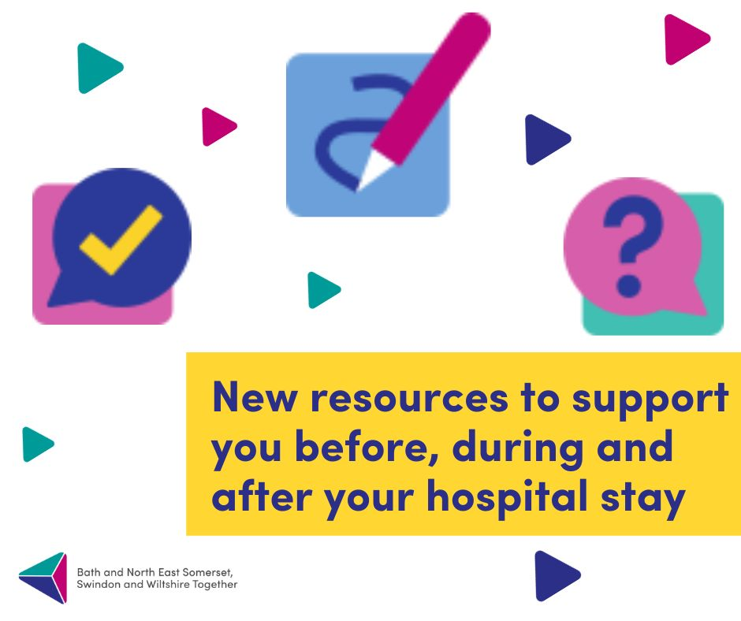 | We know that the hospital discharge process can be complicated.  Our new resources are here to explain what support will be available for you before, during and after your hospital stay.  For more information talk to your hospital team or visit:  www.bswtogether.org.uk/discharge

