BSW Digital ReSPECT plans on the ICR
Cribsheet for all users
What is the ICR?
The BSW Integrated Care Record (ICR) is a Shared Care Record accessible to everyone through your host electronic patient record (EPR) via the ICR button. Everyone involved in the patient’s care can see the same record irrespective of the system they are using. We are now transitioning to digital ReSPECT plans which can be found via the ReSPECT tile on the main menu or on the right hand side of the screen:
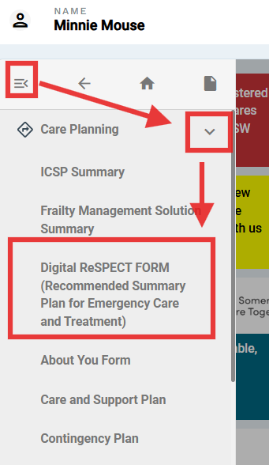 | 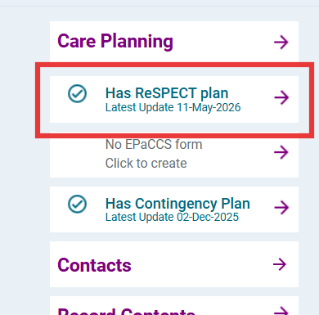

What is ReSPECT?
The ReSPECT process creates personalised recommendations for a person’s clinical care and treatment in a future emergency in which they are unable to make or express choices
More information can be found here on the Resuscitation Council website.

Why are we taking ReSPECT digital?
It will bring a number of advantages, which include:
- Instantaneous sharing of any updates to ReSPECT plans to everyone who can access the ICR across BSW.
- Acute hospital staff can check, update and print copies of ReSPECT plans completed in the community without having to repeat the discussions. The same applies for community providers with plans completed in other organisations.
- The digital ReSPECT plan will significantly improve version control, acting as the single source of truth – no more hunting for ReSPECT status updates on other organisation’s systems / in scanned notes.
- It gives the ability to access previous versions of the ReSPECT plan, to see how the patient’s status and wishes have evolved.
- Ambulance clinicians will shortly be able to access digital ReSPECT plans at the scene on their system.

How do I create or update a digital ReSPECT plan?
Please refer to the how-to guide that goes along with this cribsheet, which includes information on the below processes with screenshots.

What about paper plans?
We are not getting rid of paper copies of plans in patient’s inpatient notes or homes. However, all updates must now be completed on the digital plan, and then the new / updated plan printed out. Your current paper plans or SystmOne ReSPECT templates should not be used for new plans or updates going forwards.

Is the digital plan different to the current paper forms?
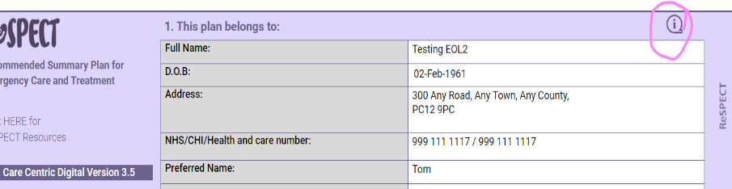
No – the content is the same, other than an extra box which gives more space to write out the capacity assessment. There are handy info guides on how to complete each section which can be accessed by hovering over the purple (i) icon at the top right of each section.

Who is it for?
A digital ReSPECT plan can be created for any patient who is registered with a BSW GP that shares to the ICR, or any inpatient at Great Western Hospital Swindon, Royal United Hospital Bath or Salisbury Hospital.

Who can create or update a digital ReSPECT plan on the ICR?
Creating or updating a digital ReSPECT plan should be done by anyone who is currently trained and competent to do so on a paper form. Anyone who can access the ICR is able to view a digital ReSPECT plan and print a paper copy.
The overall aim of Digital ReSPECT on the ICR is to improve availability of information about ReSPECT/DNACPR status in a more efficient and less time-consuming way for healthcare professionals.

Key processes
- If a patient needs a ReSPECT plan completing, you should complete a digital plan. This includes when records indicate they have had a ReSPECT/TEP form in place at some point but is not immediately available for you to review.

- Any time a digital plan is updated it is the responsibility of the person updating the plan to ensure a paper copy is printed out and put in the notes / given to patient, and removing any countersignatures if they pre-date the updated information.

- If a patient has a current paper ReSPECT plan that needs updating, then you should create a new digital plan and strike out the existing paper plan.

- If a patient has a traditional paper/Ardens ReSPECT plan that is currently valid then this should be transcribed to a digital plan, following the advice in the accompanying Digital ReSPECT user guide, and the paper plan crossed through.

- If a patient has a currently valid ReSPECT plan in the community, this should be updated at an appropriate time e.g. at annual review or during conversations about advance care planning. These updates should be completed on the digital plan, and the existing plan crossed through.

- If there is a discrepancy between the digital ReSPECT plan and a traditional paper plan, you must find out the patient’s preferences as soon as possible, and the digital ReSPECT plan updated accordingly. The paper plan should be crossed through.

- If you are at an inpatient facility and a patient is registered with a GP that does not share to the ICR, you should complete a digital ReSPECT plan as normal. However, you must ensure that the clinical recommendations are included in discharge documentation so that community providers are made aware of the plan.

- The ‘Senior Responsible Clinician’ section should ideally be signed by the relevant clinician on their own login in to ensure that it is a valid electronic signature. However, it is acceptable for these details to be entered by another member of staff as long as it is clearly documented in the summary box of section 2 that it has been signed electronically on behalf of the Senior Responsible Clinician. You must not wet sign a printed copy of a digital plan.

- ReSPECT capacity assessments should be scanned as JPEG/PNG and uploaded to the ‘Care Planning – Supporting Documents’ section in ICR Care Plan tile.

- If you work in the community and the above processes don’t fit with your way of working please continue using paper plans for now and contact Dr Natasha Wiggins.
FYI...
A few important things to remember:
- If you are creating a digital ReSPECT plan for the first time, you now need to click SAVE. This will publish the plan for other users to see. The finalise option has been removed.

- Drafts can no longer be saved – you need to complete all the mandatory fields.

- To print a ReSPECT form you can now click on the new PRINT button. This will open a printable webpage view of the form. We recommend changing the print scale to 80% for optimum sizing.

- The ‘NoK / Emergency Contact’ sections are mandatory to publish/print the form. If you need to print a form before this information is available (eg out of hours, or if a capacitous patient prefers to update NoK themselves) we suggest putting ‘awaiting signature’ or ‘N/A’ in these boxes.

- If you are a junior doctor/allied health professional who has completed a digital plan, you should fill in your details in section 7 (which will stop the Senior Clinician section being mandatory). You should then notify a senior responsible clinician so that they can review and countersign the plan at earliest opportunity.

- The plan will print with purple accents, so please print in colour if you are able. On inpatient wards, purple ReSEPCT-branded wallets should be used if possible. Please contact us for information about ordering more wallets.

- If a patient has not consented to information sharing via the ICR, we would first advise they contact their GP to re-consent to ICR usage if amenable. While this is awaited, or if they persistently do not consent to ICR info sharing then a paper plan should be completed, and details about DNACPR/treatment escalation status shared via the discharge documentation or primary care summary.

We strongly recommend you read the Digital ReSPECT user guide (available under Digital ReSPECT here) which has how-to guides for this platform and troubleshooting advice.
If you have any issues, questions or feedback, or think that you or another team would benefit from training on digital ReSPECT then please don’t hesitate to contact one of the Digital ReSPECT team and we will be very happy to help.
Karolina Fulluck – BSW ICB Project Manager – karolina.fulluck@nhs.net
Dr Natasha Wiggins - Palliative Medicine Consultant, and BSW Digital Lead for Palliative and End of Life Care - natasha.wiggins1@nhs.net

